SUBCOURSE EDITION
OD 0463 A

CANNON TUBE EVALUATION



CANNON TUBE EVALUATION

SUBCOURSE OD 0463
Edition A

United States Army Combined Arms Support Command
Fort Lee, VA 23801-1809

9 Credit Hours

GENERAL

The purpose of this subcourse is to familiarize you with cannon tube evaluation.

The scope of this subcourse covers the procedures for evaluating cannon tubes for serviceability using a pullover gage and borescope, and for completing all paperwork properly.

Nine credit hours are awarded for successful completion of this subcourse. This subcourse is organized as follows:

Lesson 1: VARIOUS TYPES OF CANNON TUBE
DETERIORATION, DAMAGE, AND
CONDEMNATION CRITERIA

TASK 1: Identify the different types of cannon tube deterioration and damage.

TASK 2: Identify condemnation criteria.

Lesson 2: STEPS IN THE USE OF THE PULLOVER GAGE

TASK 1: Describe the pullover gage.

TASK 2: Explain the use of the pullover gage.

TASK 3: Interpret readings of the pullover gage, given specific conditions of the bore diameter.

i

CANNON TUBE EVALUATION - OD 0463

Lesson 3: STEPS IN THE USE OF THE BORESCOPE

TASK 1: Identify and describe the borescope and related components.

TASK 2: Describe the correct procedures for operating the borescope.

TASK 3: Interpret borescope views, given specific conditions of the tube.

Lesson 4: PROCEDURES FOR USING THE WEAPON RECORD DATA FORM (DA FORM 2408-4)

TASK 1: Describe the purpose and correct entry procedure for the Weapon Record Data Form (DA Form 2408-4).

TASK 2: Identify miscellaneous information entries and disposition of the Weapons Record Data Form (DA Form 2408-4).

ii

CANNON TUBE EVALUATION - OD 0463

TABLE OF CONTENTS

Section Page

TITLE i

TABLE OF CONTENTS iii

Lesson 1: VARIOUS TYPES OF CANNON TUBE
DETERIORATION, DAMAGE, AND
CONDEMNATION CRITERIA 1

Task 1: Identify the different types of
cannon tube deterioration and damage 1

Task 2: Identify condemnation criteria 6

Practical Exercise 1 18

Answers to Practical Exercise 1 19

Lesson 2: STEPS IN THE USE OF THE PULLOVER
GAGE 20

Task 1: Describe the pullover gage 20

Task 2: Explain the use of the pullover
gage 24

Task 3: Interpret readings of the
pullover gage, given specific conditions
of the bore diameter 29

Practical Exercise 2 36

Answers to Practical Exercise 2 37

iii

CANNON TUBE EVALUATION - OD 0463

Lesson 3: STEPS IN THE USE OF THE BORESCOPE 38

Task 1: Identify and describe the
borescope and related components 38

Task 2: Describe the correct procedures
for operating the borescope 48

Task 3: interpret borescope views, given
specific conditions of the tube 57

Practical Exercise 3 59

Answers to Practical Exercise 3 60

Lesson 4: PROCEDURES FOR USING THE WEAPON
RECORD DATA FORM (DA FORM 2408 4) 61

Task 1: Describe the purpose and correct
entry procedure For the Weapon Record
Data Form (DA Form 2408-4) 61

Task 2: Identify miscellaneous
information entries and disposition of the
Weapon Record Data Form (DA form 2408-4) 66

Practical Exercise 4 68

Answers to Practical Exercise 4 70

REFERENCES 71

iv
CANNON TUBE EVALUATION - OD 0463 - LESSON 1/TASK 1

LESSON 1

VARIOUS TYPES OF CANNON TUBE DETERIORATION,
DAMAGE, AND CONDEMNATION CRITERIA

TASK 1. Identify the different types of cannon tube deterioration and damage.

CONDITIONS

Within a self-study environment and given the subcourse text, without assistance.

STANDARDS

Within one hour

REFERENCES

No supplementary references are needed for this task.

1. Introduction

It is the purpose of this correspondence subcourse to give ordnance personnel, concerned with cannon bore inspection, the latest information and instructions for inspecting cannon tubes. This lesson will concentrate on the various types of damage that can occur to cannon tubes and on relevant condemnation criteria.

2. Inspection Criteria for Various Types of Damage and Cannon Tube Deterioration--Intermediate Direct Support/Intermediate General Supply Personnel

a. Cracks.

(1) Cracks may grow progressively worse through continued firing. Therefore, a cannon tube may be condemnable even though condemnation limit for wear or fatigue life has not been reached; however, take care not to overstate a defect.

1

CANNON TUBE EVALUATION - OD 0463 - LESSON 1/TASK 1

(2) Not all defects that appear to be cracks are true cracks; therefore, it is necessary to evaluate each defect. Cracks must be differentiated from other defects such as scratches, heat checks, stripped lands, and superficial metallic flaws. Typical characteristics of a crack may include feathered edges running in an irregular line, varying in width and depth. Tool marks and scratches usually run in a straight line, or have smooth edges, uniform width, or shallow depth, but sometimes they deepen into cracks. Cracks may be found diagonally or transversely across or parallel to the lands and grooves.

(3) Cracks may also be found in the chamber portion of the cannon.

(4) The condition of rifling lands may affect accuracy (figure 1). This is especially true in high velocity cannons where deteriorated rifling lands can result in stripping or shearing of the ammunition's rotating band. The characteristics of deformation of lands in cannon tubes are covered in (a) through (e):

FIGURE 1. NOMENCLATURE FOR CONDITIONS OF
RIFLING LANDS.
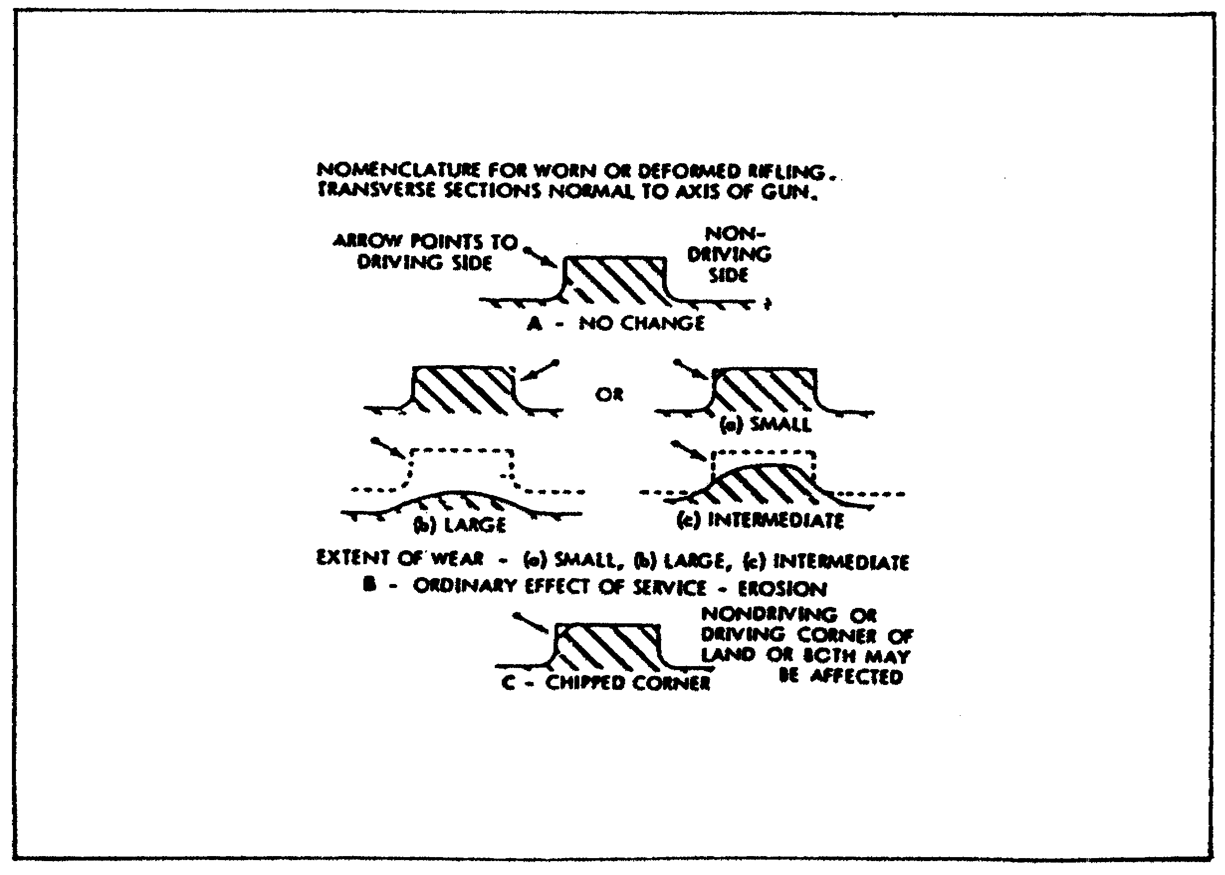

2

CANNON TUBE EVALUATION - OD 0463 - LESSON 1/TASK 1

(a) In some tubes, lands become hampered, or battered, allowing propellant gas to leak past the projectile.

(b) Edges of lands often chip or spall.

(c) When a crack spreads upward from a corner, a part of the land is sheared.

(d) When a crack spreads fully across or underneath a land, the land is said to be sheared. When one or both ends of the sheared land remain attached to bore interface, the land is raised (figure 2). If the raised portion is near the origin of rifling, it could prevent the loading or seating of a projectile. When ends break off and the land is missing, the land is said to be stripped.

(e) Lands usually erode most at origin of rifling.

b. Deformation of Lands by Erosion (Wear). Erosion at the origin of riflings, wears down the lands and causes the actual origin to move forward. This erosion is usually not critical to the tube. Erosion may cause rounding of edges of lands. Again, this erosion is usually not critical. Erosion in chrome-plated tubes appears different from that in non-plated tubes.

c. Raised Land. A tube with a raised land must be sent to depot for overhaul (figure 2).

FIGURE 2. RAISED LAND: NOT ACCEPTABLE. SEND
TO DEPOT FOR OVERHAUL.
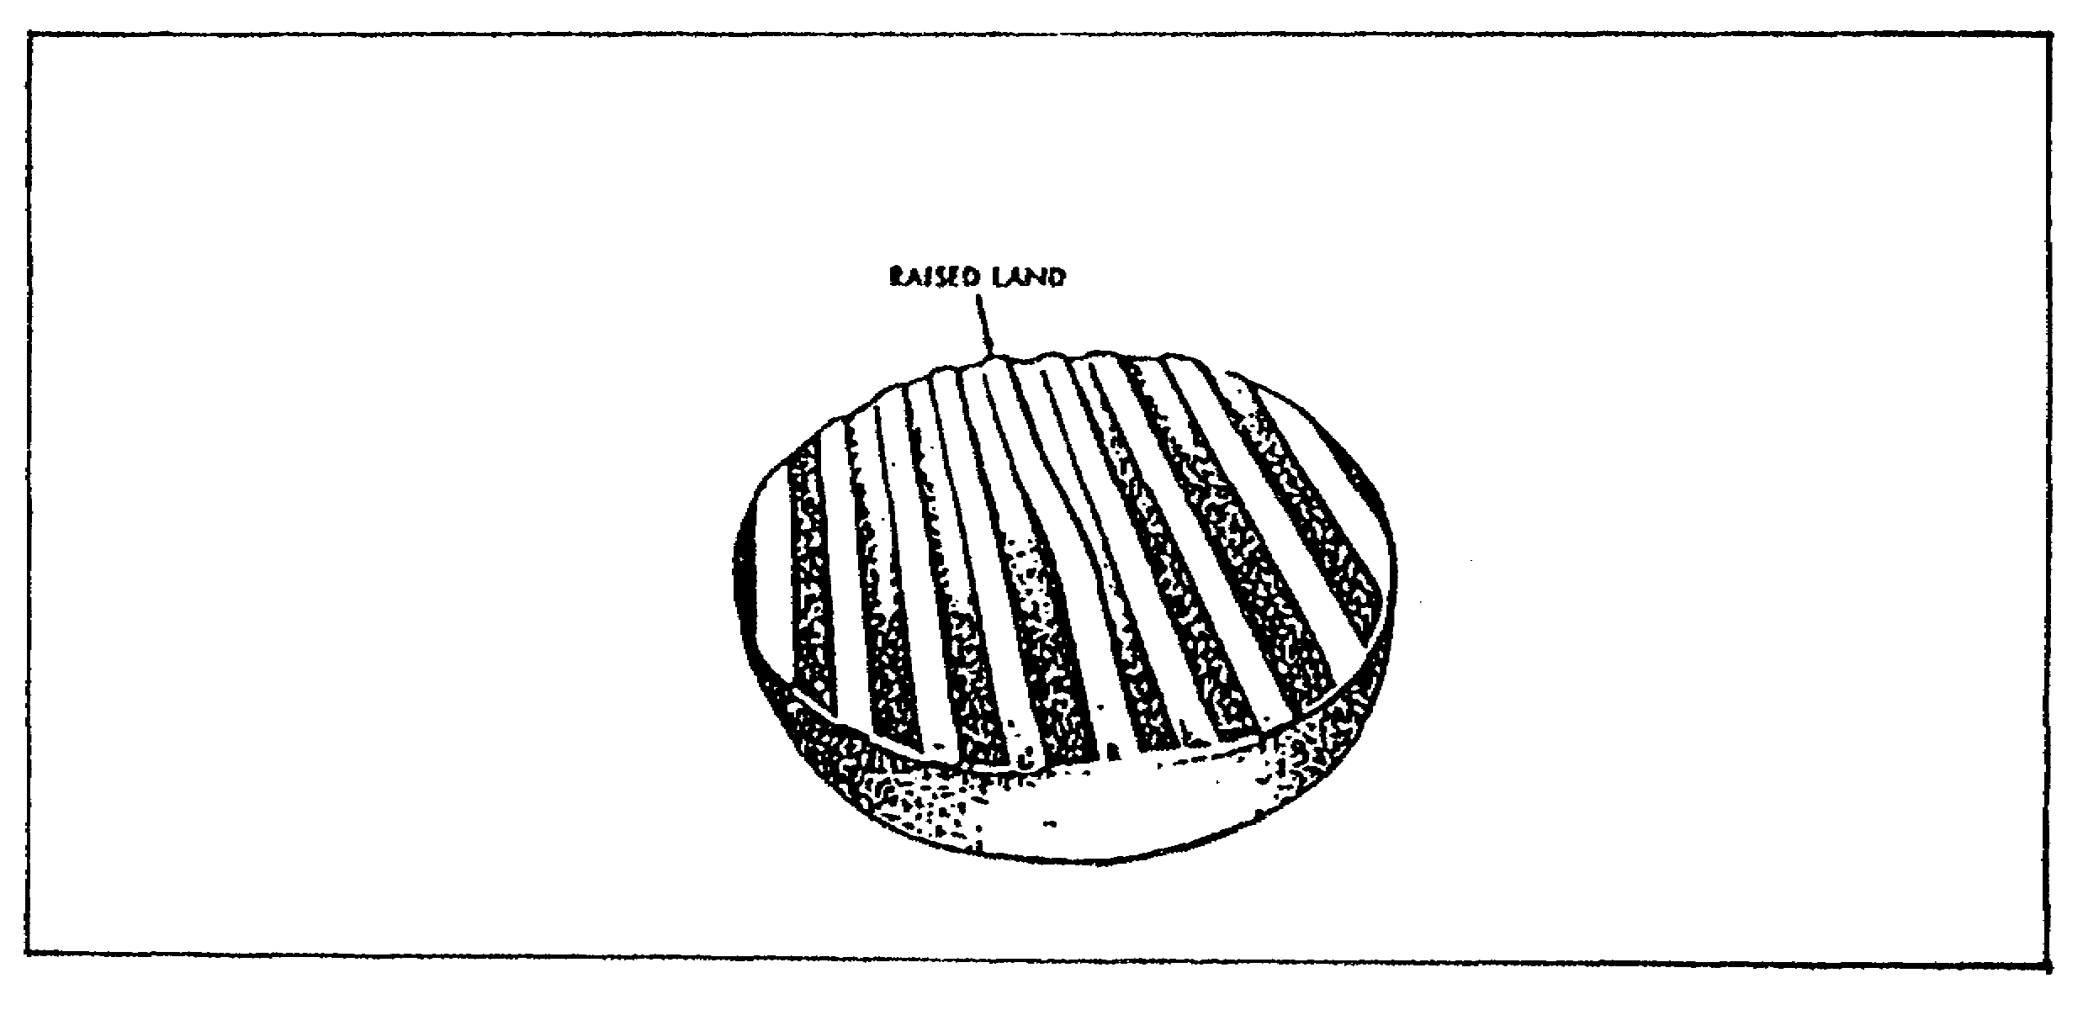

3

CANNON TUBE EVALUATION - OD 0463 - LESSON 1/TASK 1

d. Heat Checks and Heavy Scratches. Heavy heat checks and scores require extra careful examination, using borescope and different angles to determine whether they have become cracks. If they are not cracks, but are over 1-1/2 inches long, record them. Describe lengths, plus axial and circumferential locations, and add a note: "At next inspection, measure these heat checks or heavy scratches. If one has grown, condemn tube."

e. External Gouges. Gouges less than O.1 inch in depth or 1/2 caliber in length are acceptable. If the gouge is deeper or longer, it should be reported to the responsible design activity for disposition. Additionally, any gouged tube should be checked for constriction of the bore.

f. Missing Chrome-Plating. Chrome-plating missing in lands and grooves (in 90mm gun cannon, and in some 175mm gun cannons) may be serious, but missing sheets, flakes or chips should be ignored.

g. Rust. Rust is not critical, but checks should be made for pitting caused by it. Rust should be removed.

h. Coppering. Copper streaks found in the bore do not affect range or accuracy and should be ignored. Do not try to remove copper.

i. Bore Enlargement. Any tube that has been subjected to an inbore premature (a round that explodes in the tube prematurely), and has not failed, should be returned to depot for inspection. Any bulge that enlarges the land and groove diameters 0.01 inch or more for a distance of 1-1/2 calibers or more is cause for condemnation. Bulges as large as this tend to disturb the functioning of the fuse.

j. Erosion.

(1) Types of erosion. Erosion of the tube is caused by movement of high temperature gases and residue generated from the burning propellant. Movement of the projectile through the bore also erodes or wears the tube. Erosion is often divided into three phases:

4

CANNON TUBE EVALUATION - OD 0463 - LESSON 1/TASK 1

(a) Gas erosion causes a smooth wearing away of metal by action of the hot gases, heating of steel, and chemical action. Lands and grooves are both affected. The greatest erosion area is at the mouth of the chamber or the front end of the cartridge case at the 12 o'clock position.

(b) Scoring is a result of the nozzle or vent action of gas escaping past the rotating band. It appears as a longitudinal streak fanning out toward the muzzle, or as a trough. Tool marks or land damage start the erosion due to incomplete sealing.

(c) Abrasion is the slow mechanical wearing away of the lands. Greatest wear is usually at the 6 o'clock position, at the origin of rifling. This allows a larger clearance between the top of the tube bore and the rotating band of the projectile, which accelerates gas erosion and scoring at the 12 o'clock position.

(2) Effects of erosion are a decrease in muzzle velocity and a decrease in range; accuracy is not usually affected unless a large percentage or range is lost.

k. Metal Fatigue. Metal fatigue is defined as a change in molecular structure of metal (tiring), caused by the stress, shock, and heat of firing.

5

CANNON TUBE EVALUATION - OD 0463 - LESSON 1/TASK 2

LESSON 1

VARIOUS TYPES OF CANNON TUBE DETERIORATION,
DAMAGE, AND CONDEMNATION CRITERIA

TASK 2. Identify condemnation criteria.

CONDITIONS

Within a self-study environment and given the subcourse text, without assistance.

STANDARDS

Within one hour

REFERENCES

No supplementary references are needed for this task.

1. Introduction

The importance of proper inspection of cannon tubes to find any damage or too much wear cannot be over-emphasized. Ordnance personnel, concerned with bore inspection, must find defective tubes that may endanger lives of personnel by exploding or by inaccurate firing. This task will center on providing information needed to determine whether a cannon tube should be used or condemned.

2. Condemnation Criteria

a. Initial Visual Inspection, Operator and Unit Level of Maintenance. The procedures are listed here for this inspection.

(1) Visually inspect the tube's exterior for cracks, gouges, bulges, dents, out-of-roundness, and gas leaks. Check edges of keyways for cracks.

6

CANNON TUBE EVALUATION - OD 0463 - LESSON 1/TASK 2

(2) Make a careful visual inspection of as much of the bore as can be seen with the aid of a flashlight or electric lead light.

(3) Look for cracks and other internal damages that may have been caused by dirty ammunition, overheating, not being cleaned, careless handling, leaving something in the bore, or by hostile fire. Pay special attention to origin of rifling area (breech end). On most tubes, the following damages are NOT critical:

(a) External gouges less than 1/4 inch deep.

(b) Pitting in the chamber.

- Under 155mm size tube: If pits cover less than 20 percent of the entire chamber surface.

- 155mm size and up: No limit to depth or area.

(c) Pits on recoil slide surface (when uncovered).

(d) Pits on surfaces under bore evacuator.

(e) Rust that can be removed by using 320, or finer, emery cloth so that it will not conceal a crack or deep pit.

(f) Burrs and upset metal that can be removed by using 320, or finer, emery cloth.

(g) Copper-colored areas in tube.

(4) The weapon operator or unit maintenance personnel will notify intermediate direct support/intermediate general support (IDS/IGS) maintenance to borescope and gage the tube under certain circumstances. These are:

(a) When there are cracks or other damage found. This weapon WILL NOT BE FIRED!

(b) When the tube's round life limit is about to be reached.

(c) When the tube cannot be fired accurately.

(d) When there is evidence of welding found anywhere on the tube.

7

(e) When cracks or anything else suspicious is found.

(f) When gas leakage from the breech chamber cannot be cured by using a new obturator pad or split ring.

(g) When the case is hard to extract from the chamber.

b. Record Inspection. DA Form 24084 is central here.

(1) Equivalent full charge (EFC) computations are made. To compute the estimated remaining life, use tube and ammunition EFC figures.

(2) The round count is determined (round life) by using DA Form 2408-4.

(3) Inspect DA Form 2408-4 for calculation accuracy.

c. Inspection of Tubes Condemnable on Basis of Erosion by IDS/IGS Level of Maintenance.

(1) 40mm Gun Cannon.

IDS must take borescope and pullover gage readings after every 2000 rounds until 10,000 is reached, then after every 1000 rounds. Refer to table 1 to see the relationship between the wear gage reading and estimated remaining life percentage.

(a) All rounds have an equivalent full charge (EFC) number of 1.0.

(b) Tube life can vary from 4,000 to 16,000 rounds (depending on the amount of overheating due to continuous firing).

(2) 90mm Cannon.

(a) Have IDS borescope the tube every 5000 rounds, regardless of EFC.

(b) Inspect exterior every 1000 rounds. Also, have IDS take a pullover gage reading after 1000 rounds have been fired and after every additional 500 rounds, regardless of EFC.

8

CANNON TUBE EVALUATION - OD 0463 - LESSON 1/TASK 2

TABLE 1. ESTIMATED REMAINING LIFE OF CANNON TUBE OF 40mm GUN CANNON, M2A1 FOR: GUN, SP, FT, TWIN, M42 AND M42A1.

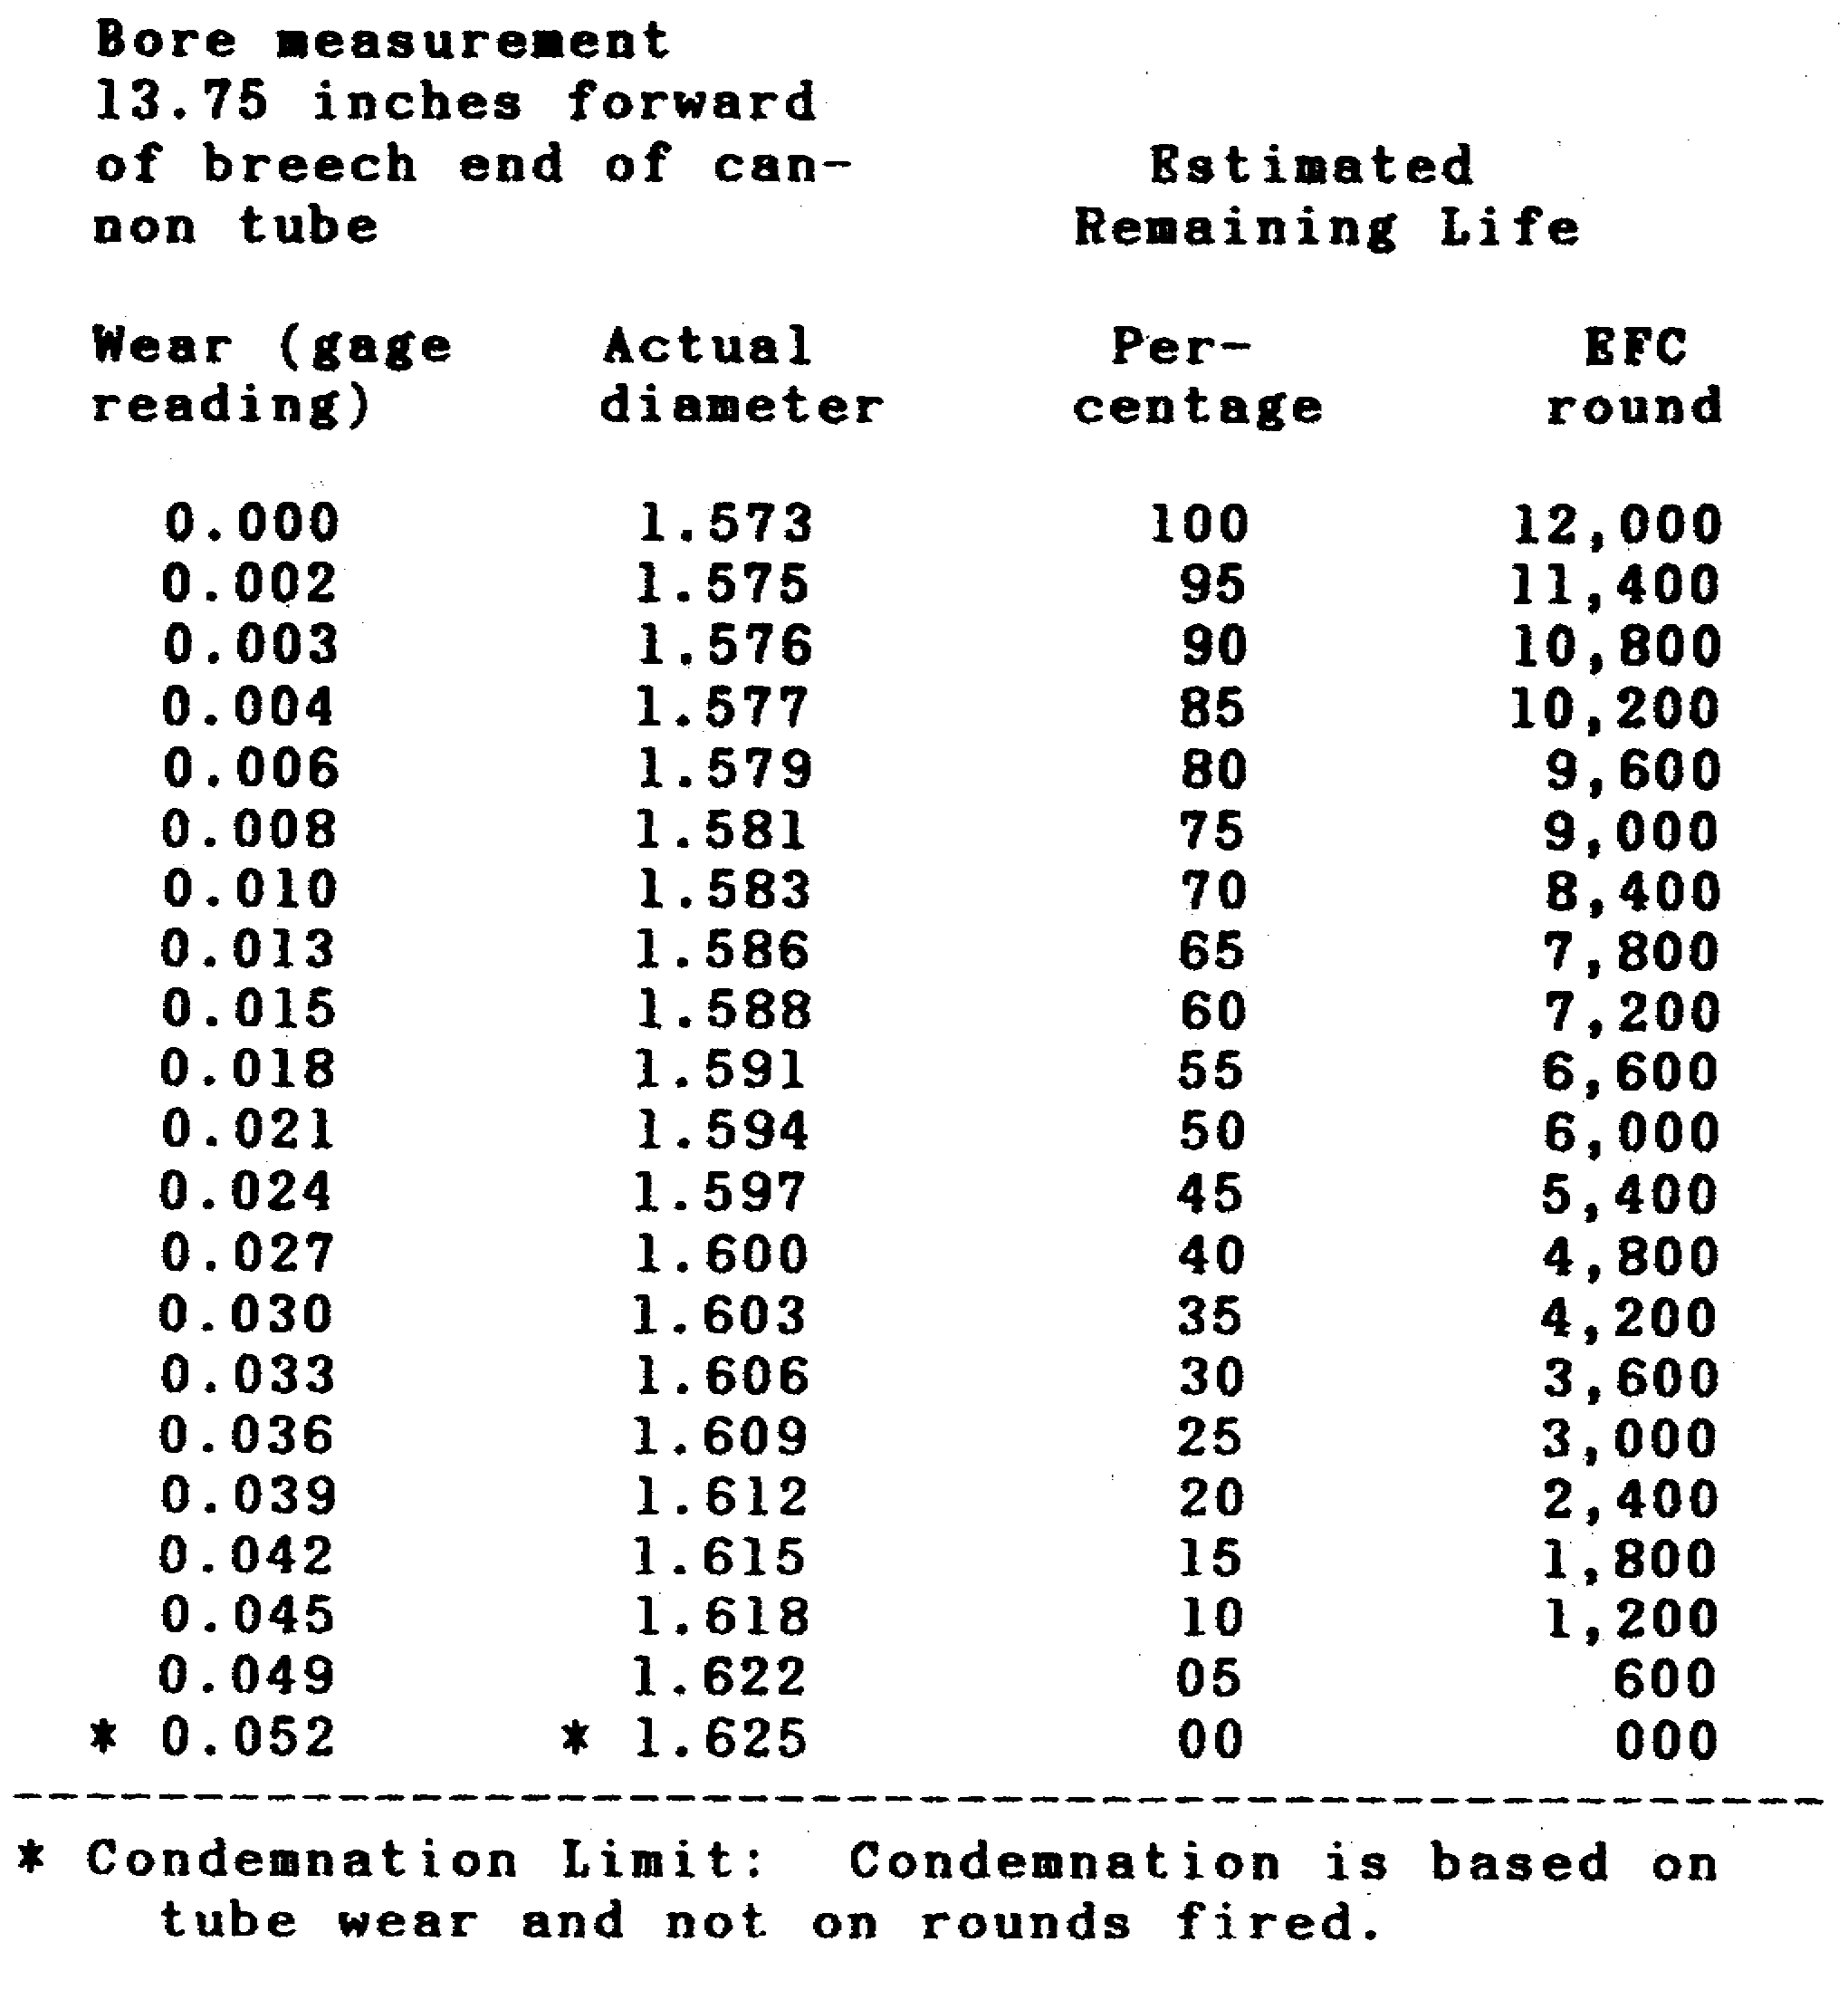

(c) After the first 1000 rounds, the tube must be borescoped and gaged by IDS after each additional 500 rounds. This will continue until the tube is condemned.

(d) When gaging, also measure for muzzle wear at 2 inches from end. Condemn tube when land diameter there reaches 3.563 inches. Wear (erosion) could be eccentric, so measure in a number of directions.

(e) Condemn tubes reaching 3000 rounds, regardless of EFC or at 0.197 inches wear, whichever comes first, as shown in table 2.

9

CANNON TUBE EVALUATION - OD 0463 - LESSON 1/TASK 2

TABLE 2. ESTIMATED REMAINING LIFE OF TUBE OF 90mm GUN CANNON, M41 FOR: M48 SERIES TANK.

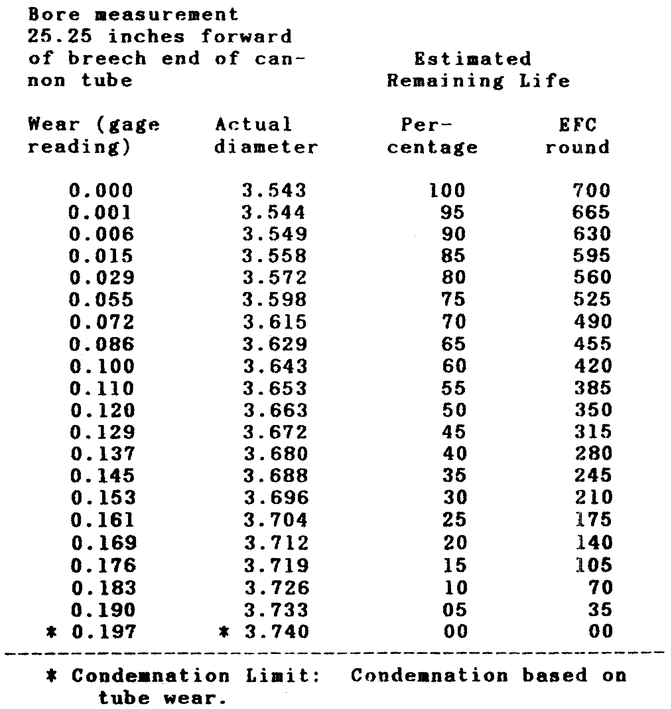

(3) 1055m Cannon.

(a) The 105mm M68 gun tube is condemned under dual criteria, based on tube wear or EFC round count.

(b) White phosphorus (WP) and high explosive phosphorus (HEP) type ammunitions have EFC factors of 0.5. All other ammunition has an EFC factor of 1.0. These EFC factors apply to ammunition fired at ambient temperatures of 105 degrees F (40.6 degrees C) or below. When fired at ambient temperature above 105 degrees F (40.6 degrees C), the EFC factor is doubled for each round.

10

CANNON TUBE EVALUATION - OD 0463 - LESSON 1/TASK 2

(c) The interval between pullover gage measurement and borescope inspection is not to exceed 200 EFC rounds. Information carried forward to each new DA Form 2408-4 is to include the EFC rounds remaining at the last pullover gage measurement and borescope inspections.

(d) Condemn the gun tube when 1000 EFC rounds have been fired or at 0.056 inch wear with measurement taken at 25.25 inches forward of breech end of cannon tube with original diameter of 4.134 inches, whichever occurs first.

TABLE 3. ESTIMATED REMAINING LIFE OF CANNON TUBE OF 120mm GUN CANNON, M58 FOR: TANK, COMBAT, FT, M103A2.

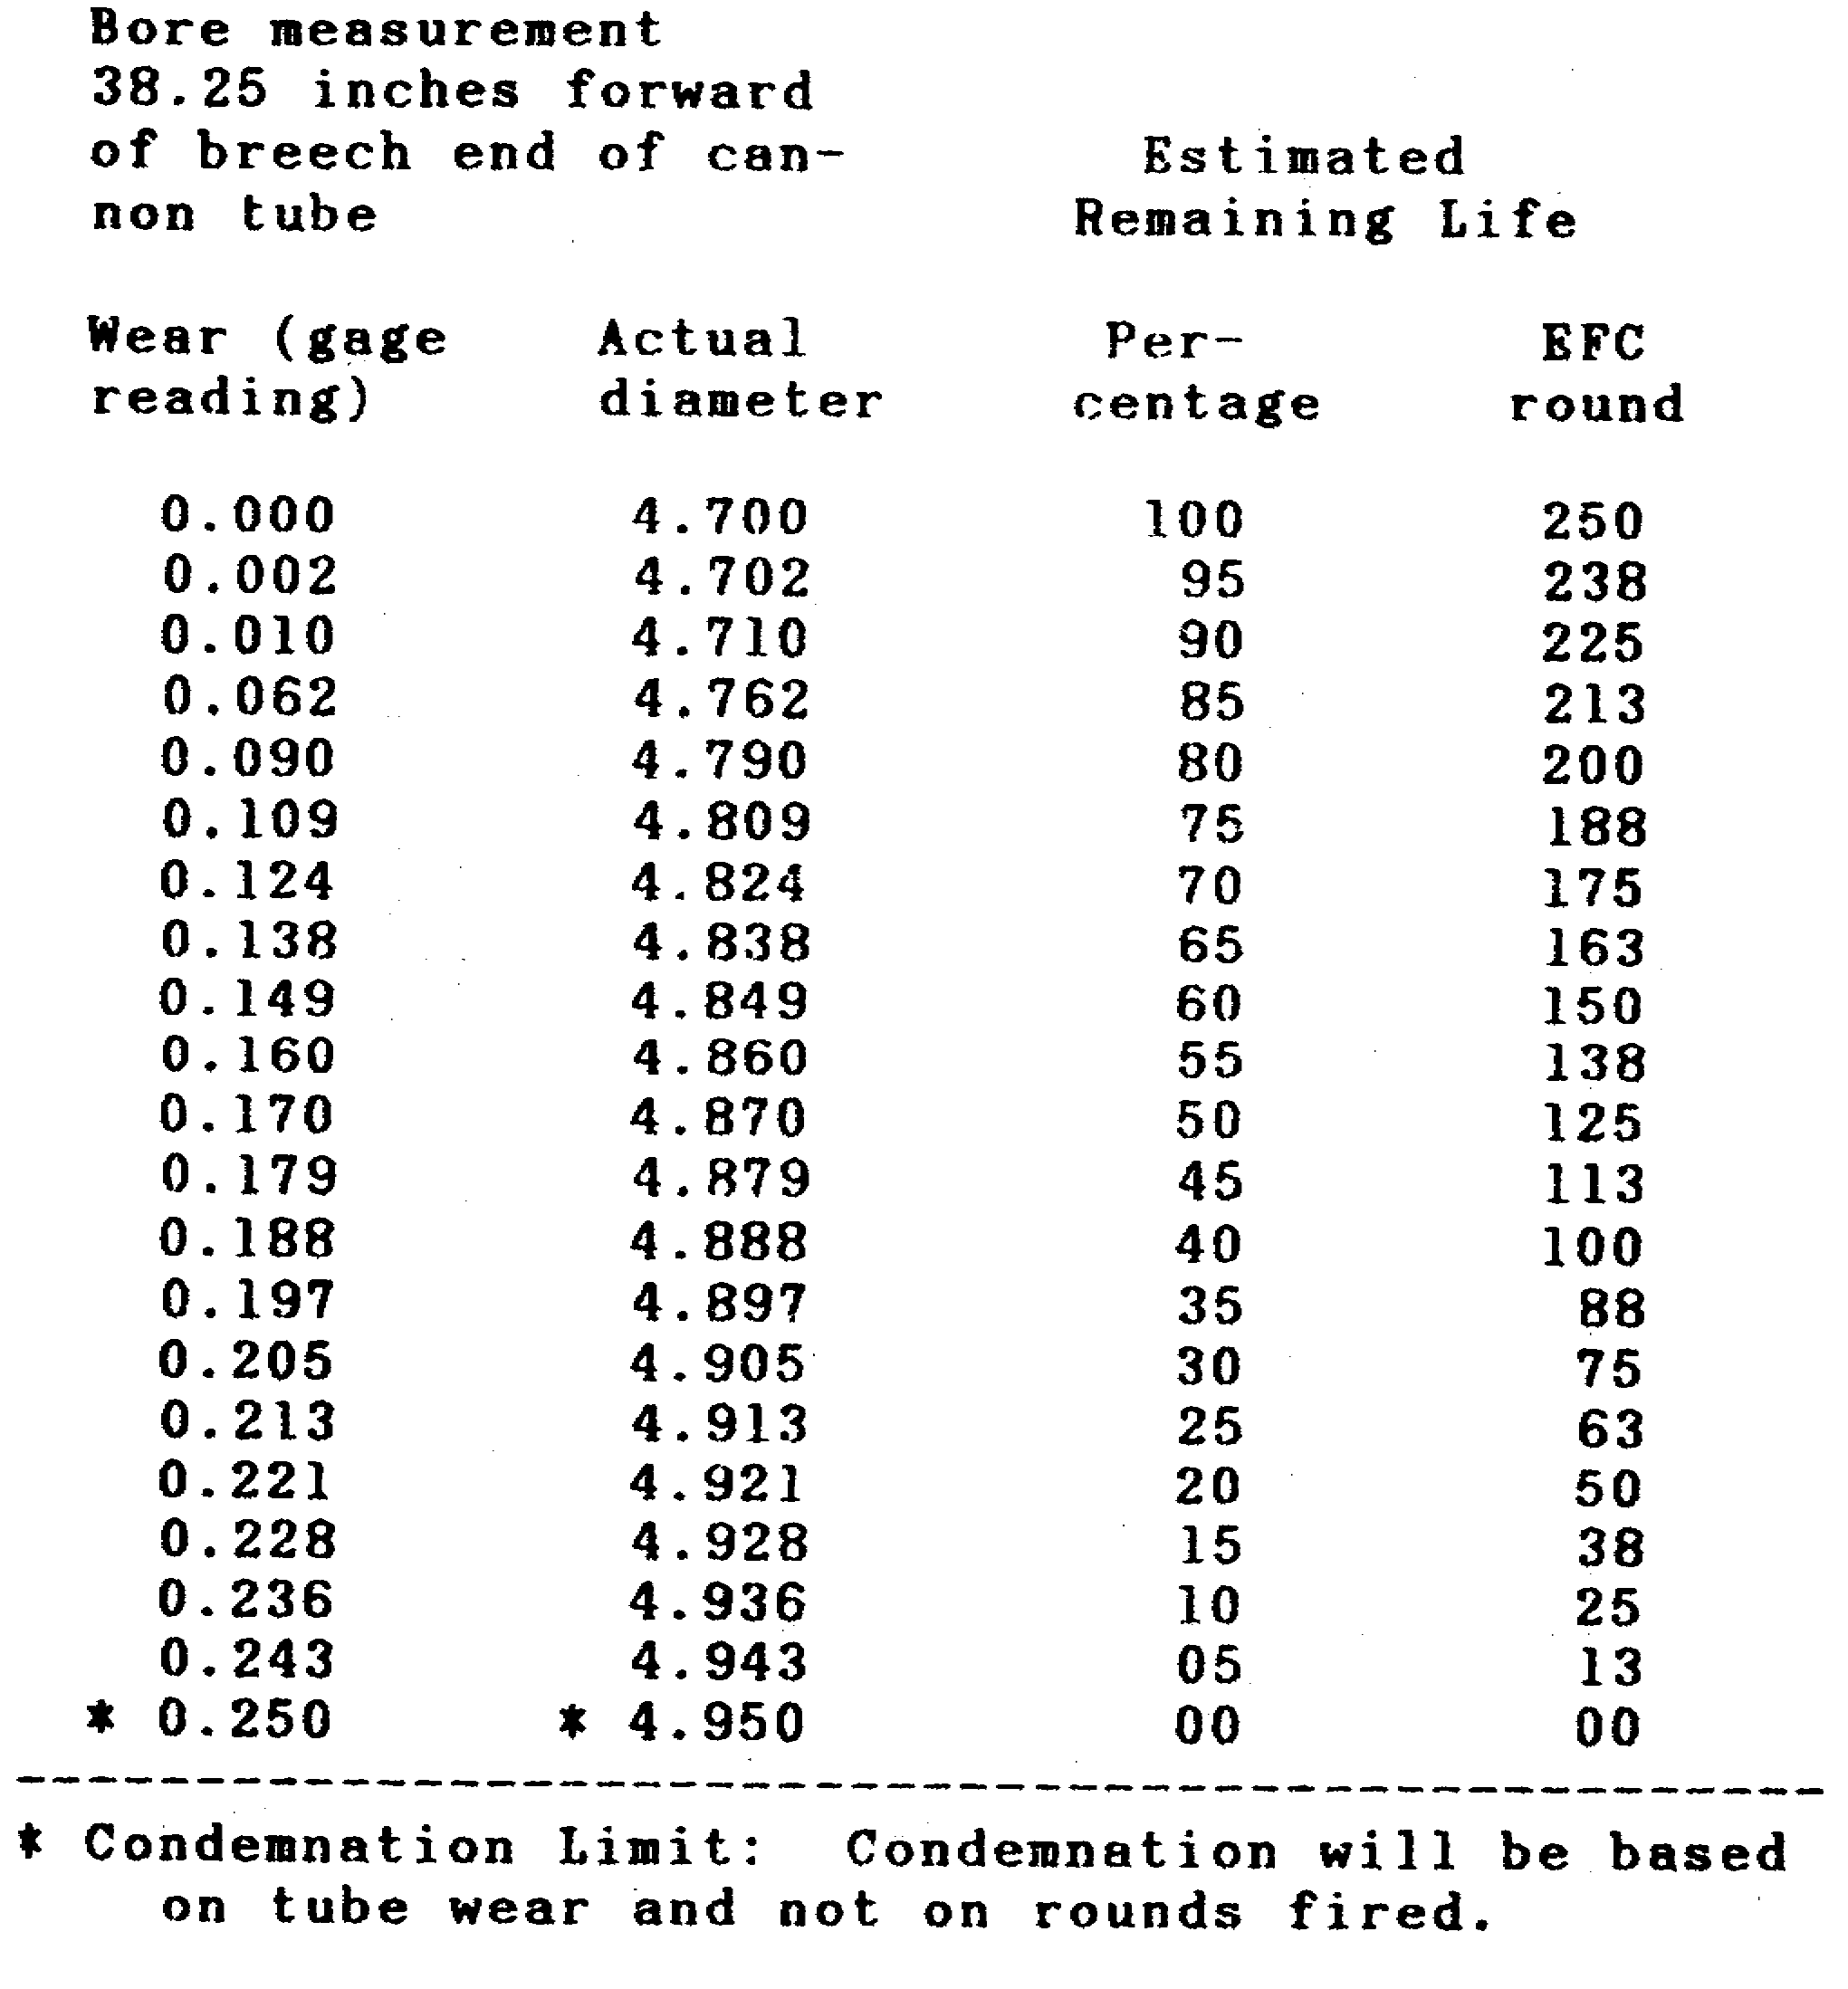

11

CANNON TUBE EVALUATION - OD 0463 - LESSON 1/TASK 2

(e) In addition to the general visual inspection associated with all cannon tube inspections, visual evidence of a complete interruption of any rifling land is cause for condemnation of this gun tube.

(4) 120mm Cannon.

Borescope and gage the tube, and inspect exterior keyways and threads after every 100 EFC rounds. Refer to table 3 (on the previous page) for estimated remaining life percentages.

TABLE 4. ESTIMATED REMAINING LIFE OF CANNON TUBE OF 155mm GUN CANNON, M46 FOR: GUN, SP, FT, M53.

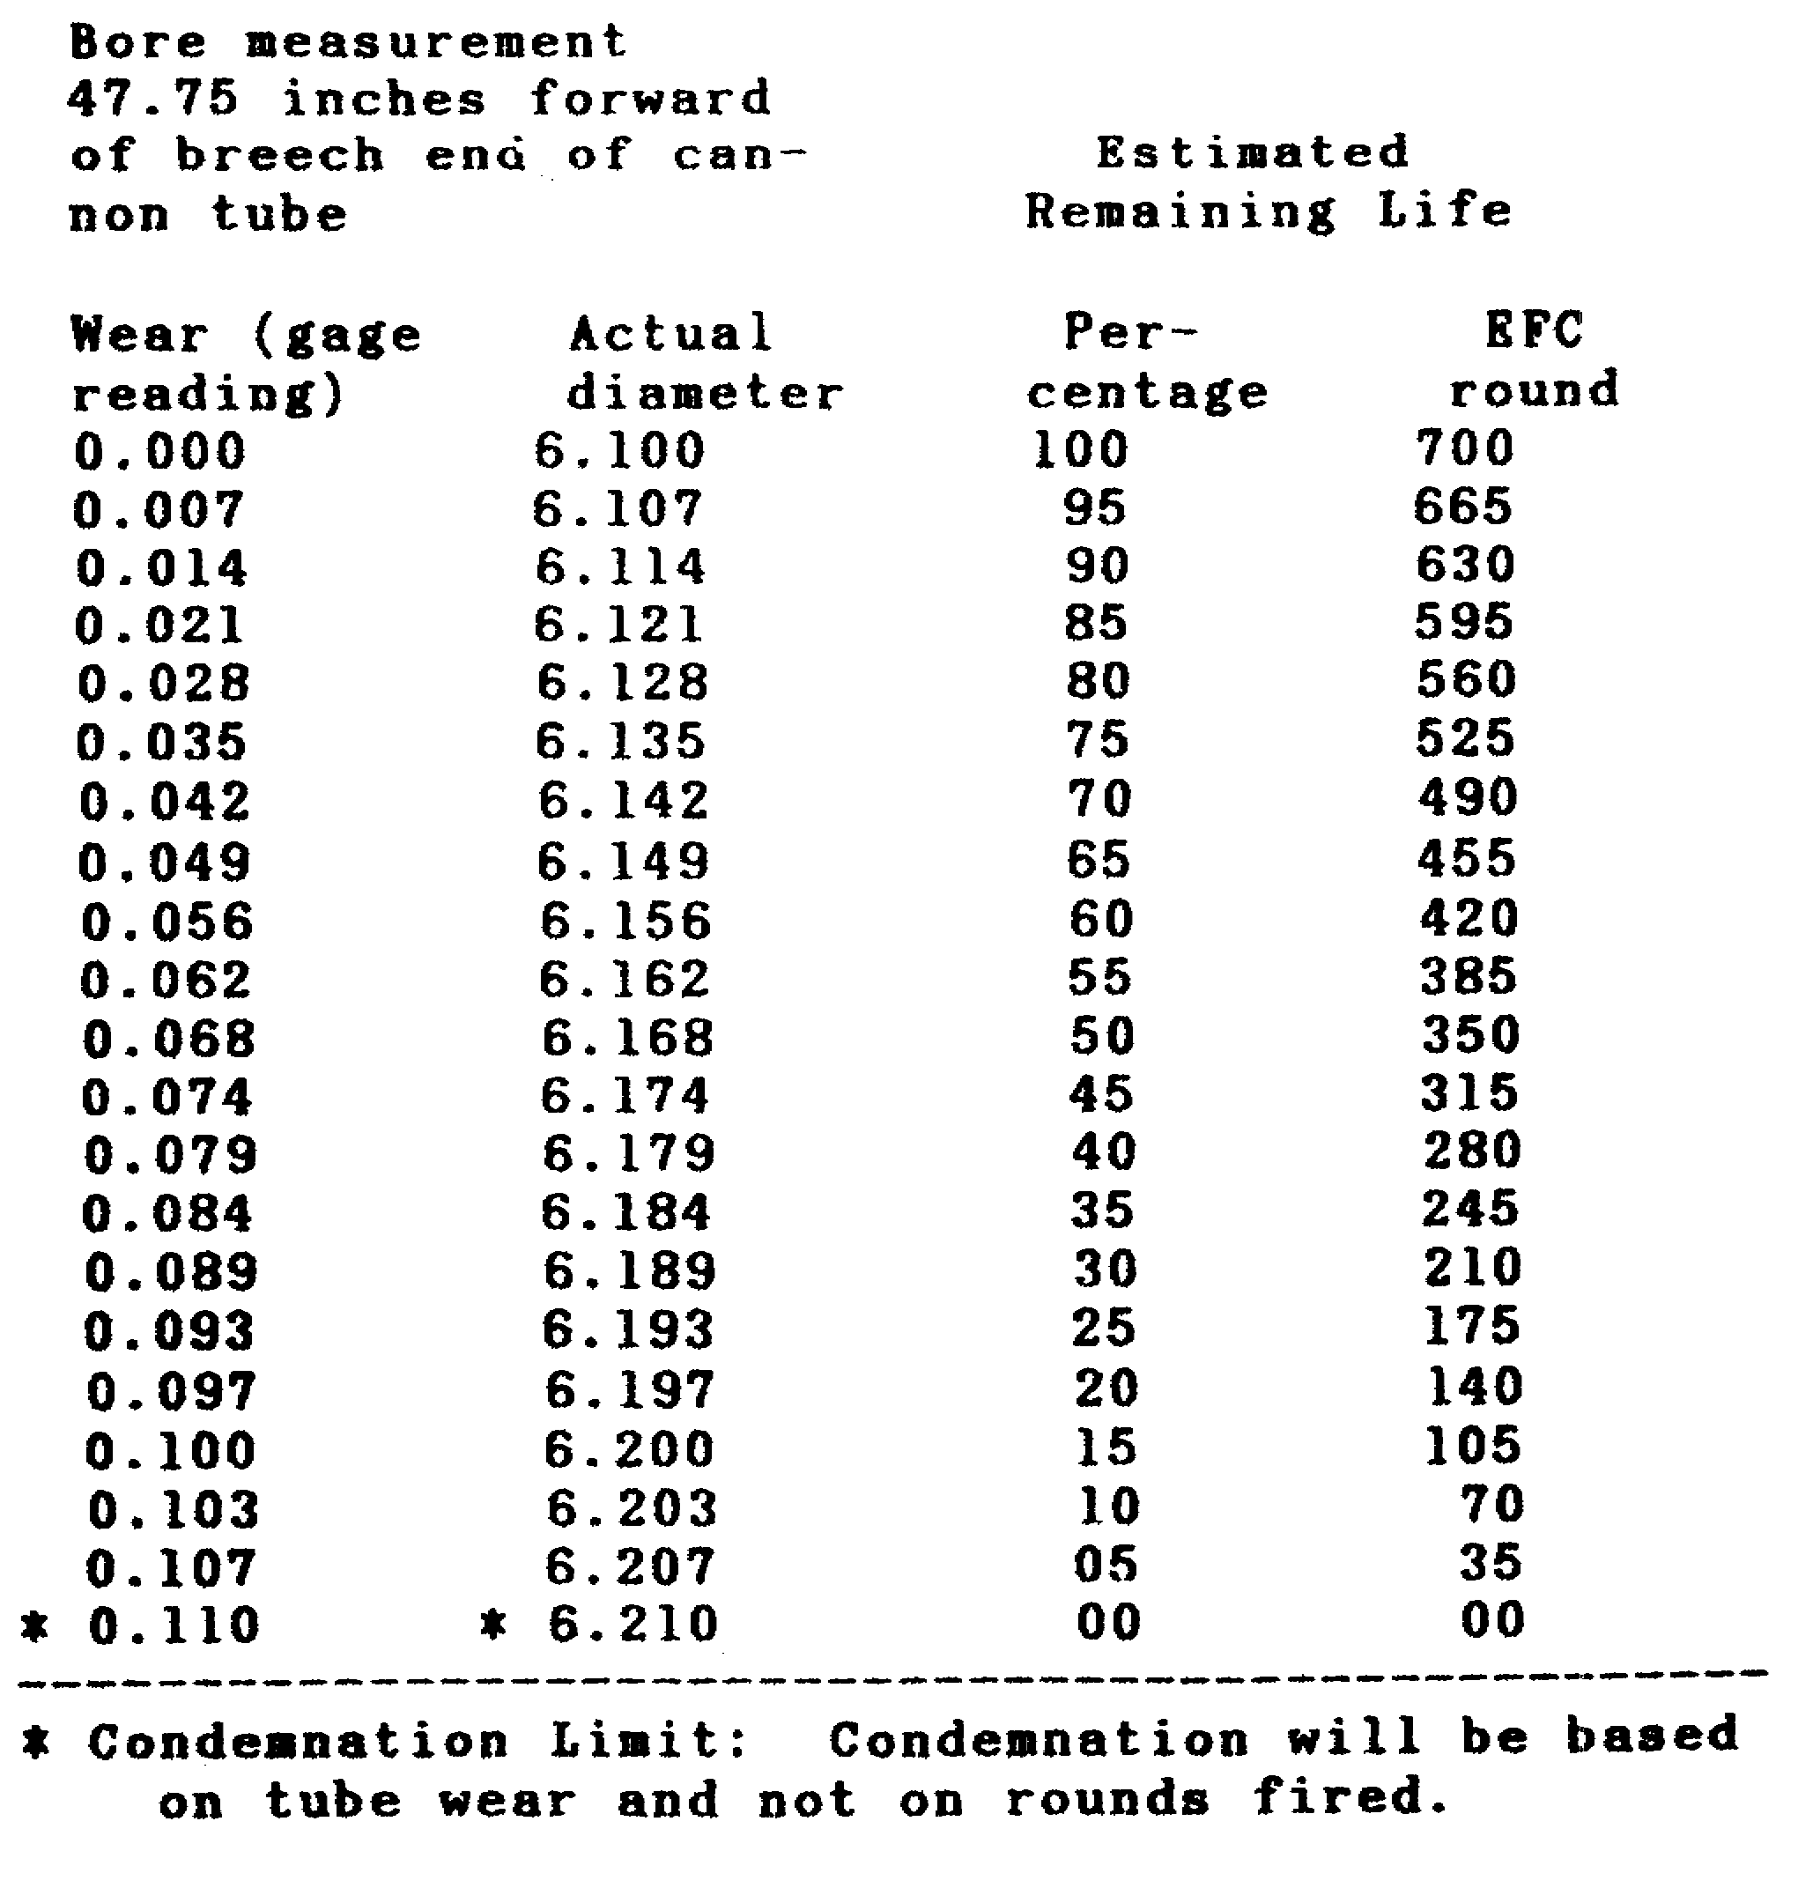

12

CANNON TUBE EVALUATION - OD 0463 - LESSON 1/TASK 2

(5) 155mm Gun Cannon.

When 500 EFC rounds have been fired, borescope and gage the tube after every additional 100 EFC rounds, since condemnation will be based on tube wear and NOT on rounds fired. Refer to table 4 on the previous page to see the condemnation limits.

d. Condemnation Criteria for Various Types of Damage by 1B$/G$S Level of Maintenance.

(1) Criteria on Cracks.

CAUTION

Take great care to make certain that it is a real crack. View each suspected crack or damaged area from a number of angles to assure that lighting and shadows are not creating "false' cracks.

(a) External Surfaces: Condemn tube when you find:

- Any crack (except cracks on threads for evacuators or muzzle brakes that do not reach tube surface or thread root).

- On 105mm gun, M68 tube of serial number 7500 or higher: cracks over 1/4 inch long in keyways, threads or evacuator holes; cracks over 3/8 inch long elsewhere.

(b) Internal Surfaces.

- Condemn any traverse or diagonal crack in the chamber that extends from a land into a groove (figure 3).

FIGURE 3. CRACK ACROSS THREAD EXTENDING INTO
TUBE SURFACE: CONDEMN.


13

CANNON TUBE EVALUATION - OD 0463 - LESSON 1/TASK 2

- Longitudinal (axial) cracks or suspected cracks in chamber or in adjacent 2 feet of rifling, over 2 inches long, condemn. Between 1 and 2 inches long, measure length, record it, allow 100 EFC rounds to be fired, re-measure and condemn if crack has lengthened. Under 1 inch long, record it and be sure to inspect it next time.

- Longitudinal cracks or suspected cracks in lands or grooves over 2 feet away from origin of rifling, condemn if over 1/2 inch long, except that on 105mm gun, M68 tubes of serial number 7500 and higher allow maximum of 1-1/4 inch.

- Land raised from tube (figure 3): Send to depot for overhaul.

(c) At evacuator holes: When borescope shows crack at hole, see whether crack extends to tube exterior. If so, condemn. If borescope shows crack extending from hole across adjacent land, condemn.

(2) Condemnation of Tube when Lands are Found in the Following Condition:

(a) Condemn the tube if missing ("stripped") or severely damaged lands are found on any tube (except 20mm gun M139). Condemn the tube when three or more adjacent lands are found missing (stripped) or severely damaged. Also, condemn the tube if damage to lands reaches all around the tube's circumference and is as deep as a land at one or more locations on the circumference of the tube.

(b) Stripping of one land more than 20mm (0.8 inch) long or deeper than the groove, or stripping of any six or more lands on 20mm gun tube.

(c) Any rifling damage (other than a raised land) that may result in a shearing or stripping of projectile's rotating band, or any evidence that such has occurred (evidenced by sudden, extremely short ranges during firing).

(d) Stripping or spalling of one or more grooves between lands.

(3) Internal Gouges, Burrs, Upset Metal, Spelling, Gas Scoring, and Erosion.

14

CANNON TUBE EVALUATION - OD 0463 - LESSON 1/TASK 2

(a) Condemn tube if an internal gouge, spall, or erosion covers a complete circumferential area and is as deep as one land at any one location, or if it cuts into a groove between lands, or if a land is stripped deeper than a groove.

(b) Gas scoring is a longitudinal streak or trough eroded into the tube near the origin or rifling. Condemn tube if it has lost accuracy, a symptom of gas scoring.

CAUTION

Check very carefully to ascertain that a crack has not developed from one of these.

(4) Internal Pits. Condemn tube in accordance with the following internal pitting criteria:

Tube Sizes In Bore In Chamber On Gas
Check Seat

Under Ignore Condemn tube Doesn't
155mm pitting if pits cover apply
20% of entire
chamber area
or are over
0.01 inch deep
155mm & Ignore Ignore See para
larger pitting pitting 2d(6)
this
lesson

(5) External Pits.

(a) Recoil slide surfaces--condemn tube if pitting exceeds any of the following external pitting criteria:

Tube Depth or Total Slide
Surface Area

90mm, 105mm, 0.015 inch or 20%
Howitzer only,
120mm, 165mm (cont'd.)
105mm gun, M68 0.020 inch or 50%

15

CANNON TUBE EVALUATION - OD 0463 - LESSON 1/TASK 2

Tube Depth or Total Slide
(cont.) Surface Area

152mm, 155mm, Ignore pitting
175mm, 8 inch

(b) Surface under the bore evacuator—condemn tube if pitting exceeds any of the following criteria:

Tube Nonbearing Surface Bearing under

Depth at Total Depth at any Area
any one area one or more each
or more locations end
locations
105mm 0.040 inch 90% 0.020 inch 20%
Howitzer
105mm 0.125 inch 80% *Condemn tube if N/A
gun, M41 you see gas leak-
age during firing
or powder streaks
or gas erosion path.
90mm 0.040 inch 80% *Condemn tube if N/A
gun you see gas leak-
age during firing
or powder streaks
or gas erosion path.
120mm 0.040-inch 80% *Condemn tube if N/A
gun you see gas leak-
age during firing
or powder streaks
or gas erosion path.
152mm Ignore pitting
guns &
Howitzers

* This assumes that you've found the evacuator seals to be satisfactory.

(6) Gas Check Seat. Condemn tube if an erosion (gas) path crosses seat and is 0.003 inch or deeper. Condemn tube if gas check seat is so chipped, spalled, peeled, indented, nicked or

16

CANNON TUBE EVALUATION - OD 0463 - LESSON 1/TASK 2

pitted that it does not make full contact circumferentially (360 degrees) with mating surface on split rings, or its fore and aft mating surface contacts less than 80% of rings. To make this inspection proceed as follows:

(a) Remove all burrs with a medium India oil stone or equivalent.

(b) Clean gas check seating surfaces of oil, grease, abrasive or foreign material.

(c) To test for proper seating, lightly coat tube seating surface of the split rings with red lead or Prussian blue. Close and lock breech. Open breech and examine the imprint of the red lead or Prussian blue on contact area in the tube to determine compliance with preceding requirements.

(d) After inspection, remove red lead or Prussian blue from obturator parts and tube seat by wiping with a clean, nonabrasive cloth.

(7) Visible Bulges, Bends, Out-of-Roundness. If any of these are present, the tube should be condemned.

(8) Scoring in Chamber. Condemn tube only if scoring causes extraction of case to be difficult.

(9) Recoil Keyway Wear. Condemn tube if recoil keyway has over 0.010 inch wear caused by key (1.010 inch maximum width).

(10) Welding. Under no circumstances will tubes be welded. Any visible sign of welding should result in immediate condemnation of the tube.

e. Summary. The types of inspections that may result in cannon tube condemnation are: (1) visual inspection performed by the operator and unit level maintenance personnel, (2) inspection of DA Form 2408-4 (Weapons Record Data form) by intermediate direct support/intermediate general support personnel (IDS/IGS), and (3) bore measurement and tube evaluation by IDS/IGS personnel.

17

CANNON TUBE EVALUATION - OD 0463 - LESSON 1/PE 1

PRACTICAL EXERCISE 1

Instructions

On a plain sheet of paper, write down the answers to the following questions. When you have answered them, turn the page and check your answers.

(1) Typical characteristics of a crack include feathered edges running in an irregular line, varying in width and depth. What descriptive characteristics pertain to tool marks and scratches?

(2) When is a land said to be sheared?

(3) When erosion causes rounding of the edges of lands, is this USUALLY considered critical cannon tube damage or NOT considered critical damage?

(4) What action would be taken when a raised land was found in a cannon tube?

(5) What action usually accompanies a tube that is found with copper streaks in the bore?

(6) Gas erosion is one type of erosion. What are two other types of erosion?

(7) When an operator finds that the tube cannot be fired accurately, what course of action should he follow?

(8) Depending on the amount of overheating due to continuous firing of a 40mm cannon, what number of rounds (minimum/maximum) can be fired through this tube?

(9) What type of crack would condemn a cannon tube?

18

CANNON TUBE EVALUATION - OD 0463 - LESSON 1/PE 1

LESSON 1. PRACTICAL EXERCISE - ANSWERS

(1) They usually run in a straight line, or have smooth edges, uniform width, or shallow depth.

(2) When a crack spreads fully across or underneath a land.

(3) Usually NOT considered critical.

(4) Tube is NOT ACCEPTABLE. Send to depot for overhaul.

(5) No action. Streaks found in the bore do not affect range or accuracy and should be ignored.

(6) (a) scoring, (b) abrasion.

(7) Operator should immediately notify support IDS/IGS maintenance.

(8) Minimum 4,000 rounds, maximum 16,000 rounds.

(9) A crack that extends from a land into a groove.

19

CANNON TUBE EVALUATION - OD 0463 - LESSON 2/TASK 1

LESSON 2

STEPS IN THE USE OF THE PULLOVER GAGE

TASK 1. Describe the pullover gage.

CONDITIONS

Within a self-study environment and given the subcourse text, without assistance.

STANDARDS

Within thirty minutes

REFERENCES

No supplementary references are needed for this task.

1. Introduction

Defective cannon tubes may endanger personnel by exploding or firing inaccurately. It is thus essential that the ordnance noncommissioned officer be thoroughly acquainted with the instruments and procedures that are used to evaluate whether a cannon tube should be used or condemned. The pullover gage is one instrument used to locate and evaluate the extent of erosion and damage in a cannon bore. This instrument makes it possible to identify the type and degree of erosion or damage, thereby offering a means of evaluating and estimating the life and ballistic accuracy of a weapon.

2. Pullover Gage

The pullover gage is used to measure the wear of the bore diameter of all types of artillery weapons (37mm through 280mm). It is a rugged, accurate gage designed for use in the field. The gage employs a vernier type slide that is calibrated in thousandths of an inch from the standard size of

20

CANNON TUBE EVALUATION - OD 0463 - LESSON 2/TASK 1

the bore being measured. Authorized use of the pullover gage is at the intermediate direct support/intermediate general support (IDS/IGS) level of maintenance.

a. Components. The pullover gage comprises the components listed, described and shown below in figures 4 and 5.

FIGURE 4. PULLOVER GAGE ASSEMBLY FOR 90mm GUN.
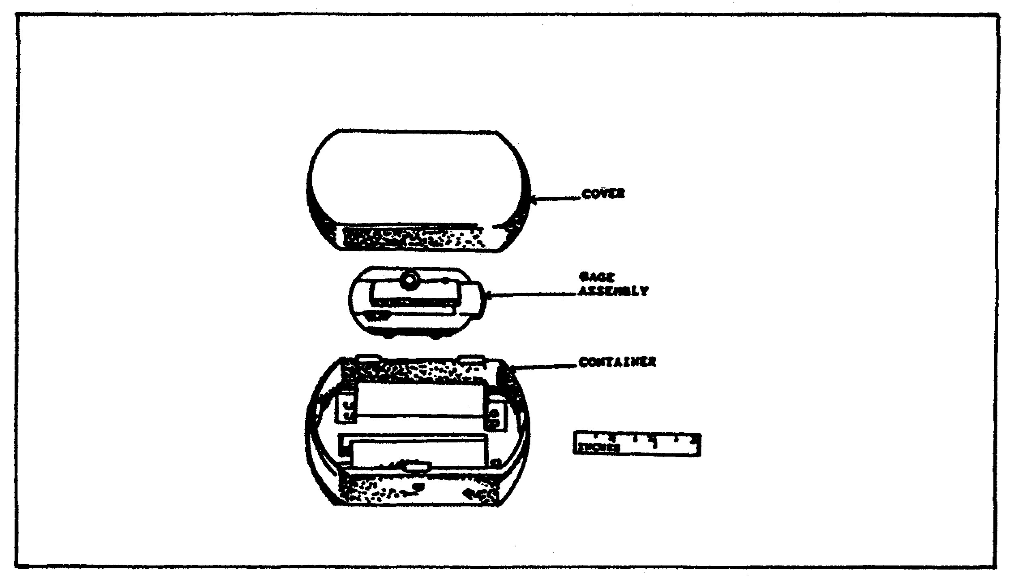

FIGURE 5. PULLOVER GAGE FOR 8 INCH WEAPON.
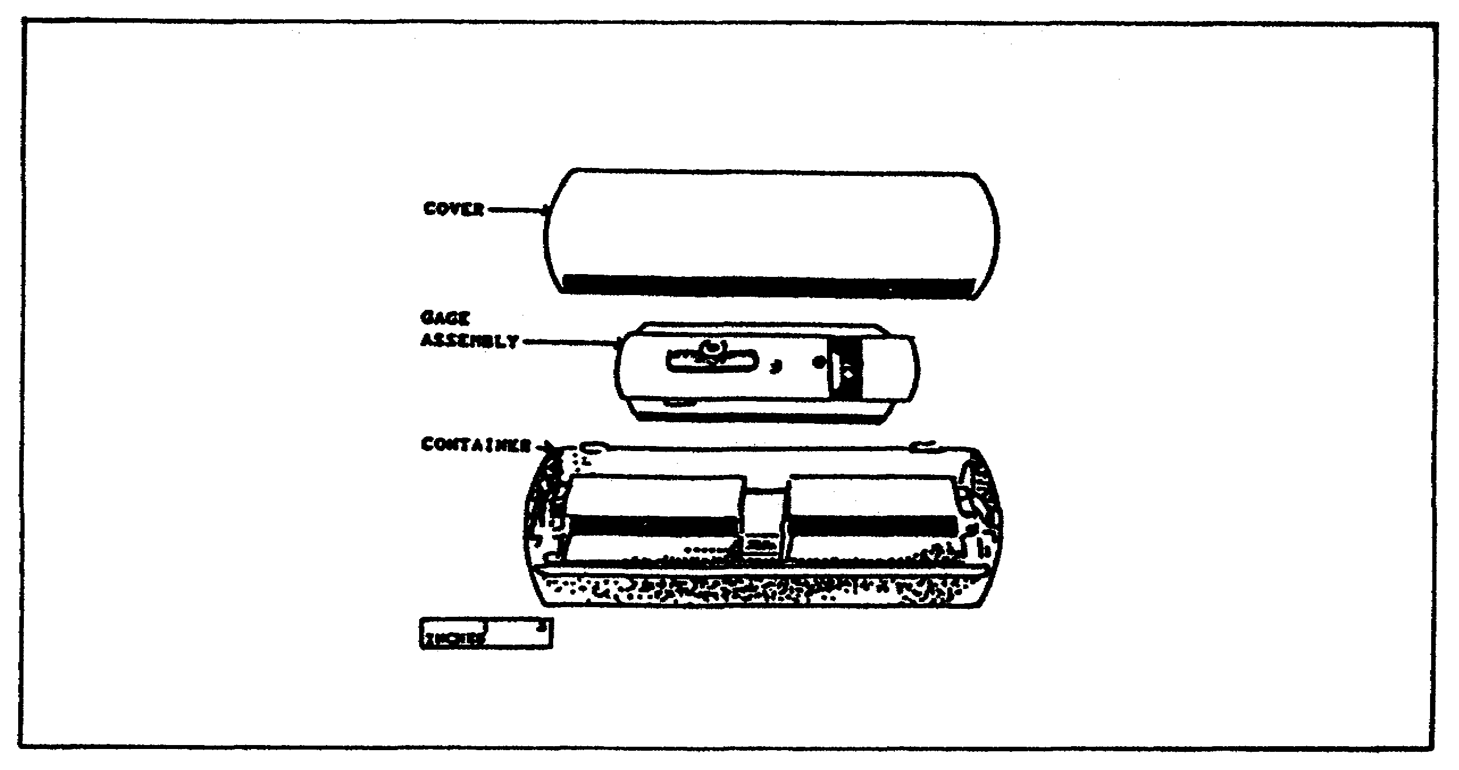

21

CANNON TUBE EVALUATION - OD 0463 - LESSON 2/TASK 1

(l) Body and Slide Assembly. The body and slide assembly contain the components necessary for measuring the bore diameter. The slide is located in the channel of the body. It is engraved with a scale that is marked in 0.1 inch divisions and subdivided in 0.025 inch intervals. The vernier scale, attached to the body, is marked in 0.005 inch divisions and subdivided in 0.001 inch intervals, thus allowing measurements of one .001 inch.

(2) Spring. The spring is used to hold the slide in position. A tee screw, having two sides milled flat, is inserted through the body, slide, and spring and is held in place by a knurled adjusting nut.

(3) Hinge. Two hinges are attached to the body by pins and are used to rotate the gage in the cannon bore. The hinges are provided with male type threaded ends.

(4) Accessories. The accessories listed below are also vital parts of the pullover gage:

(a) Rods. Rods are furnished in pairs and consecutive pairs. These rods are connected to the hinges of the pullover gage. The rods are available in two sizes, 3/8 inch and 5/8 inch diameter. Each is 30 inches in length, and is graduated consecutively every inch, with 1/4 inch subdivisions (figure 6 on the following page).

FIGURE 6. PULLOVER GAGE RODS.
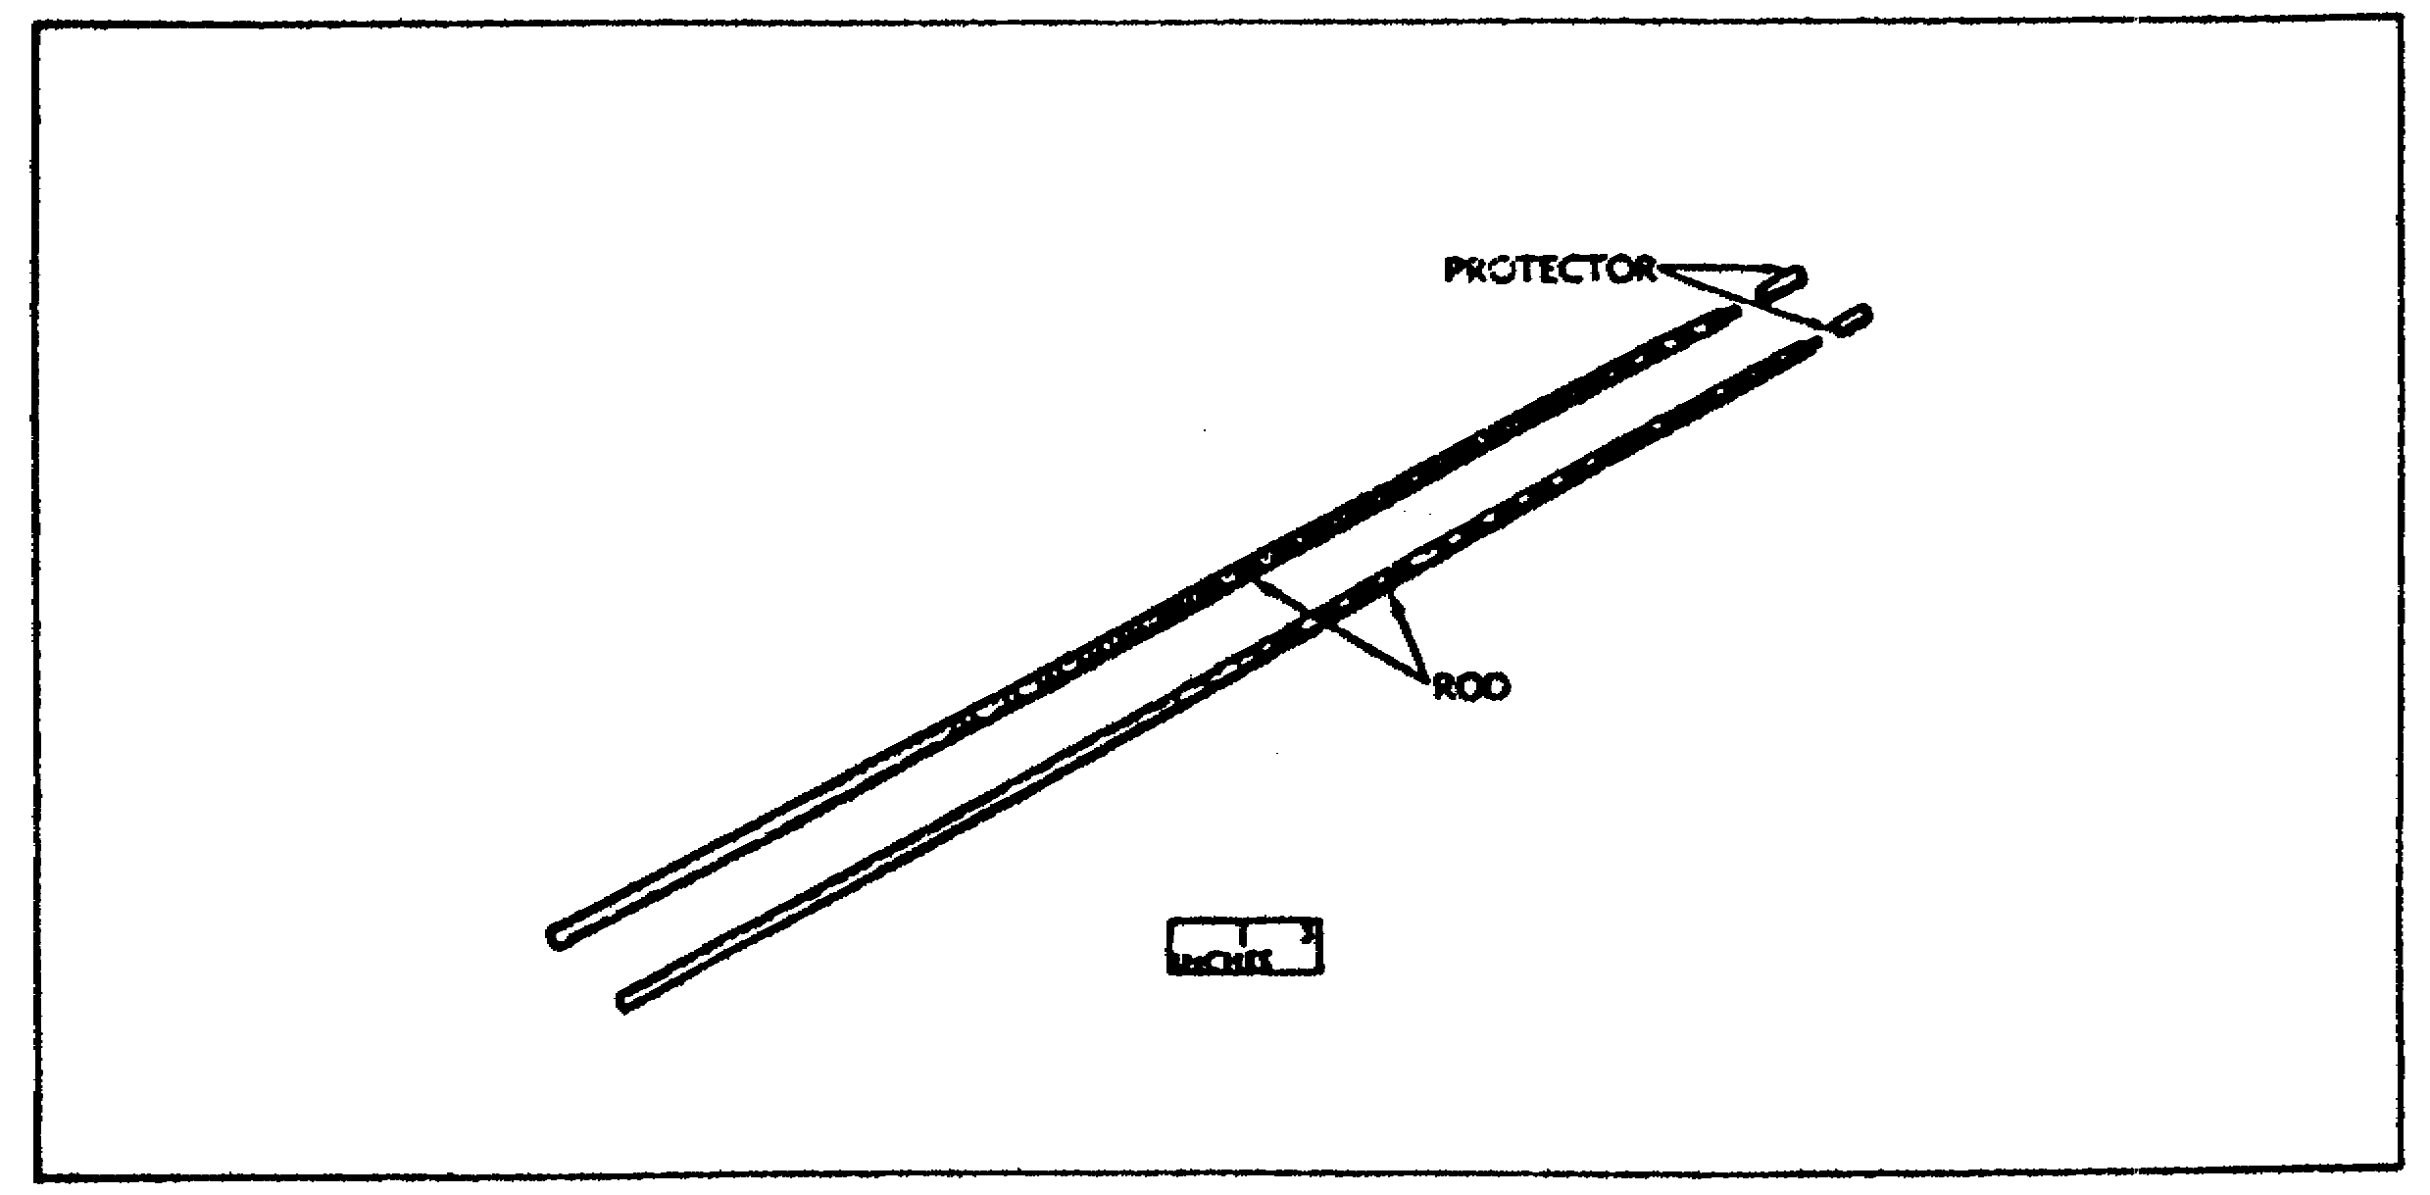

22

CANNON TUBE EVALUATION - OD 0463 - LESSON 2/TASK 1

(b) Stop. A stop is furnished in lengths suitable for each bore. The stop length is designed to allow measurements to be taken from the face of the tube inside the breech recess. Each stop is equipped with a clamp to allow it to be set at the proper distance on the lower rod (figure 7).

FIGURE 7. PULLOVER GAGE STOP.
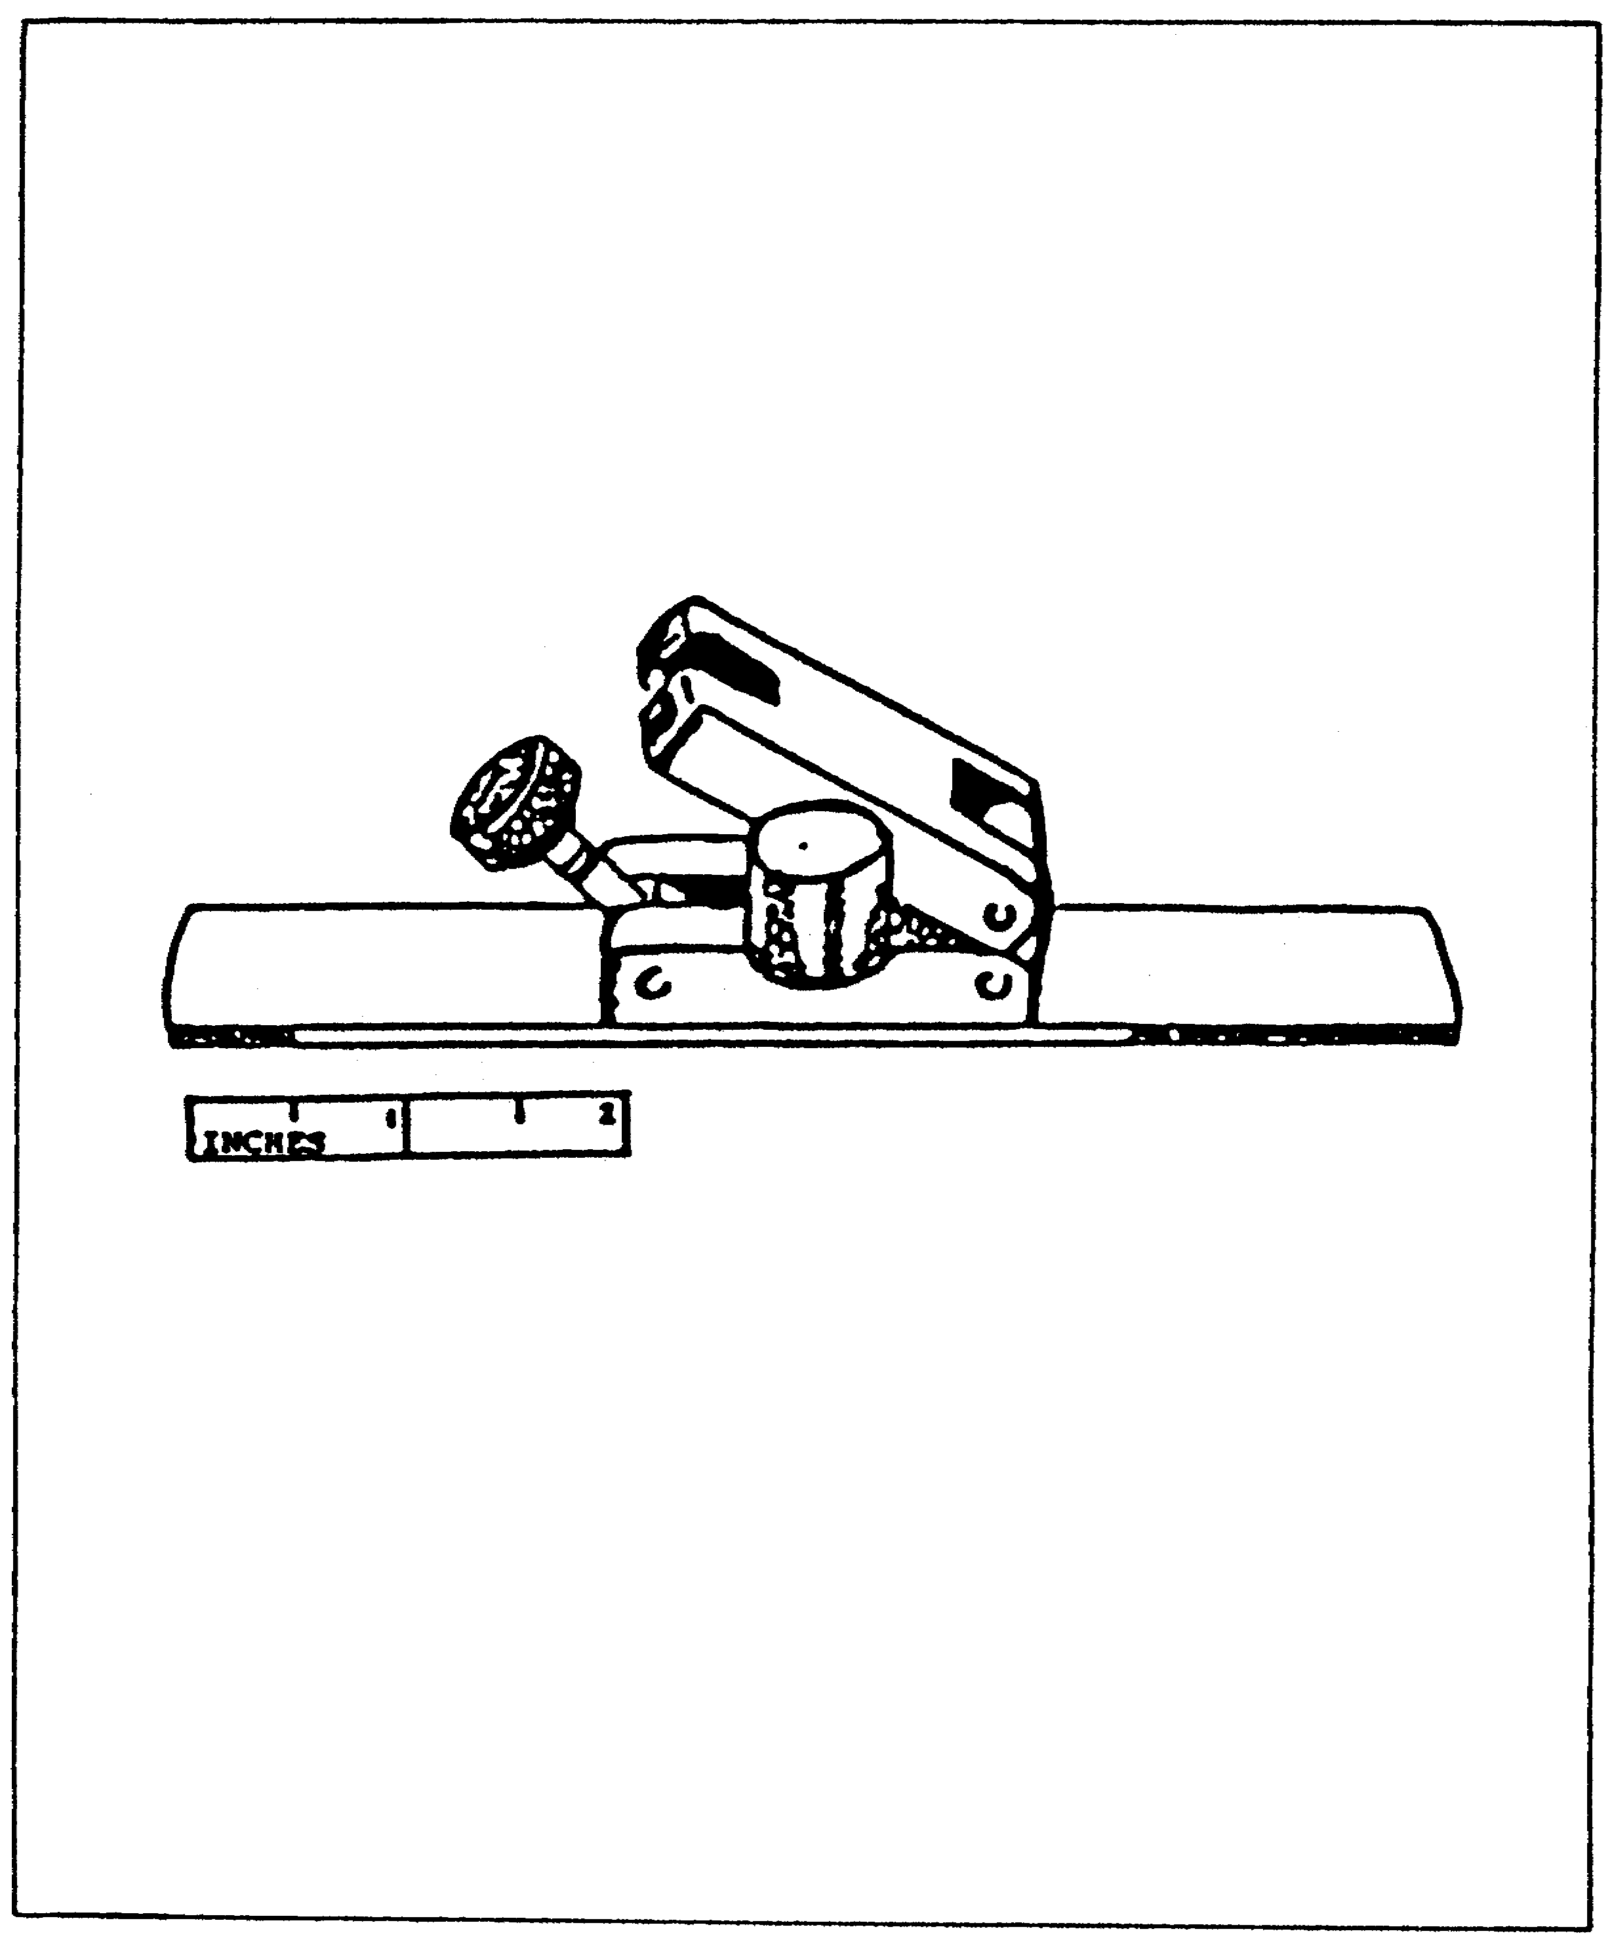

23

CANNON TUBE EVALUATION - OD 0463 - LESSON 2/TASK 2

LESSON 2

STEPS IN THE USE OF THE PULLOVER GAGE

TASK 2. Explain the use of the pullover gage.

CONDITIONS

Within a self-study environment and given the subcourse text, without assistance.

STANDARDS

Within thirty minutes

REFERENCES

No supplementary references are needed for this task.

1. Introduction

After becoming familiar with the specific components of the pullover gage, the next procedure the non-commissioned officer (NCO) faces is to properly assemble the pullover gage. This task contains instructions for the mechanical steps necessary to operate the pullover gage under conditions of moderate temperature and humidity.

2. Operation

In the operating steps listed below, the tables referred to are found in TM 9-4933-200-35, chapter 2, section II.

a. Assembling Operations. Select the required pullover gage assembly from table 5 (or in the manual noted above) and remove it from the container (a separate pullover gage is required for each size bore). Determine the number of rod assemblies necessary for the cannon to be measured (table 6) and screw them into the gage hinges.

24

CANNON TUBE EVALUATION - OD 0463 - LESSON 2/TASK 2

TABLE 5. PULLOVER GAGES FOR ARTILLERY WEAPON
INSPECTION.

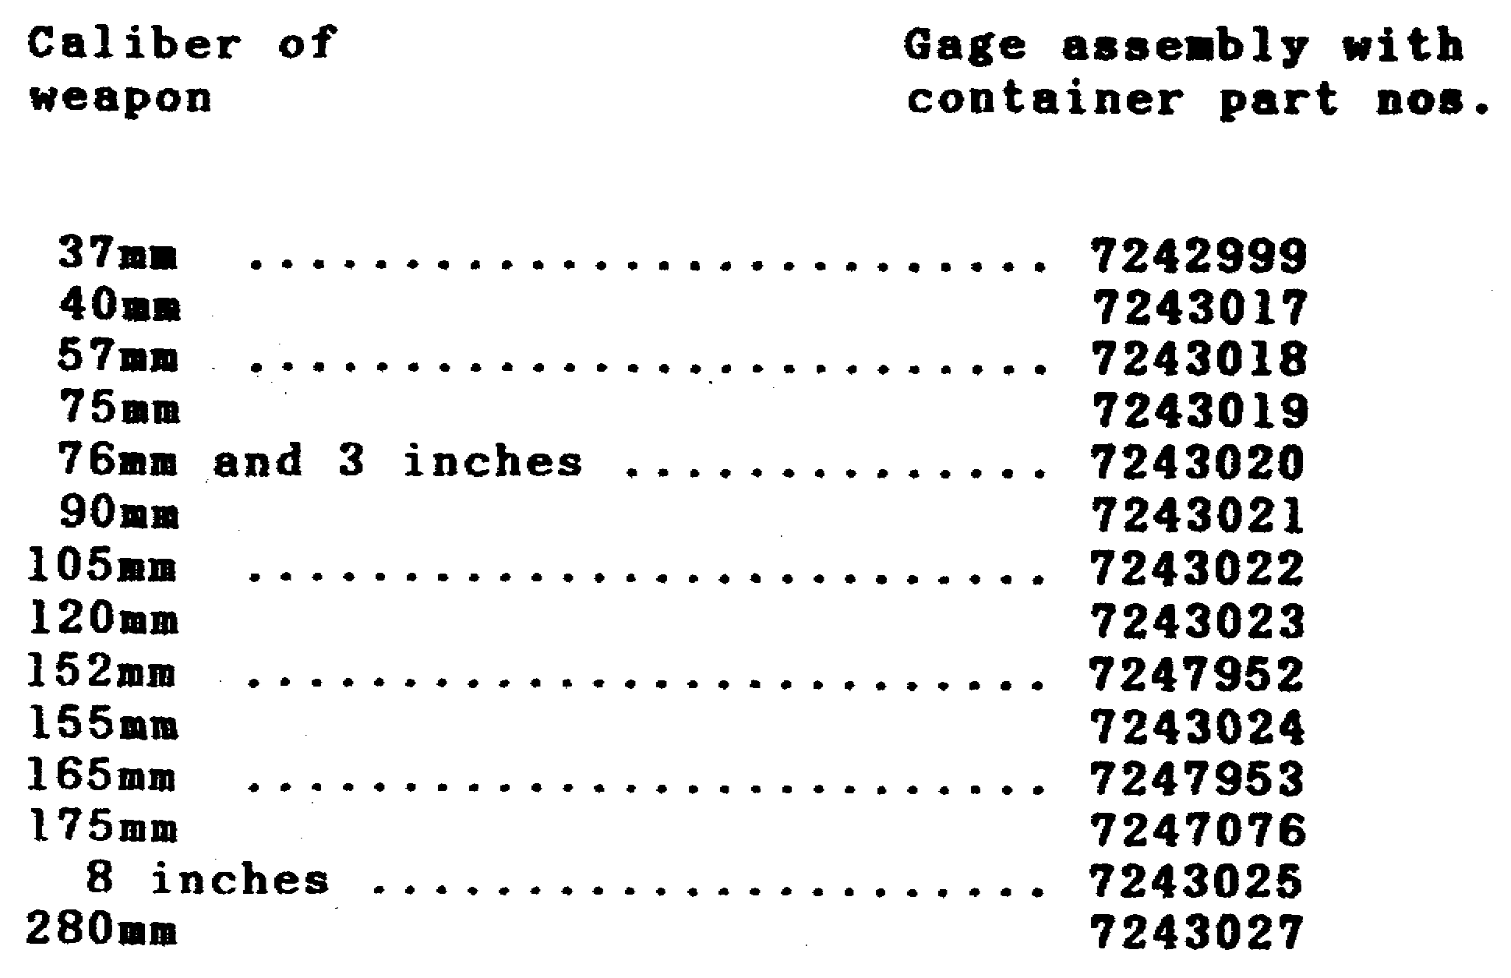

TABLE 6. ROD ASSEMBLIES FOR ARTILLERY WEAPON
INSPECTION.

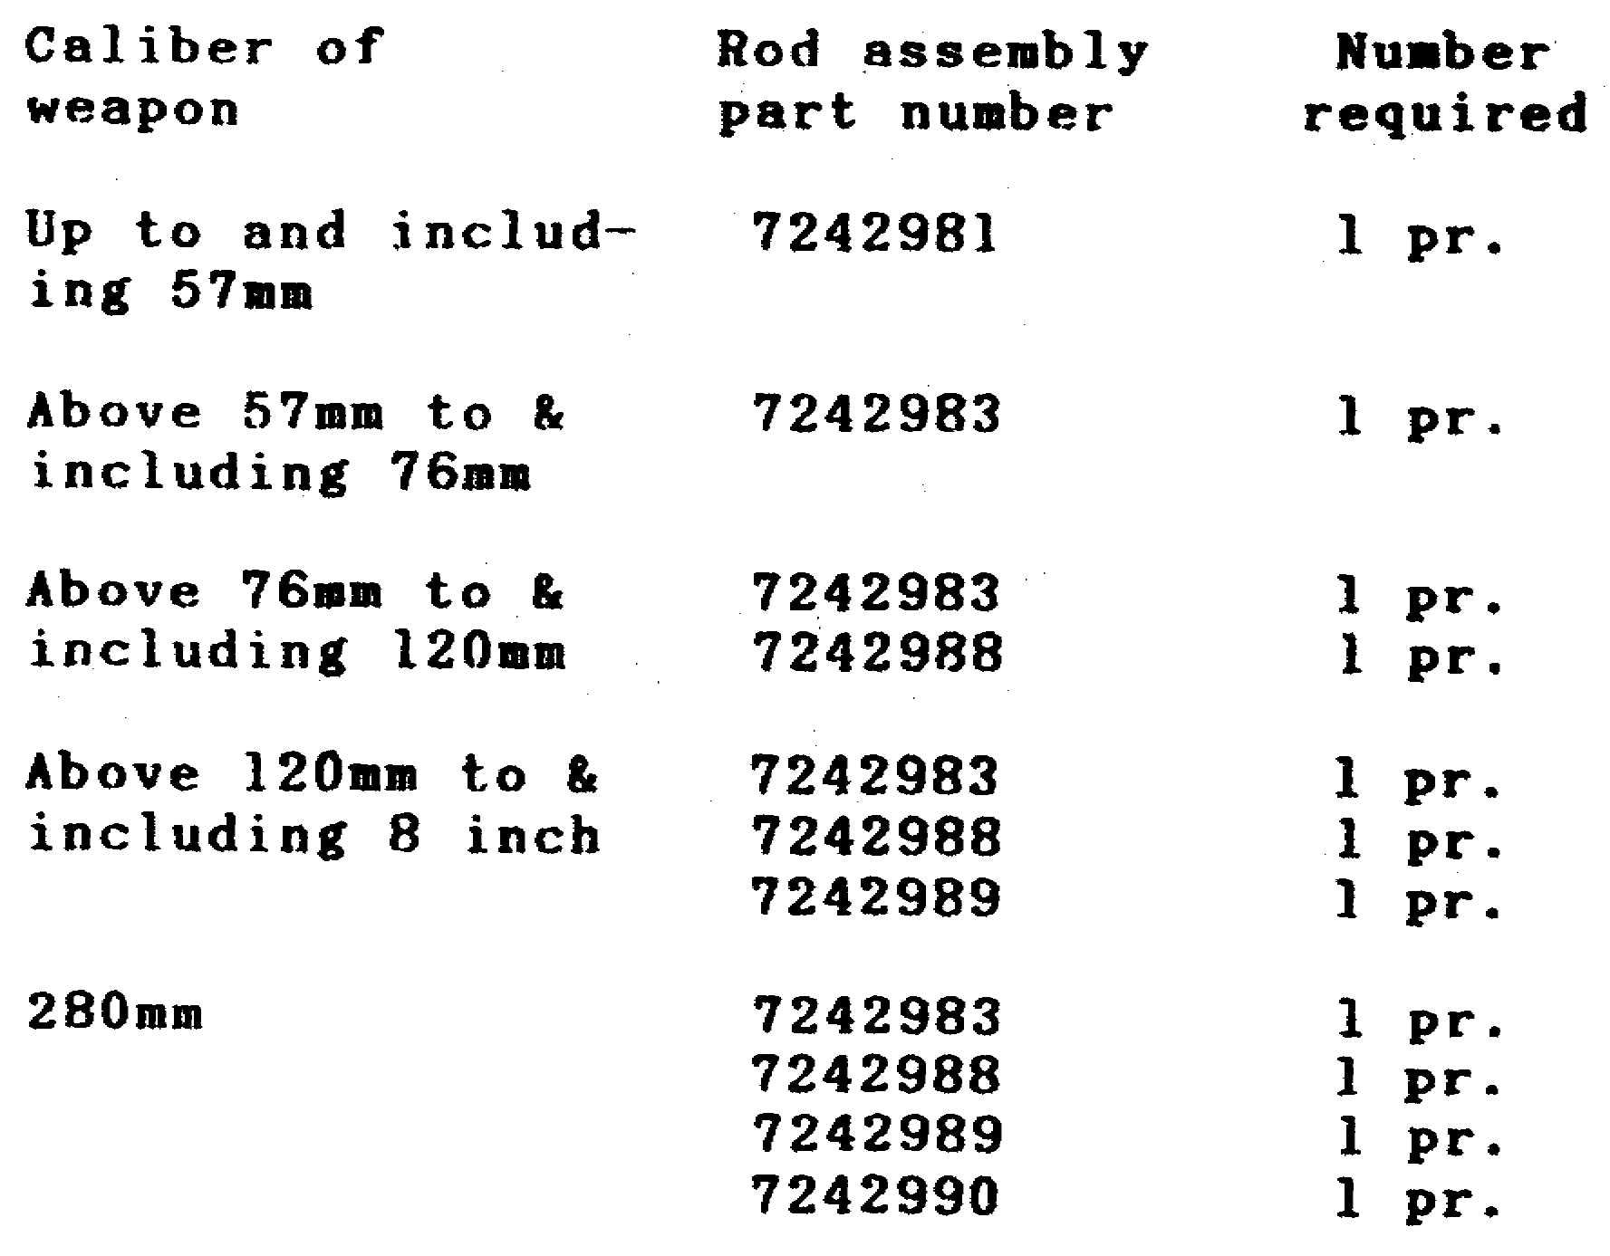

25

CANNON TUBE EVALUATION - OD 0463 - LESSON 2/TASK 2

TABLE 7. PULLOVER GAGE STOPS FOR ARTILLERY
WEAPON INSPECTION.

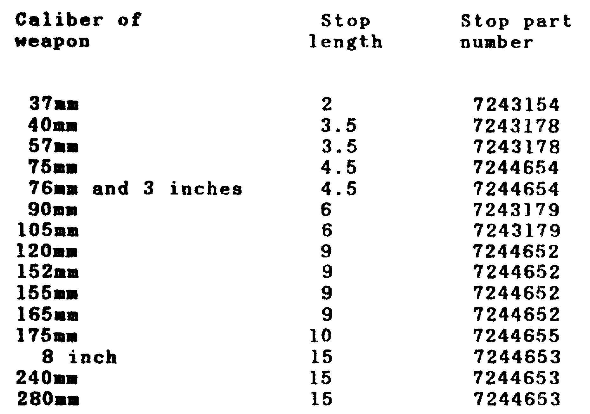

Choose the stop required for the cannon as shown in table 7, and secure it to the lower rod assembly by use of the stop clamp. The stop should be assembled so that the straight contact surface is toward the gage and set so that the distance predetermined for inspection is indicated by the marking. on the rod assembly at the rear of the stop. The distance mark is set from the rear of the stop to compensate for the fact that the measuring surface of the gage is one inch ahead of the end of the rod assembly.

b. Setting the Gage. Release the adjusting nut that holds the spring and slide, and set the slide approximately 0.3 to 0.4 inches larger than the basic diameter of the bore. Tighten the adjusting nut sufficiently to prevent the slide from jarring easily out of position while being inserted and removed from the cannon.

26

CANNON TUBE EVALUATION - OD 0463 - LESSON 2/TASK 2

c. Inserting the Gage in the Bore. Holding the gage vertical and the slide in the upward position, push the upper rod assemblies forward until the gage is tilted approximately 40 degrees; insert through the cannon into the chamber until the stop rests against the rear face of the cannon tube (figure 8).

FIGURE 8. POSITION OF PULLOVER GAGE DURING
GAGING.
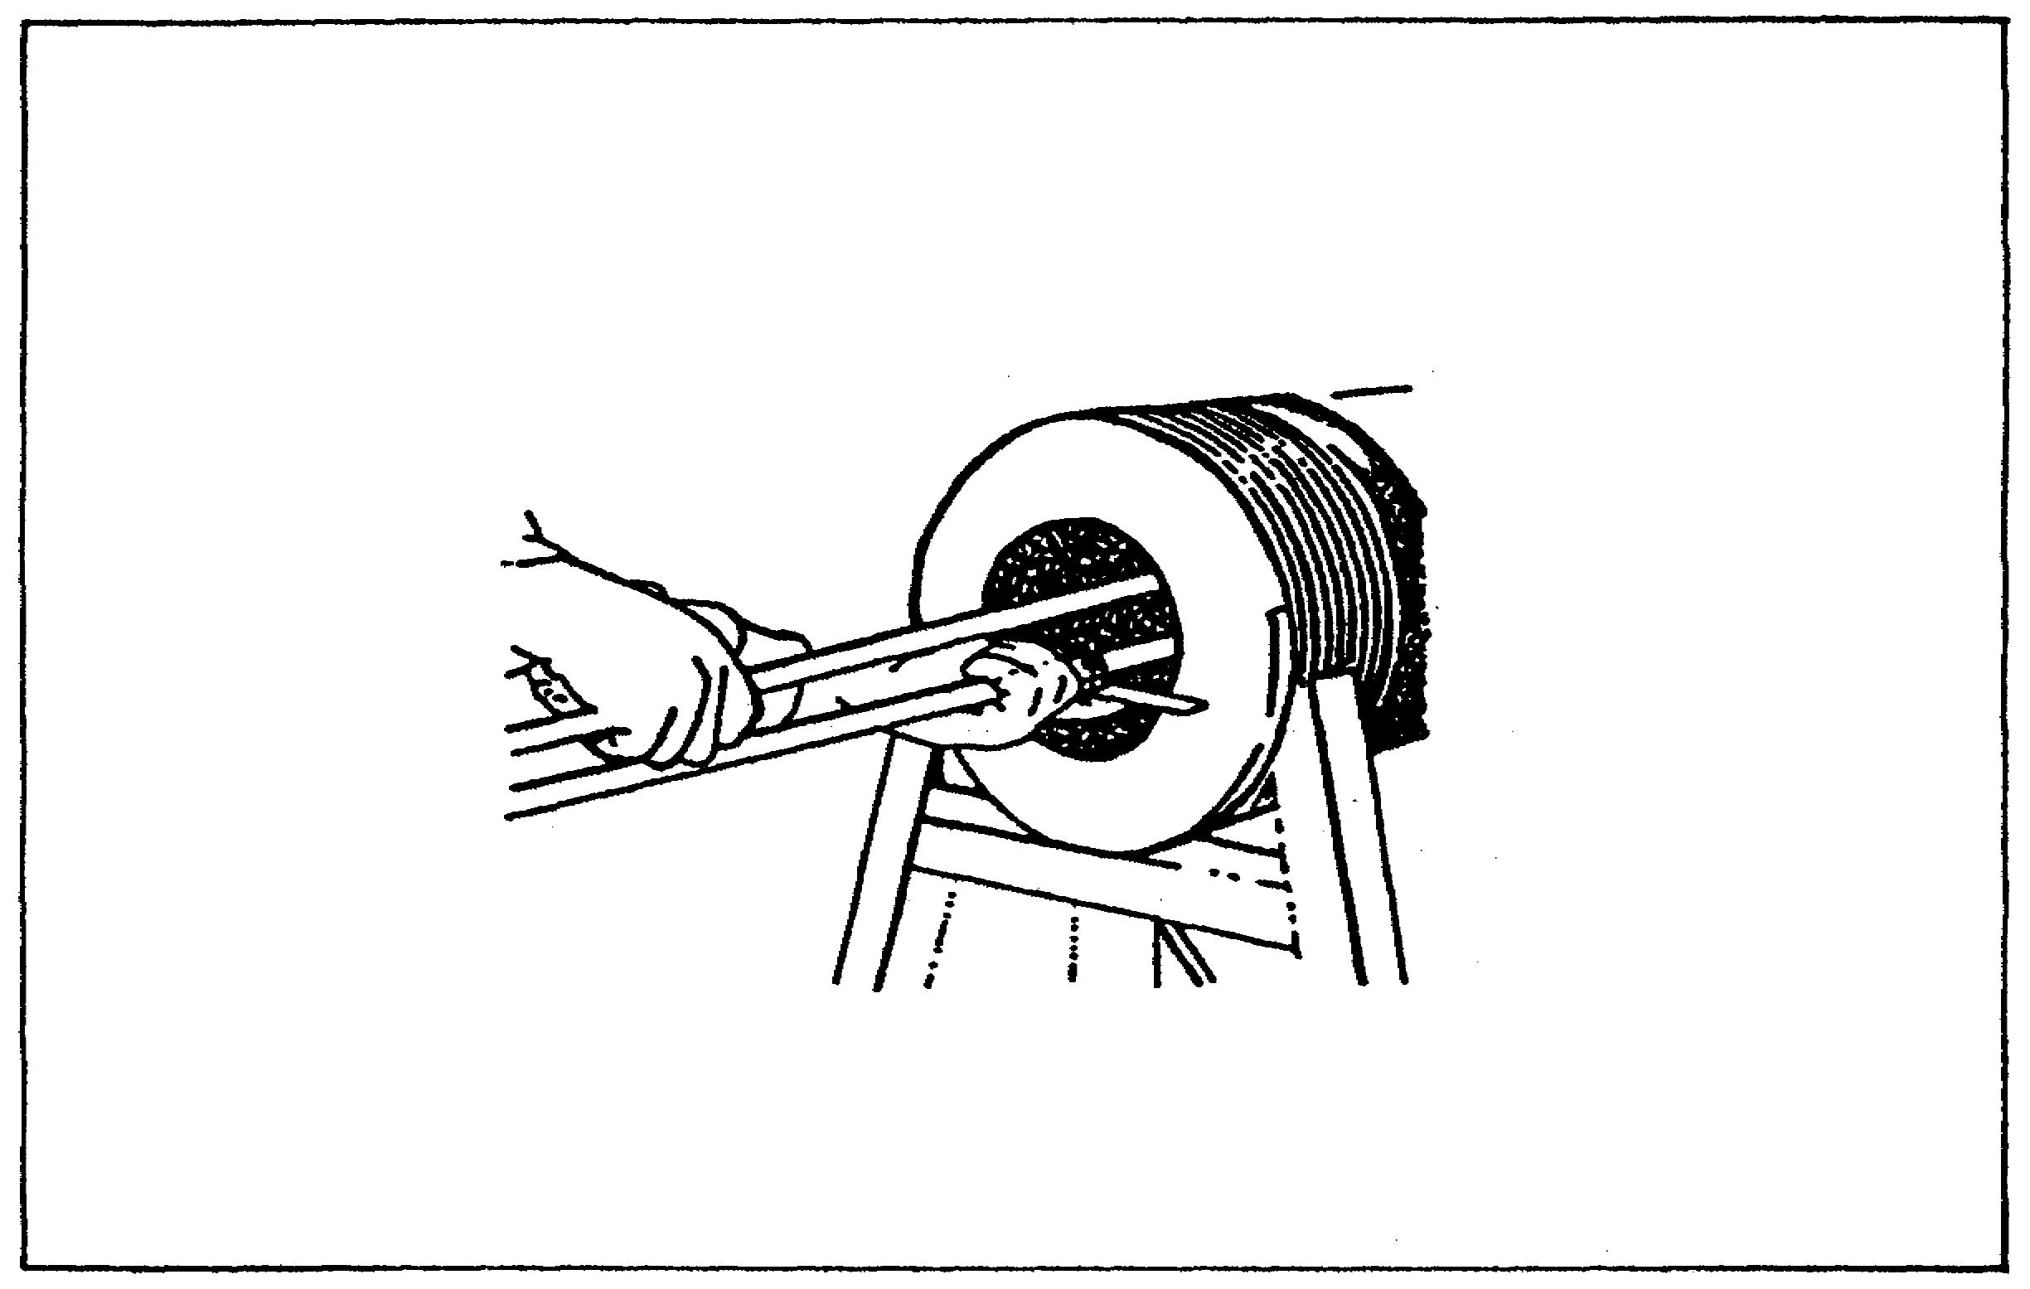

d. Centering and Setting the Assembled Gage. With the stop resting firmly against the cannon face, pull the upper rod assemblies rearward until the slide contacts the bore. Check for evenness of contact and for centering and vertical positioning of the gage. Continue a smooth rearward movement of the upper rod assemblies as far as the gage permits (figure 9).

FIGURE 9. PULLOVER GAGE IN POSITION.
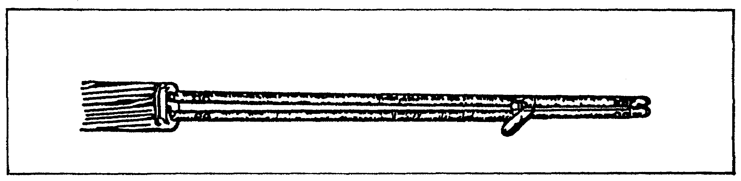

27

CANNON TUBE EVALUATION - OD 0463 - LESSON 2/TASK 2

The diameter of the bore at the desired point is now set on the gage. Carefully withdraw the gage from the cannon with the upper rod assemblies in the rearward position as shown in figure 10.

FIGURE 10. PULLOVER GAGE WITHDRAWN FROM CANNON.
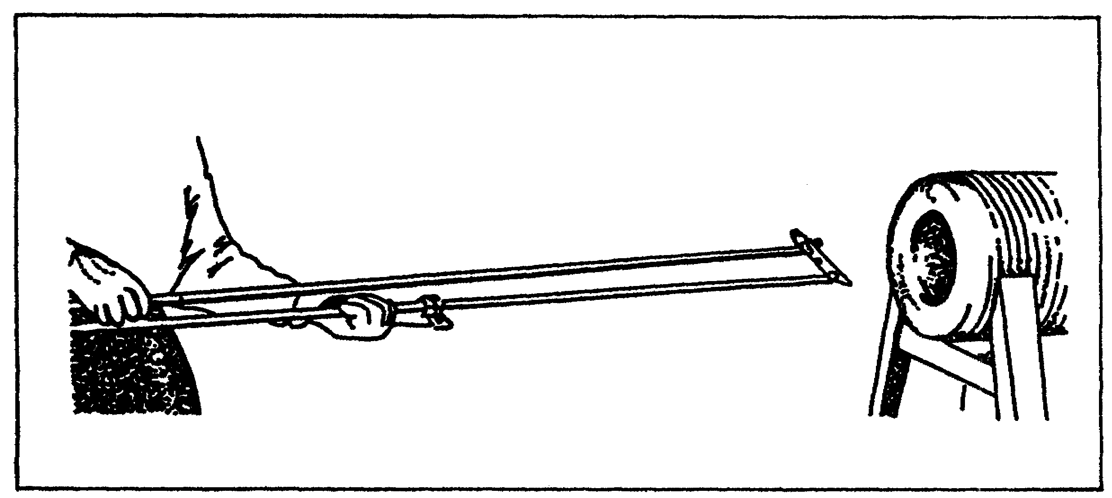

Now that a reading has been taken of a cannon bore, the next task to be discussed will be interpreting this pullover gage reading.

28

CANNON TUBE EVALUATION -OD 0463 - LESSON 2/TASK 3

LESSON 2

STEPS IN THE USE OF THE PULLOVER GAGE

TASK 3. Interpret readings of the pullover gage, given specific conditions of the bore diameter.

CONDITIONS

Within a self-study environment and given the subcourse text, without assistance.

STANDARDS

Within one hour

REFERENCES

No supplementary references are needed for this task.

1. Introduction

Following the initial setup, insertion, and removal of the pullover gage, it is vitally necessary for the user to be able to properly interpret the readings this instrument provides.

2. Vernier Caliper

For accuracy and confirmation of pullover gage readings, use of a vernier caliper is recommended.

a. Description. Vernier calipers can make a very accurate outside measurement of the pullover gage. A vernier caliper (figure 1] on the following page) is used by loosening the two locking screws (1) and (2) in figure 11. This allows the movable jaw (3) to move along the rule until the desired position is obtained. The locking screw (1) is then retightened securing the movable jaw (3). Any fine adjustments to the vernier scale (4) are then made using adjustment control (5). Locking screw (2) is then secured and the vernier caliper is ready to read.

29

CANNON TUBE EVALUATION - OD 0463 - LESSON 2/TASK 3

FIGURE 11. VERNIER CALIPER.
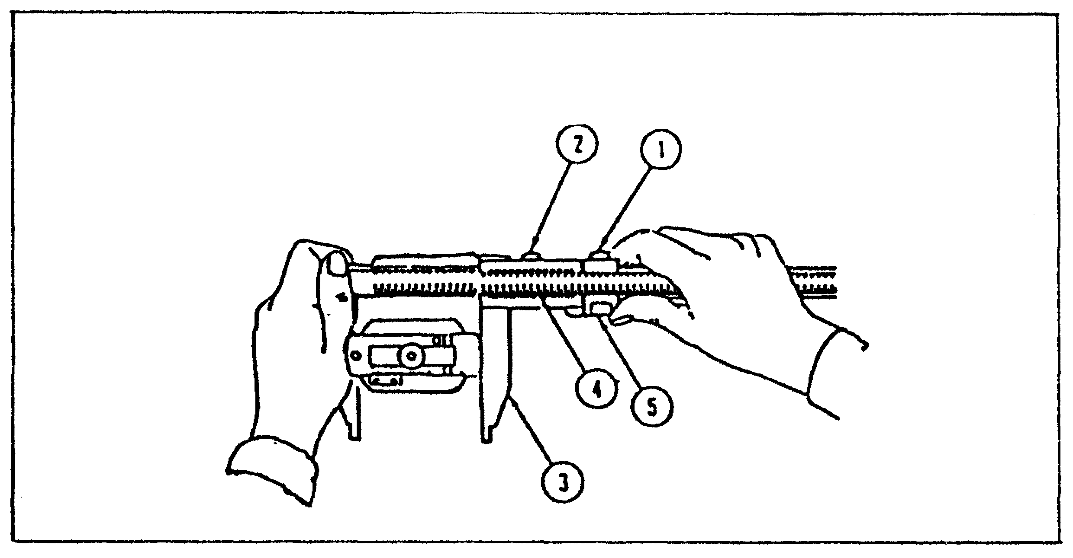

b. Caliper Reading. To read a vernier caliper (see figure 12 below), you must be able to understand both the steel rule and vernier scales. The steel rule (1)(figure 12) is graduated in 0.025 of an inch. Every fourth division (2) (representing a tenth of an inch) is numbered.

The vernier scale (3) is divided into 25 parts and numbered 0, 5, 10, 15, 20, and 25. These 25 parts are equal to 24 parts on the steel rule (1). The difference between the width of one of the 25 spaces on the vernier scale (3) and one of the 24 spaces on the steel rule (]) is 1/1000 of an inch.

Figure 12. VERNIER CALIPER INCH GRADUATIONS.
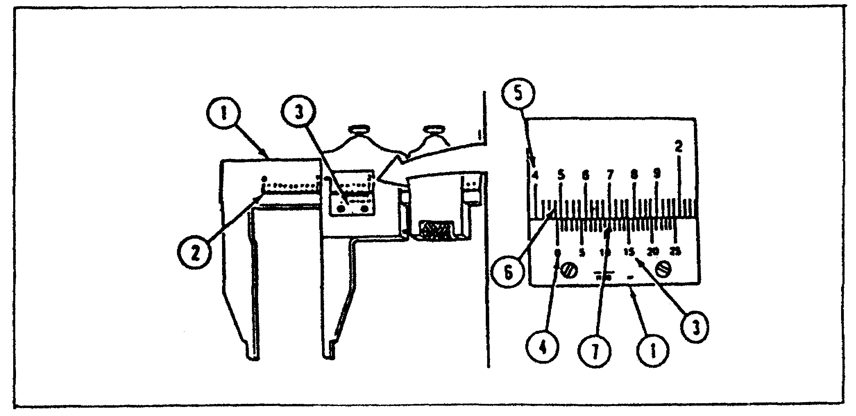

30

CANNON TUBE EVALUATION - OD 0463 - LESSON 2/TASK 3

(1) Read the measurement as shown in figure 12 (on the previous page). Read the number of whole inches on the top scale (]) (figure 12) to the left of the vernier zero index (4) and record 1.000 inch

(2) Read the number of tenths (5) to the left of the vernier zero index (4) and record 0.400 inch

(3) Read the number of twenty-fifths (6) between the tenths mark (5) and the zero index (4) and record .. 3 x .025 = .075 inch

(4) Read the highest line on the vernier scale (3) that lines up with the lines on the top scale (7) and record (remember 1/25 = .001 inch) 11/25 or 0.011 inches

(a) The vernier reading illustrated in figure 12 is 1.486 inch (1.000 + .400 + .075 + .011 = 1.486).

(b) Having measured a pullover gage with a vernier caliper and calculated the reading, refer to column 2 (Actual Diameter, as read off the vernier caliper) tables 8, 9, 10, 11, to determine the remaining cannon tube life.

3. Inspection of Tubes Condemnable on the Basis of Erosion

a. 40mm Gun Cannon. Read the scale on the gage and confirm with vernier caliper. The actual reading of the vernier scale will be the difference between the designated caliber and the actual bore diameter. The actual bore diameter will be the caliber of the cannon plus the vernier reading. To estimate the remaining life of a 40mm gun cannon, use table 8 on the following page. For a vernier reading of 0.015 inch, the bore diameter of a 40mm gun (1.573 inches) would be 1.573 plus 0.015 inches (column I - wear gage reading) or 1.588 (column 2 – actual diameter). Estimated remaining life, as a percentage, would be 60 percent (column 3 - percentage) and effective full charge (EFC) life of the tube would be 7200 rounds (column 4 - EFC round).

31

CANNON TUBE EVALUATION - OD 0463 - LESSON 2/TASK 3

TABLE 8. ESTIMATED REMAINING LIFE OF CANNON TUBE OF 40mm GUN CANNON, M2A1 FOR: GUN, SP, FT, TWIN, M42 AND M42A1.

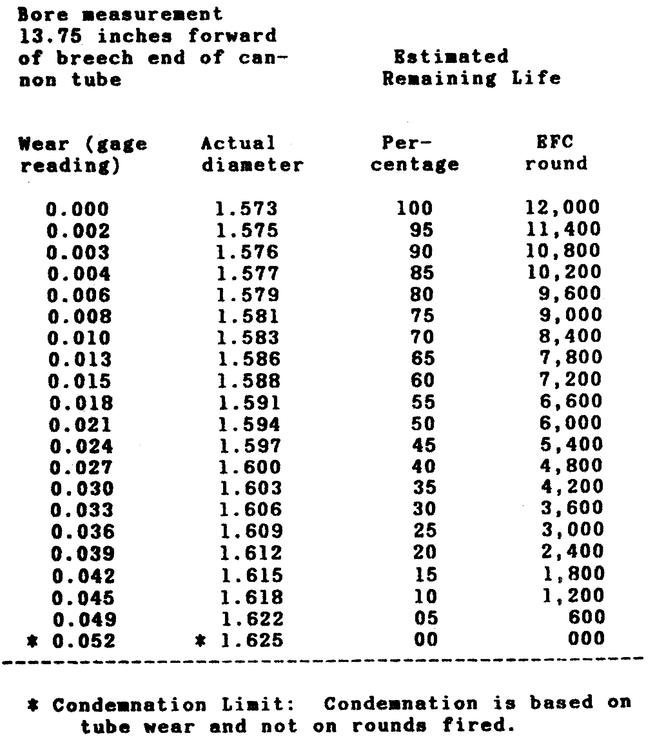

32

CANNON TUBE EVALUATION - OD 0463 - LESSON 2/TASK 3

b. 90mm Gun Cannon. Read the scale on the gage and confirm with vernier caliper. The actual reading of the vernier scale will be the difference between the designated caliber and the actual bore diameter. The actual bore diameter will be the caliber of the cannon plus the vernier reading. To estimate the remaining life of a 90mm gun cannon use table 9.

TABLE 9. ESTIMATED REMAINING LIFE OF TUBE
OF 90mm GUN CANNON, M41 FOR: M48
SERIES TANK.

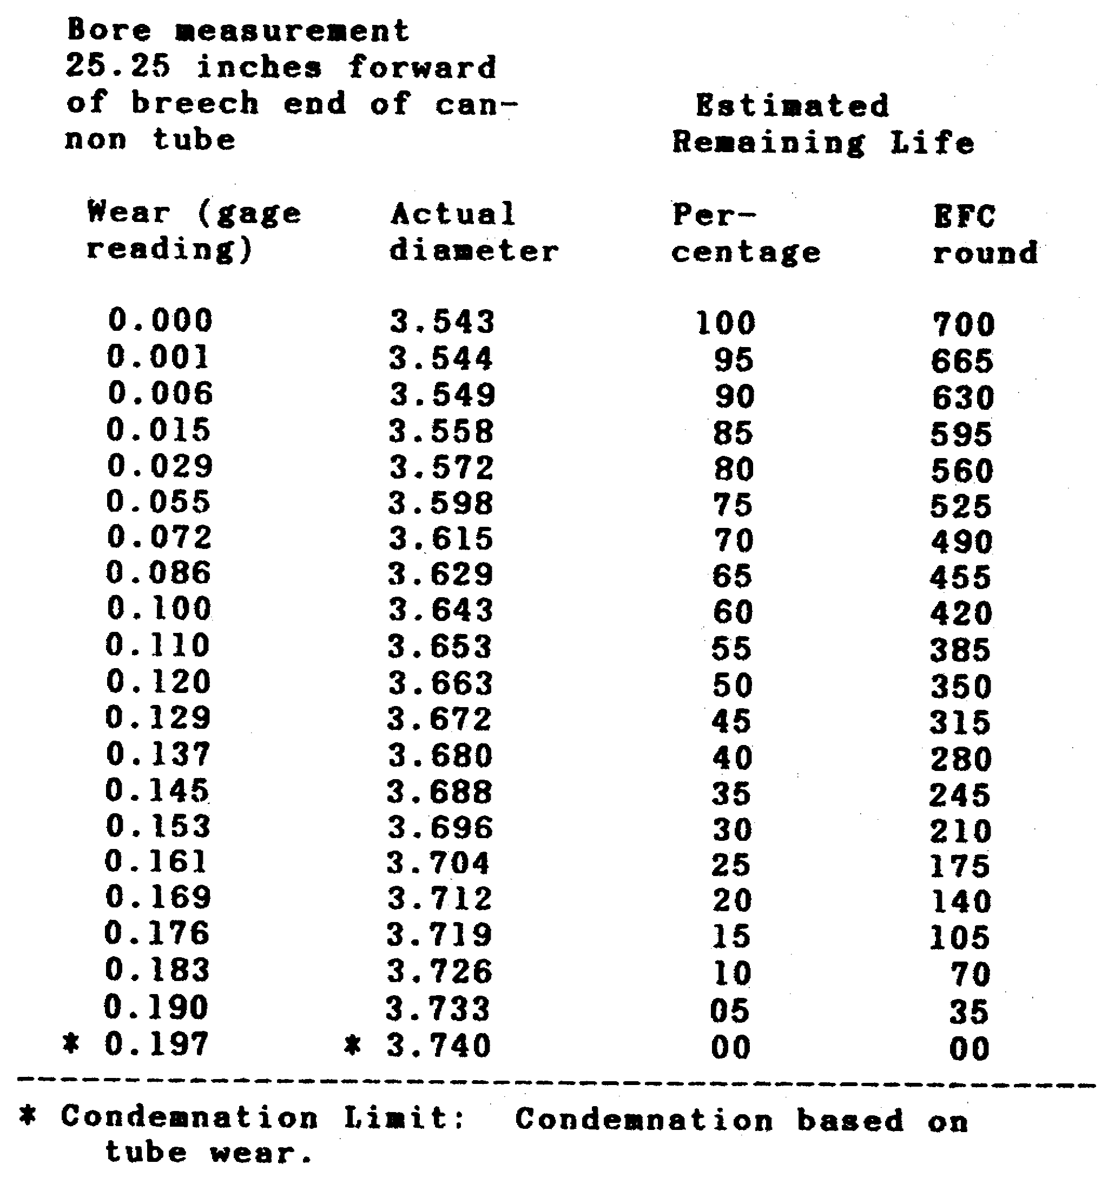

33

CANNON TUBE EVALUATION - OD 0463 - LESSON 2/TASK 3

c. 120mm Gun Cannon. Read the scale on the gage and confirm with vernier caliper. The actual reading of the vernier scale will be the difference between the designated caliber and the actual bore diameter. The actual bore diameter will be the caliber of the cannon plus the vernier reading. To estimate the remaining life of cannon tube for a 120mm gun cannon, use table 10.

TABLE 10. ESTIMATED REMAINING LIFE OF CANNON
TUBE OF 120mm GUN CANNON, M58 FOR:
TANK, COMBAT, FT, M103A2.

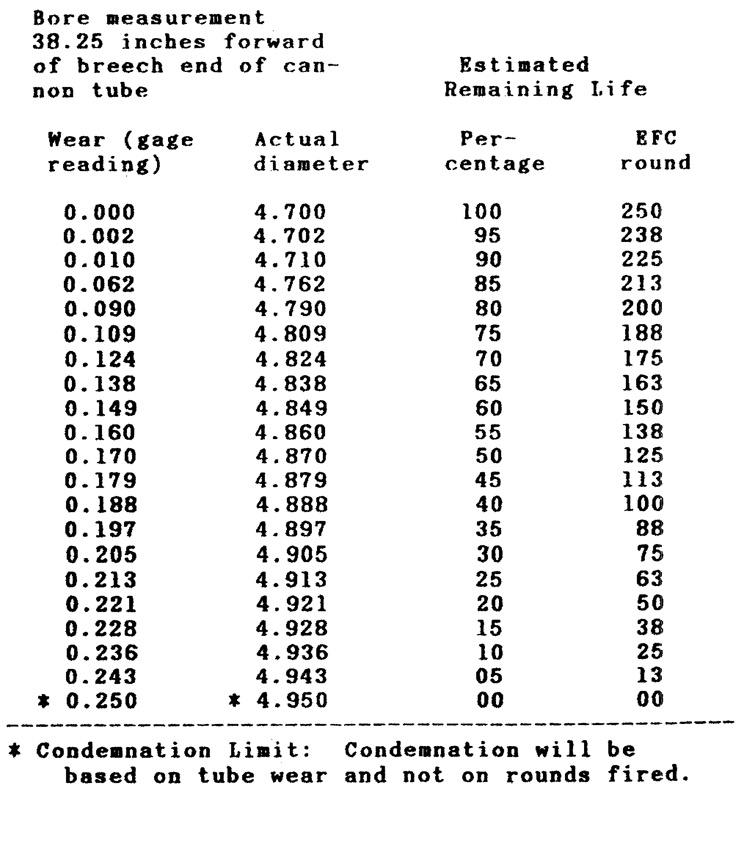

34

CANNON TUBE EVALUATION - OD 0463 - LESSON 2/TASK 3

d. 155mm Gun Cannon. Read the scale on the gage and confirm with vernier caliper. The actual reading of the vernier scale will be the difference between the designated caliber and the actual bore diameter. The actual bore diameter will be the caliber of the cannon plus the vernier reading. To estimate the remaining life of a cannon tube for a 155mm gun cannon use table 11.

TABLE 11. ESTIMATED REMAINING LIFE OF CANNON
TUBE OF 155mm GUN CANNON, M46 FOR:
GUN, SP, FT, M53.

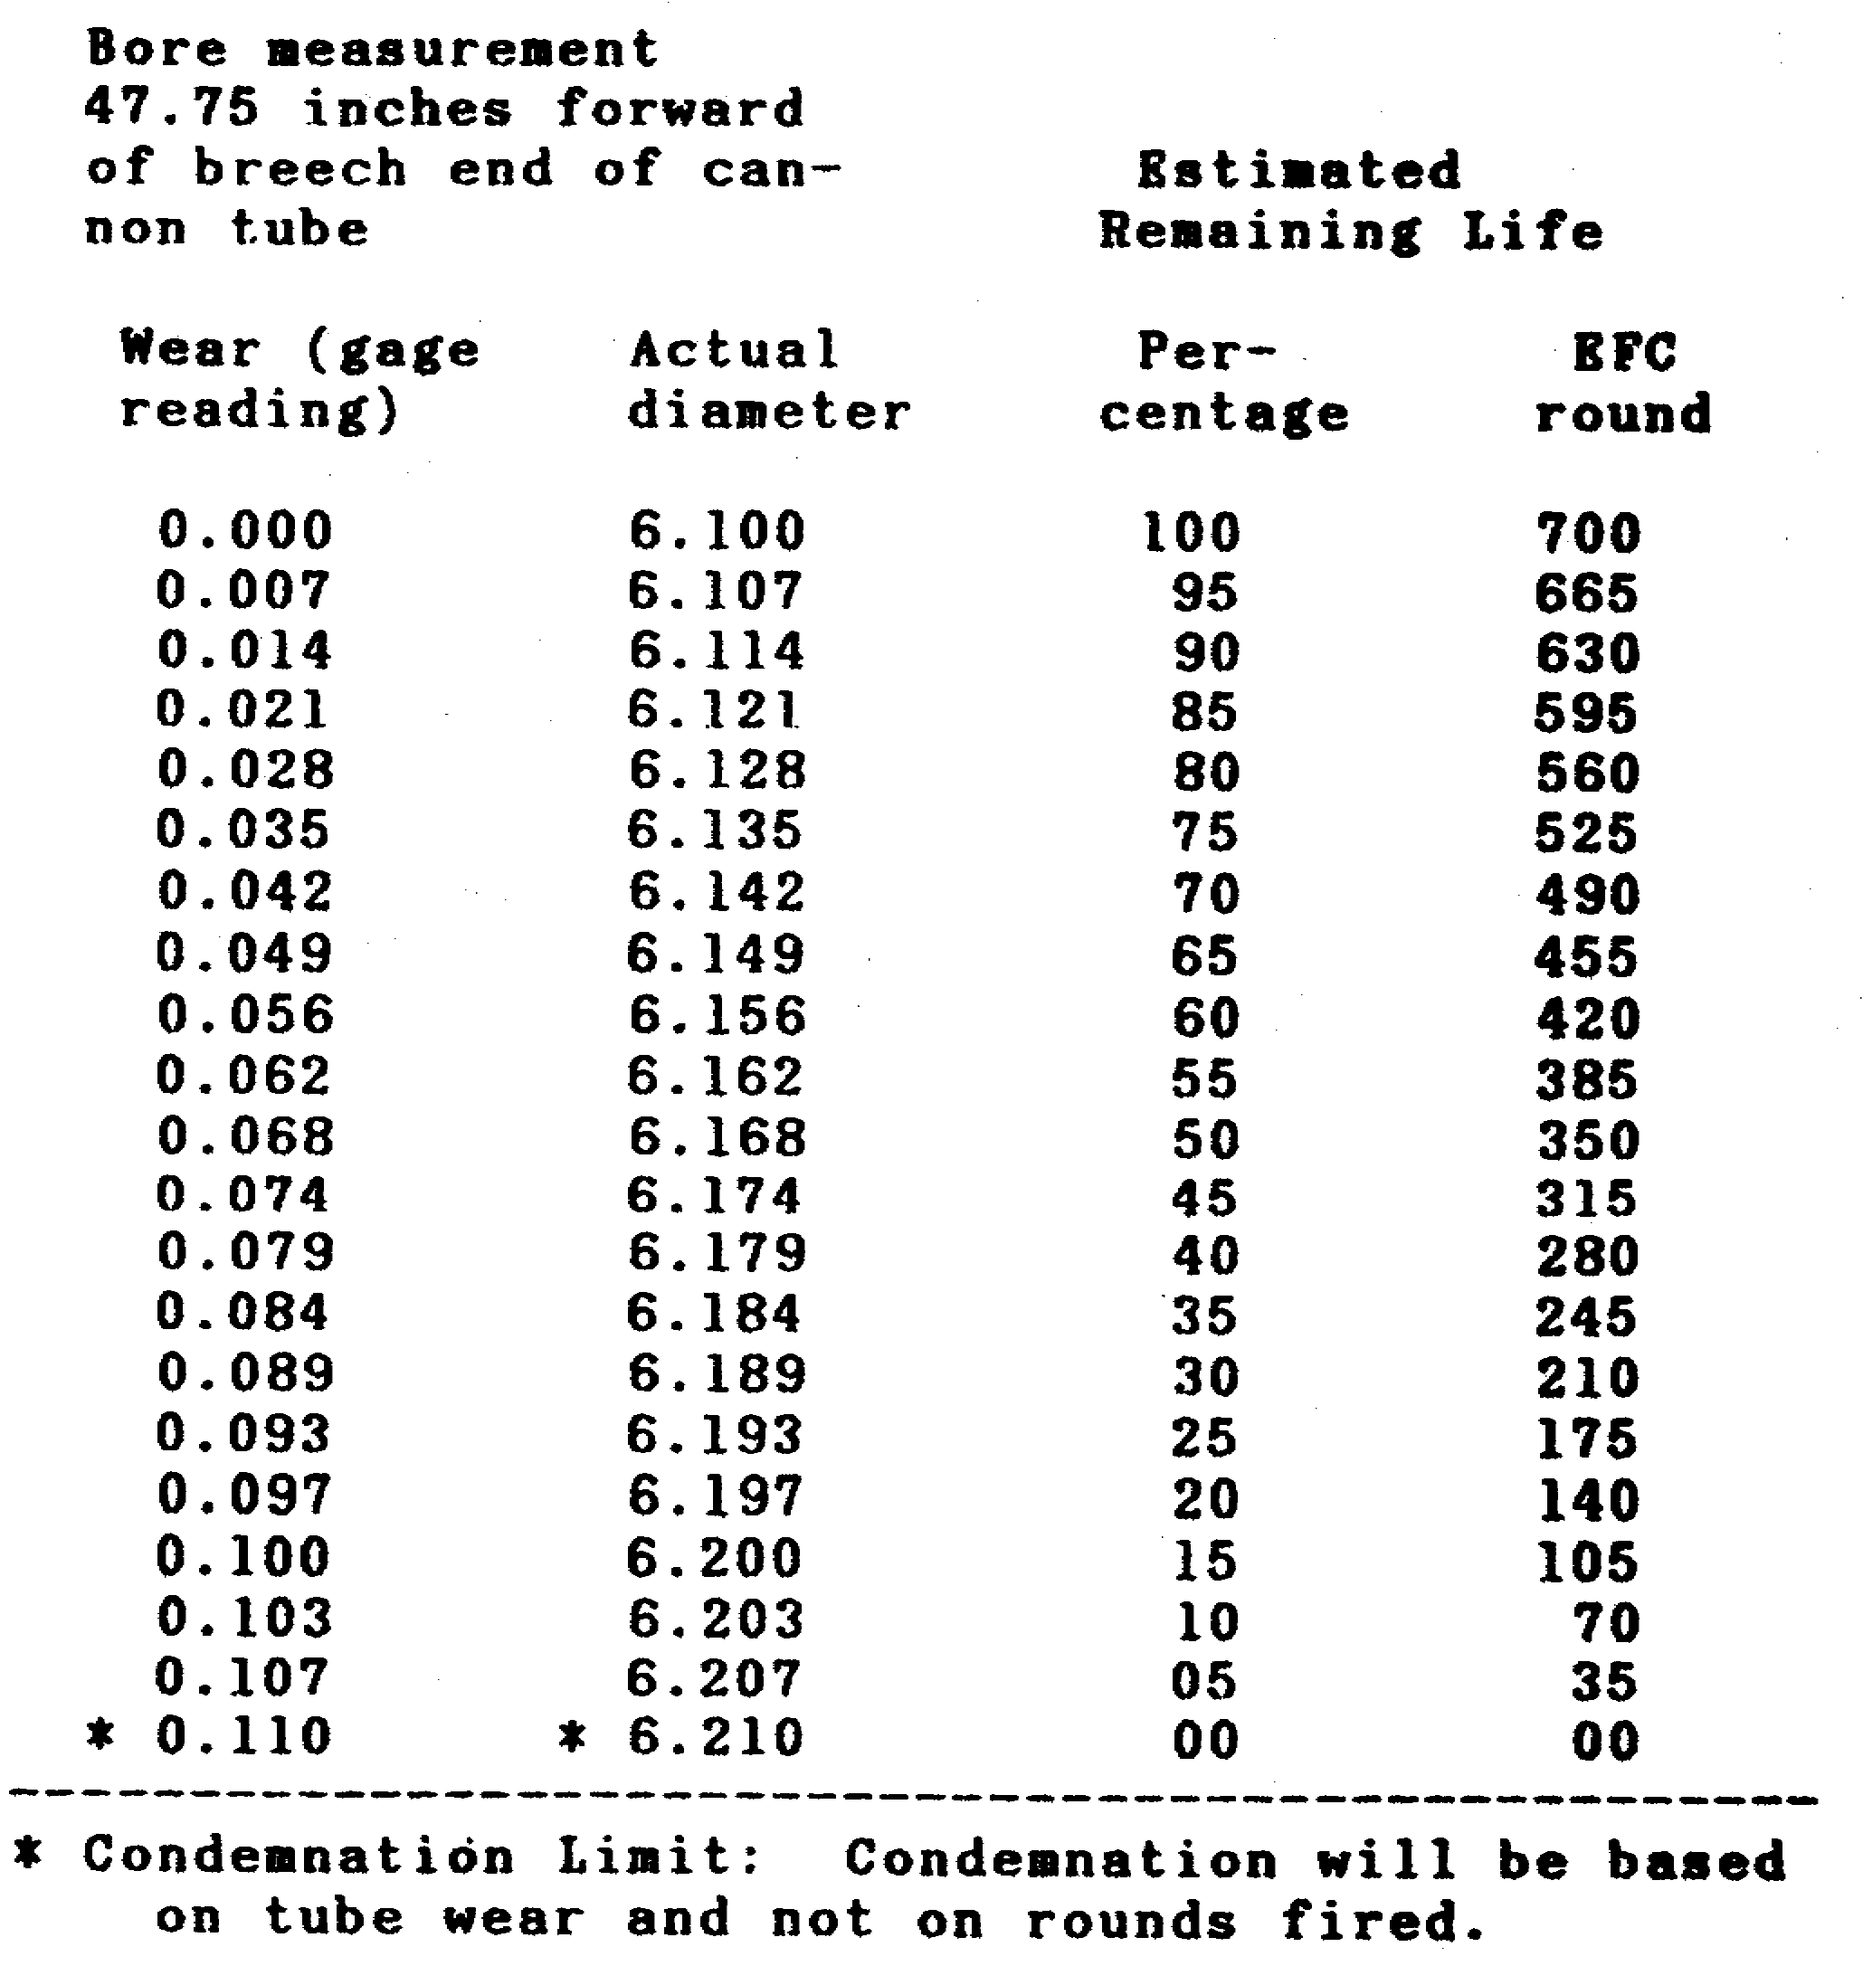

35

CANNON TUBE EVALUATION - OD 0463 - LESSON 2/PE 2

PRACTICAL EXERCISE 2

Instructions

On a plain sheet of paper, write down the answers to the following questions. When you have answered then, turn the page and check your answers.

(1) Specify, in millimeters, what bore diameter parameters (minimum bore/maximum bore) the pullover gage can be used to measure.

(2) The vernier scale, which is attached to the body of the body and slide assembly, is marked in 0.005 inch divisions and subdivided in 0.001 inch intervals. What is the minimum measurement that can be made with this instrument?

(3) What TM would be used to find the correct sequence of steps for assembling the pullover gage?

(4) From Table 7, identify what stop length is used for a 106mm weapon.

(5) The pullover gage and rods are inserted into the cannon until the stop rests against what portion of the cannon tube?

(6) What would be the percentage of remaining cannon tube life of a 120mm gun cannon that had a wear (gage reading) of 0.149?

36

CANNON TUBE EVALUATION - OD 0463 - LESSON 2/PE 2

LESSON 2. PRACTICAL EXERCISE - ANSWERS

(1) 37mm - 280mm.

(2) .001 inch.

(3) TM 4933-200-35.

(4) 6.

(5) Rear face.

(6) 60 percent.

37

CANNON TUBE EVALUATION - OD 0463 - LESSON 3/TASK 1

LESSON 3

STEPS IN THE USE OF THE BORESCOPE

TASK 1. Identify and describe the borescope and related components.

CONDITIONS

Within a self-study environment and given the subcourse text, without assistance.

STANDARDS

Within thirty minutes

REFERENCES

No supplementary references are needed for this task.

1. Introduction

The borescope is used to visually inspect the cannon bore on all types of artillery weapons (20mm through 280mm) for defects in manufacture and for erosion damage caused by firing. Erosion is caused by movement of high temperature gasses and residue generated from the burning propellent. Movement of the projectile through the bore also erodes and wears the tube.

2. Borescope

The borescope is used at the intermediate direct support/intermediate general support (IDS/IGS) level of maintenance and comes in four models. These models are: M1 (used for 20mm and 40mm) figure 13; M2 and M3 (for 57mm and 280mm) figure 14; M4 (only used for the chamber of the MlO10 SP Howitzer). All devices are basically a straight tube telescope using a mirror (mirror or prism borescope M2) set at an angle to present a view of the bore being inspected.

38

CANNON TUBE EVALUATION - OD 0463 - LESSON 3/TASK 1

FIGURE 13. BORESCOPE M1 W/EQUIPMENT.
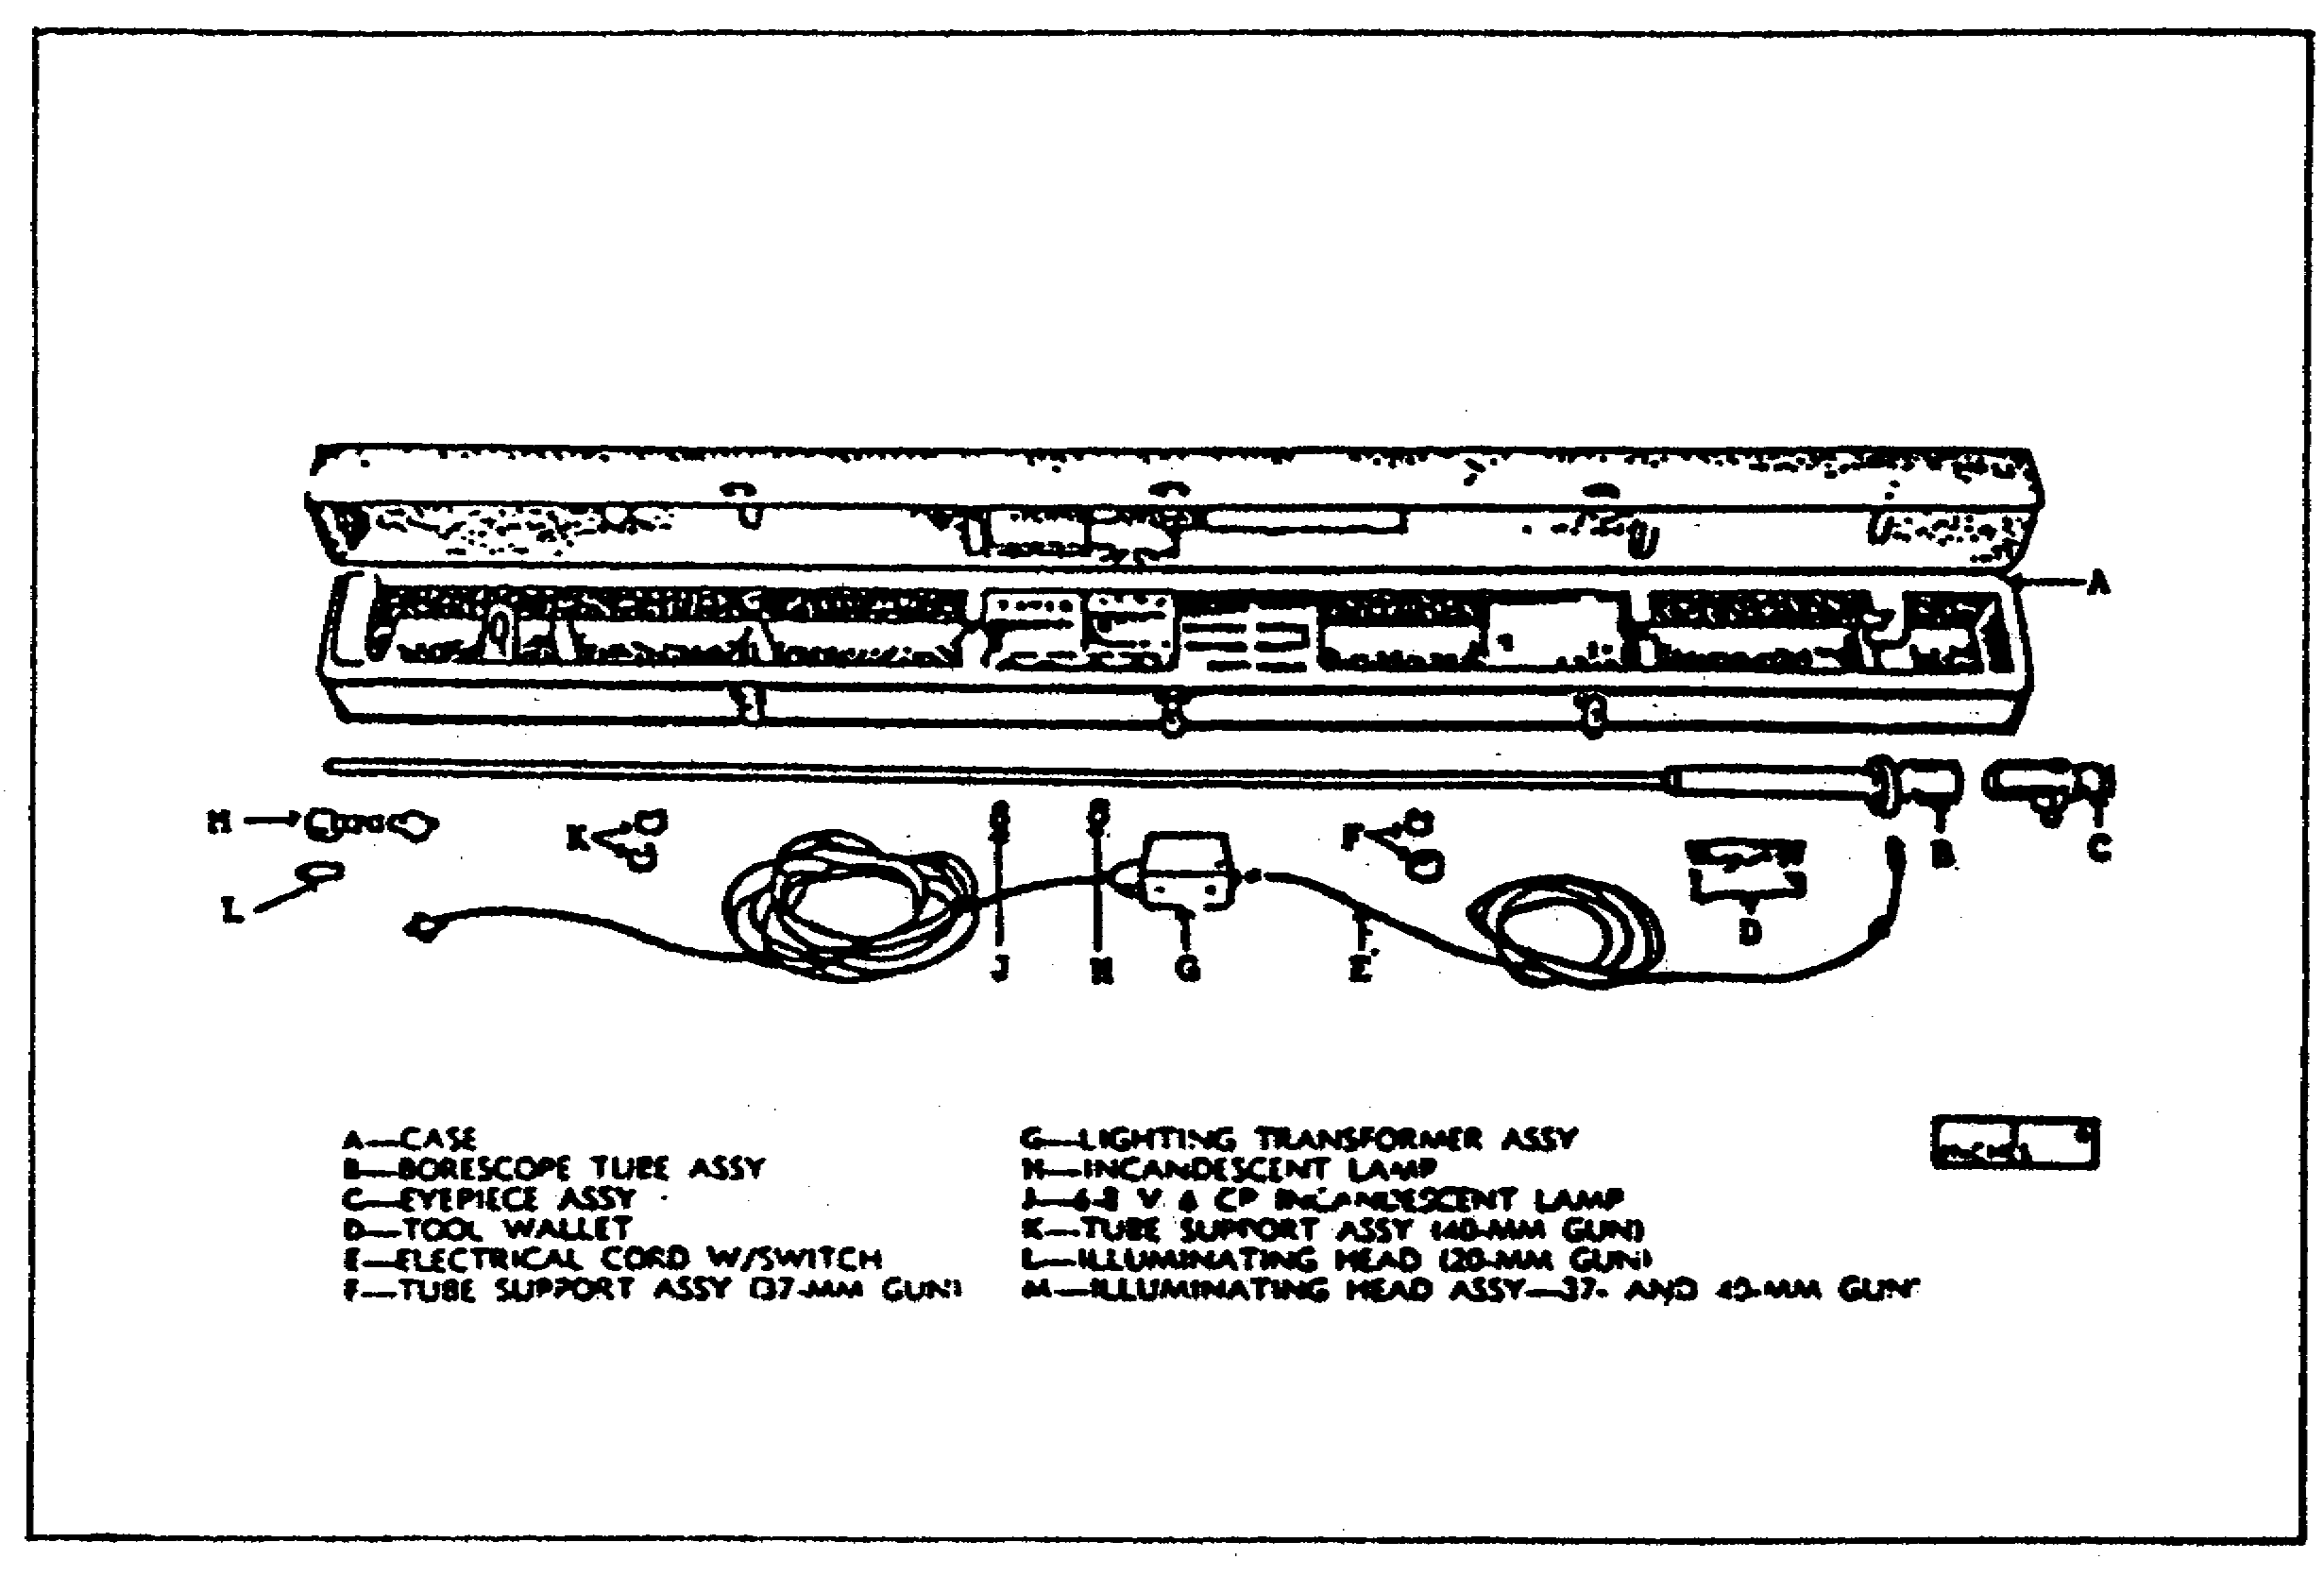

FIGURE 14. BORESCOPE M2 W/EQUIPMENT.
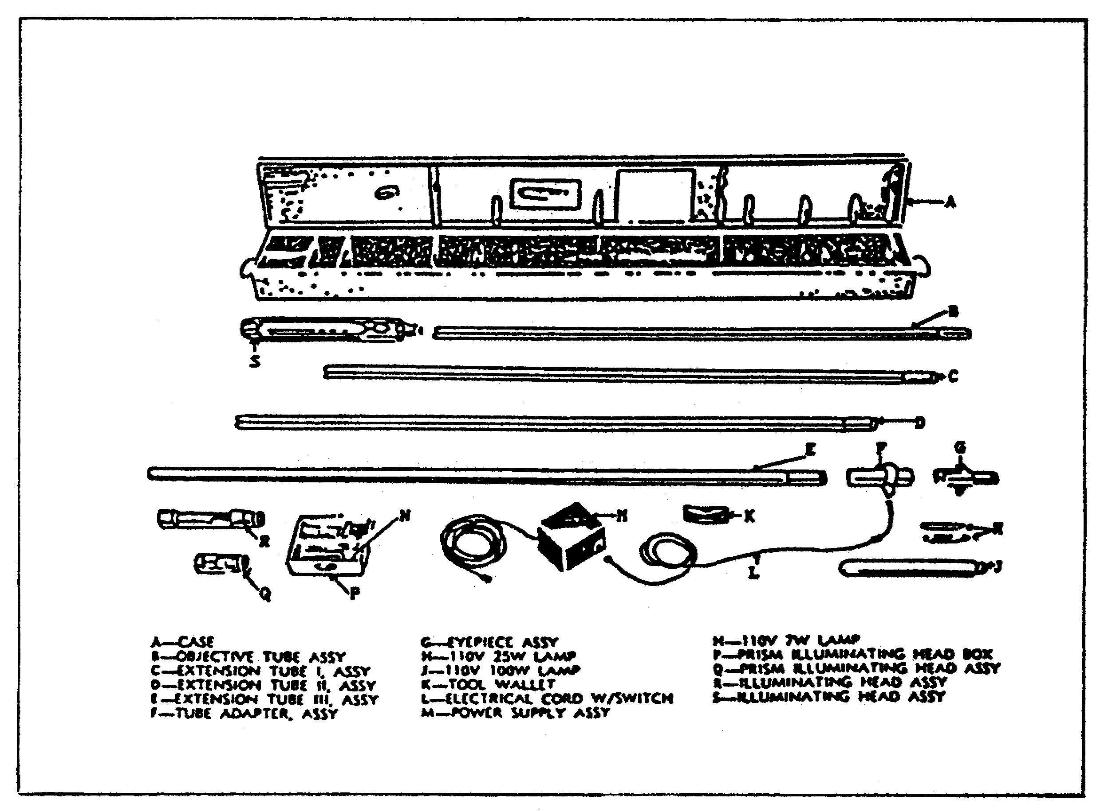

39

CANNON TUBE EVALUATION - OD 0463 - LESSON 3/TASK 1

a. Components. The M1 and M2 borescopes are the most commonly used; a listing and description of their components appears below.

(1) Borescope MI. Four assemblies and several accessories will be described here.

(a) Eyepiece Assembly. This assembly (figure 15) is located on the viewing end of the instrument. A rubber eyeshield is provided to form a light block. Focal adjustment is obtained through operation of either of the two larger knurled knobs. A knurled head screw is provided to lock the assembly in focus.

FIGURE 15. EYEPIECE ASSEMBLY.
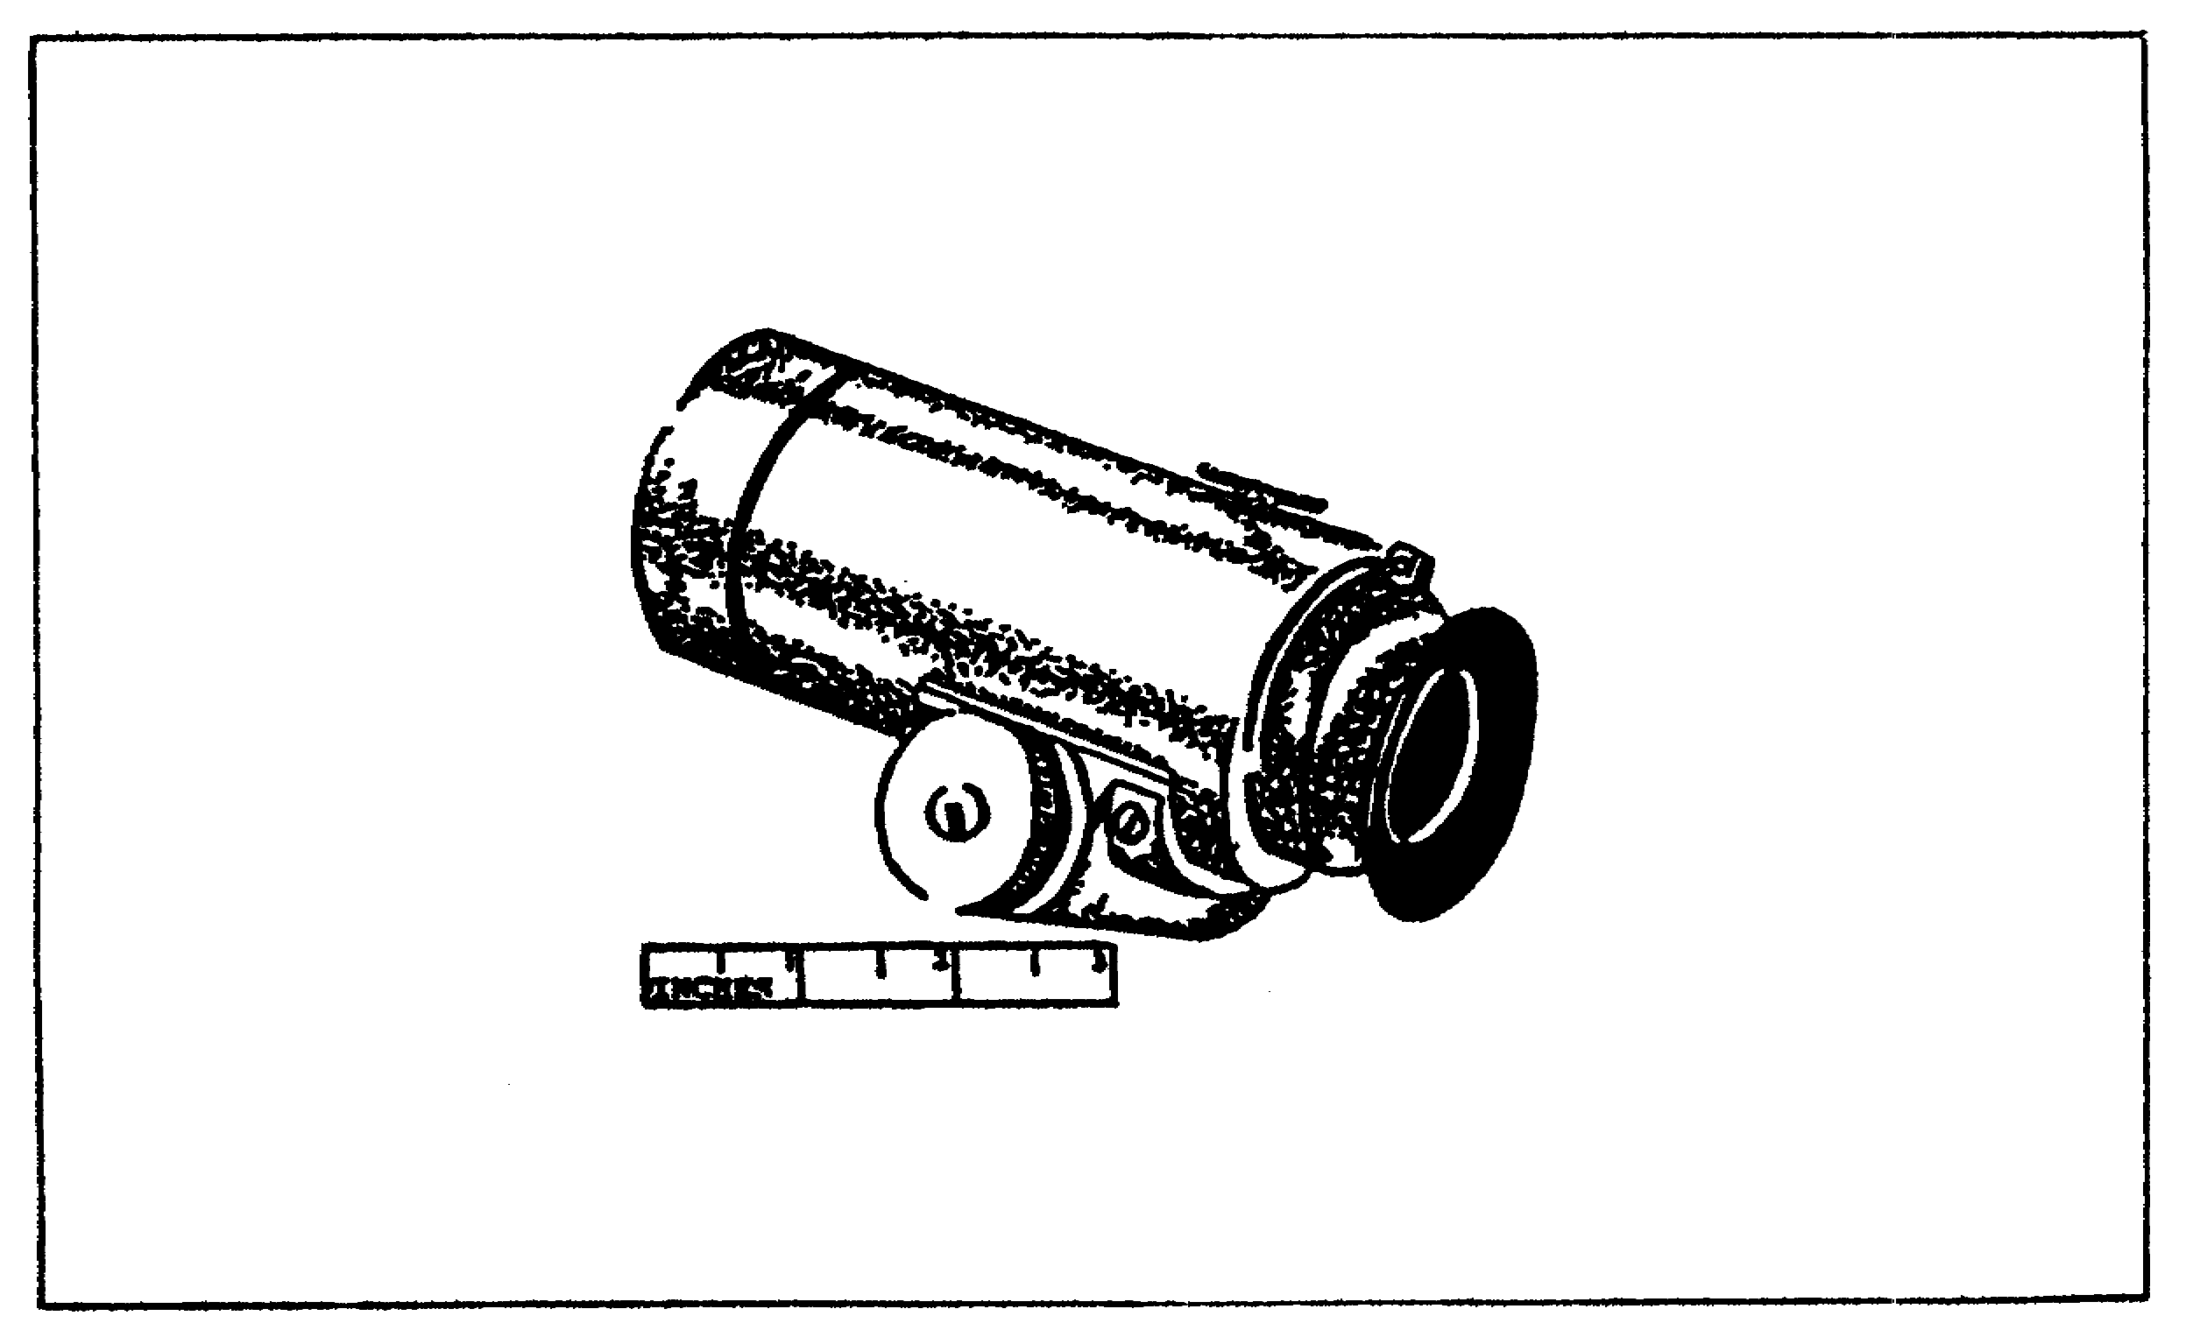

(b) Borescope Main Tube Assembly. This assembly (figure 16) contains all the optical elements incorporated in the borescope other than in the eyepiece assembly. The collector assembly, located on the borescope tube, provides the electrical connection between the lamp in the illuminating head and the transformer. The outside of the tube is graduated in 1 inch intervals. Every fifth line is numbered. These lines are arranged so that they indicate the distance from the center of the area being viewed in the weapon tube to the edge of the opening into which the instrument was inserted.

40

CANNON TUBE EVALUATION - OD 0463 - LESSON 3/TASK 1

FIGURE 16. BORESCOPE TUBE ASSEMBLY.
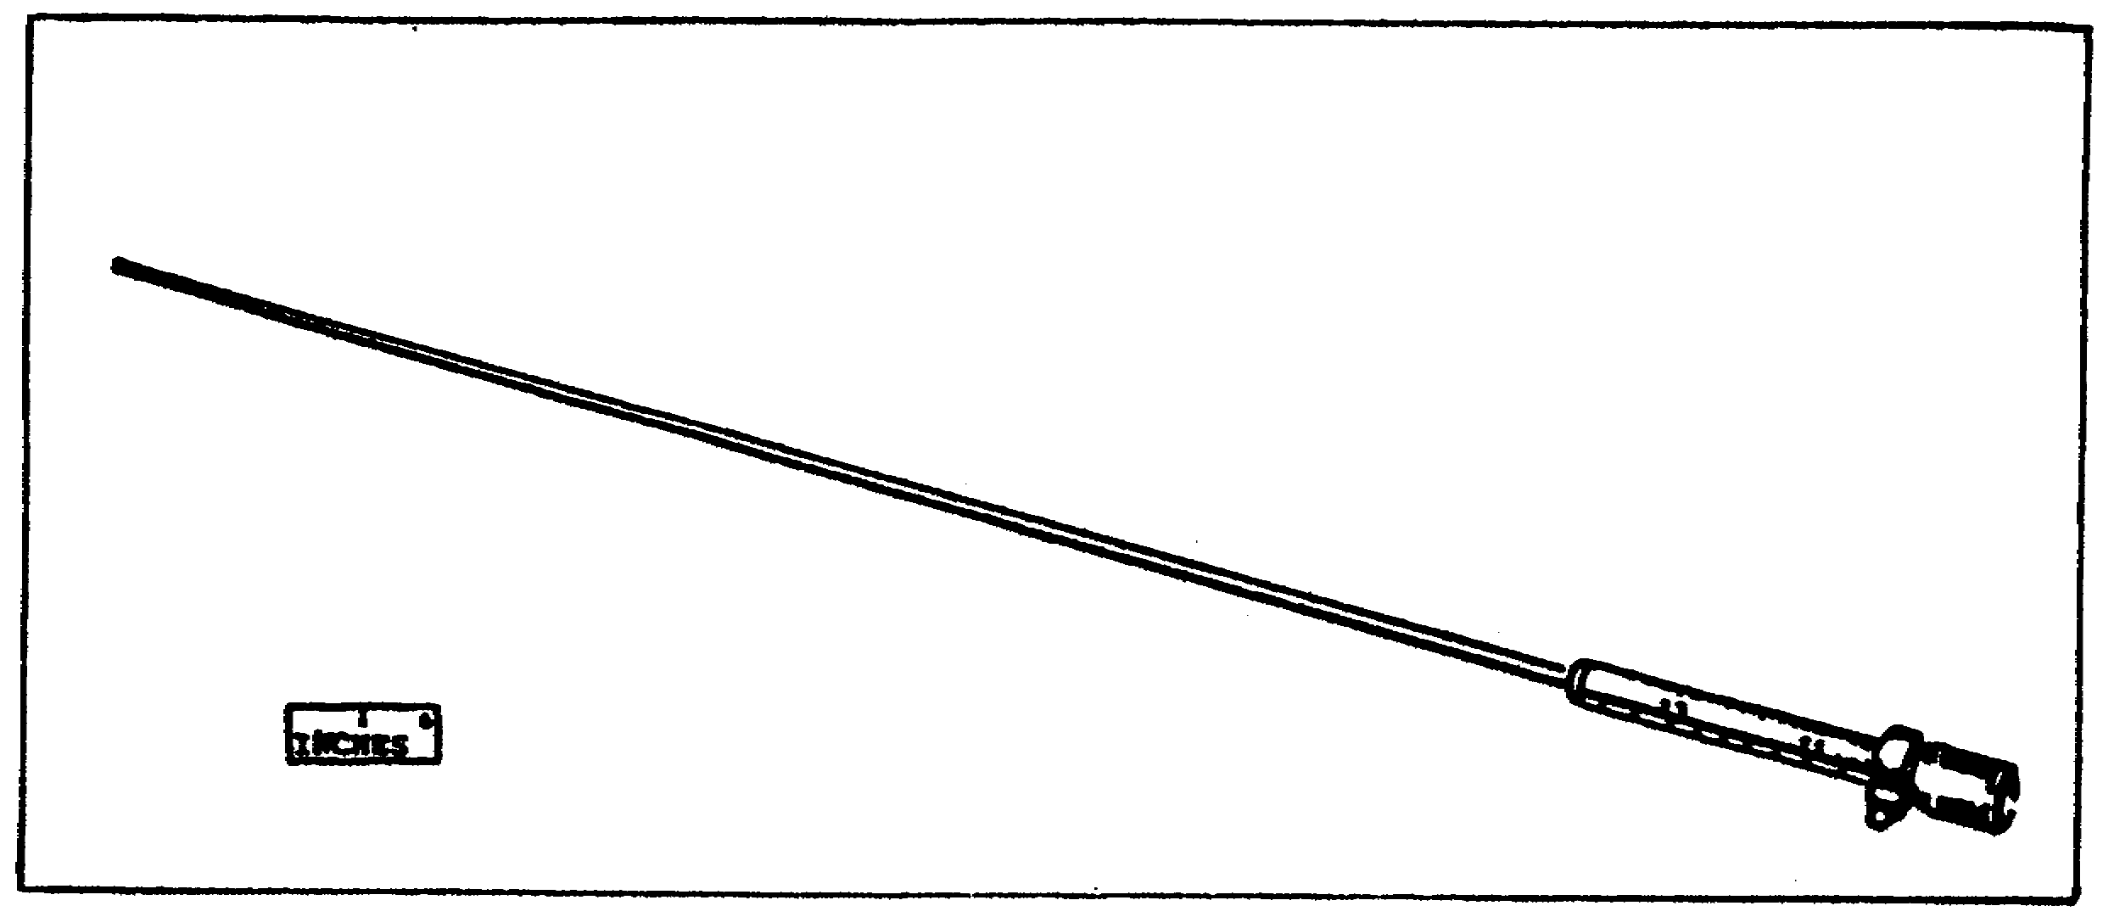

(c) Illuminating Head Assembly. The illuminating heads are furnished in two sizes, one for the 20mm weapons (figure 17 below) and one for the 37mm and 40mm weapons (figure 18 on the following page). These heads contain two mirrors. One mirror bends the optical path so that the bore of the tube in which the borescope is inserted will be viewed. The other mirror reflects the light from the lamp contained in the head of the section of the tube bore being observed. On the 20mm head, the lamp screws into the end of the illuminating head. This is to facilitate removal of the lamp for replacement purposes, The lamp assembly on the 37mm and 40mm illuminating head is secured in the end by a hidden version of the bayonet lock. These head assemblies fit snugly into the borescope tube assembly, which locks in place when fully seated.

FIGURE 17. ILLUMINATING HEAD FOR 20mm GUN.
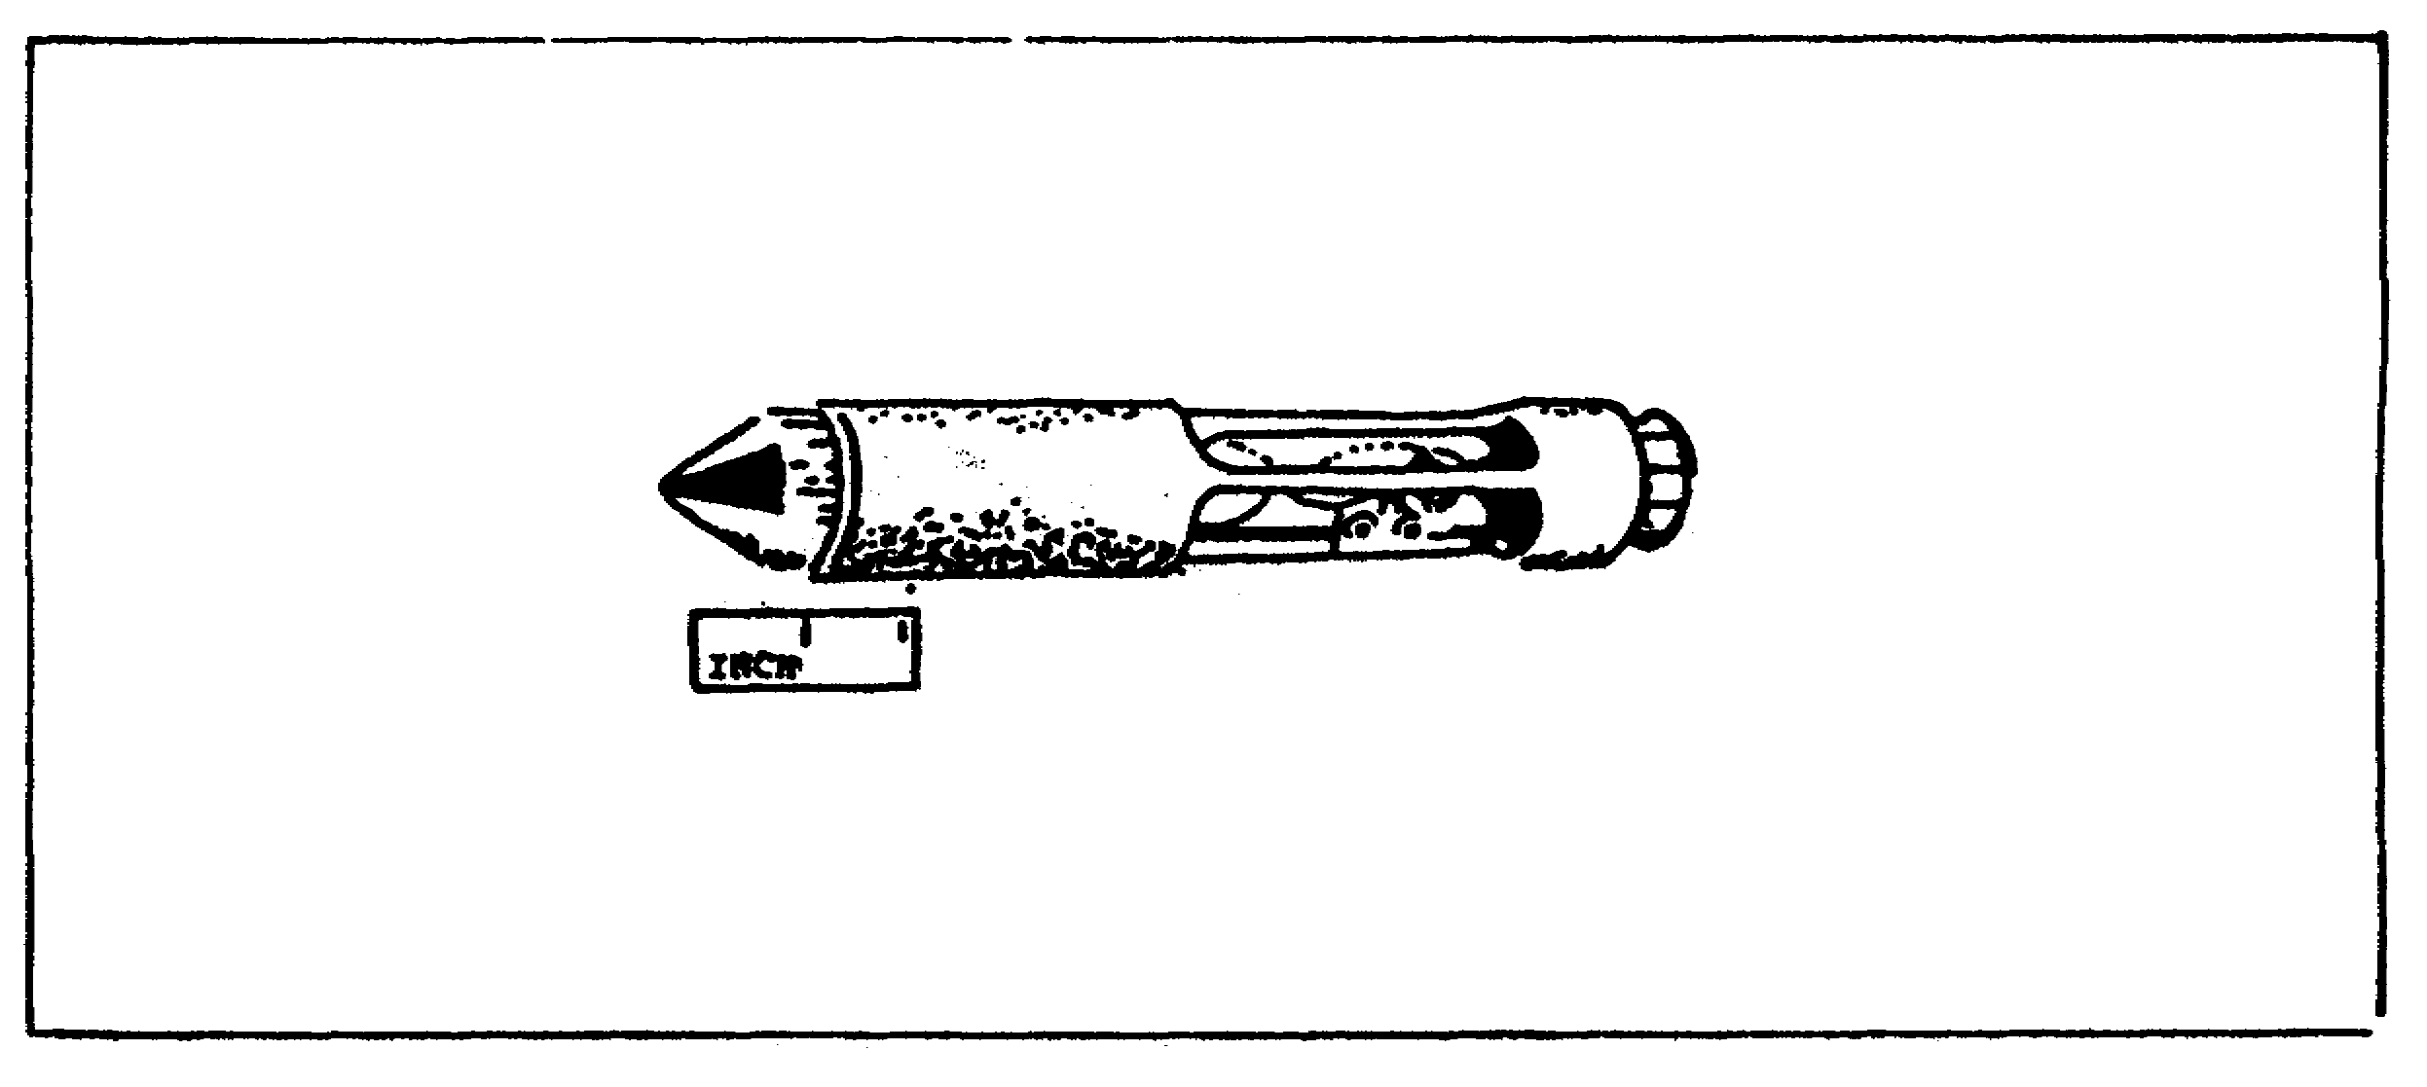

41

CANNON TUBE EVALUATION - OD 0463 - LESSON 3/TASK 1

FIGURE 18. ILLUMINATING HEAD FOR 37mm
AND 40mm WEAPONS.
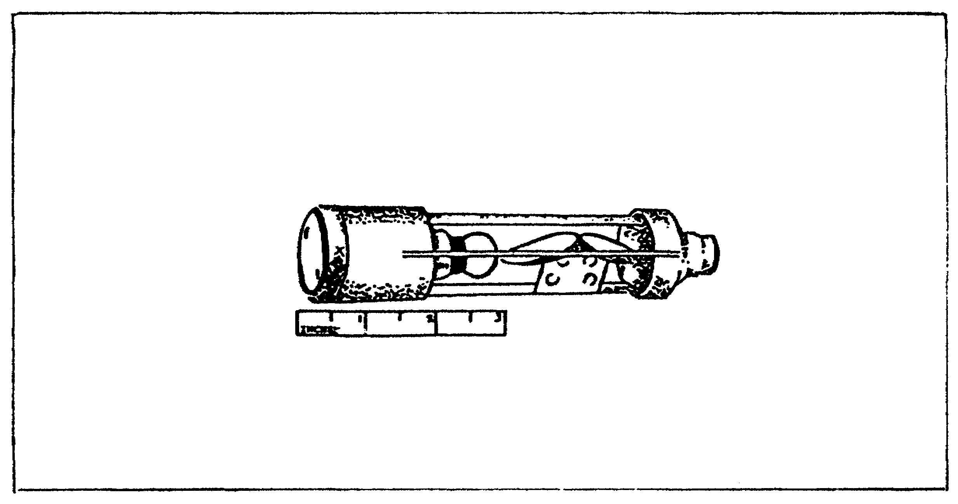

(d) Lighting Transformer Assembly. The lighting transformer assembly (figure 19) is essentially a transformer that converts IO1 volt 60 cycle current to 6.3 volts. The transformer is contained in a housing with required leads and plugs (cord assemblies). One lead is the conventional two-prong type used with 110 volt electrical equipment. The other lead has a connector with a clamping ring. This connector attaches to the collector housing on the borescope.

FIGURE 19. LIGHTING TRANSFORMER ASSEMBLY.
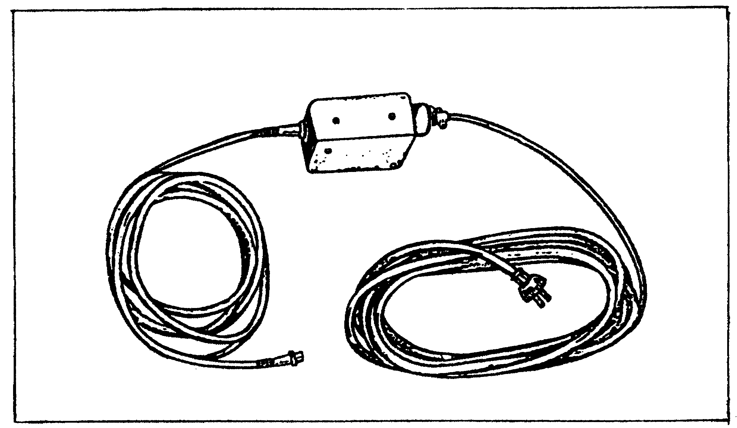

42

CANNON TUBE EVALUATION - OD 0463 - LESSON 3/TASK 1

(e) Accessories.

- Support. Supports (figure 20) are furnished for the 37mm and 40mm weapons. They are essentially collars that are slipped over the borescope and held in place by setscrews. Supports are used to center and balance the borescope in the cannon bore.

FIGURE 20. BORESCOPE SUPPORTS 37mm & 40mm.
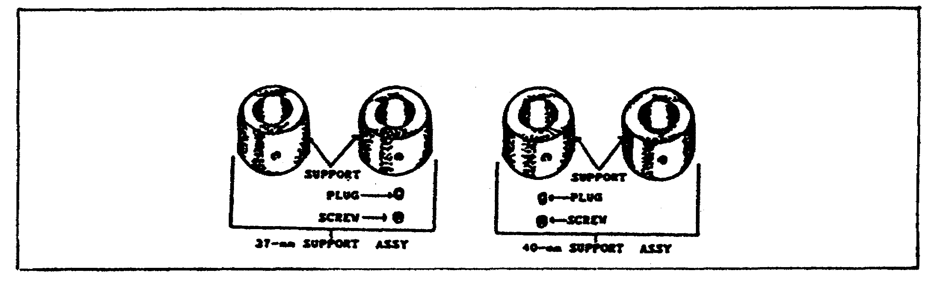

- Stand. Stands (figure 21) are used for supporting the weight of the borescope. They can be adjusted for height and serve the purpose of aligning the borescope with the cannon bore.

FIGURE 21. BORESCOPE STAND.
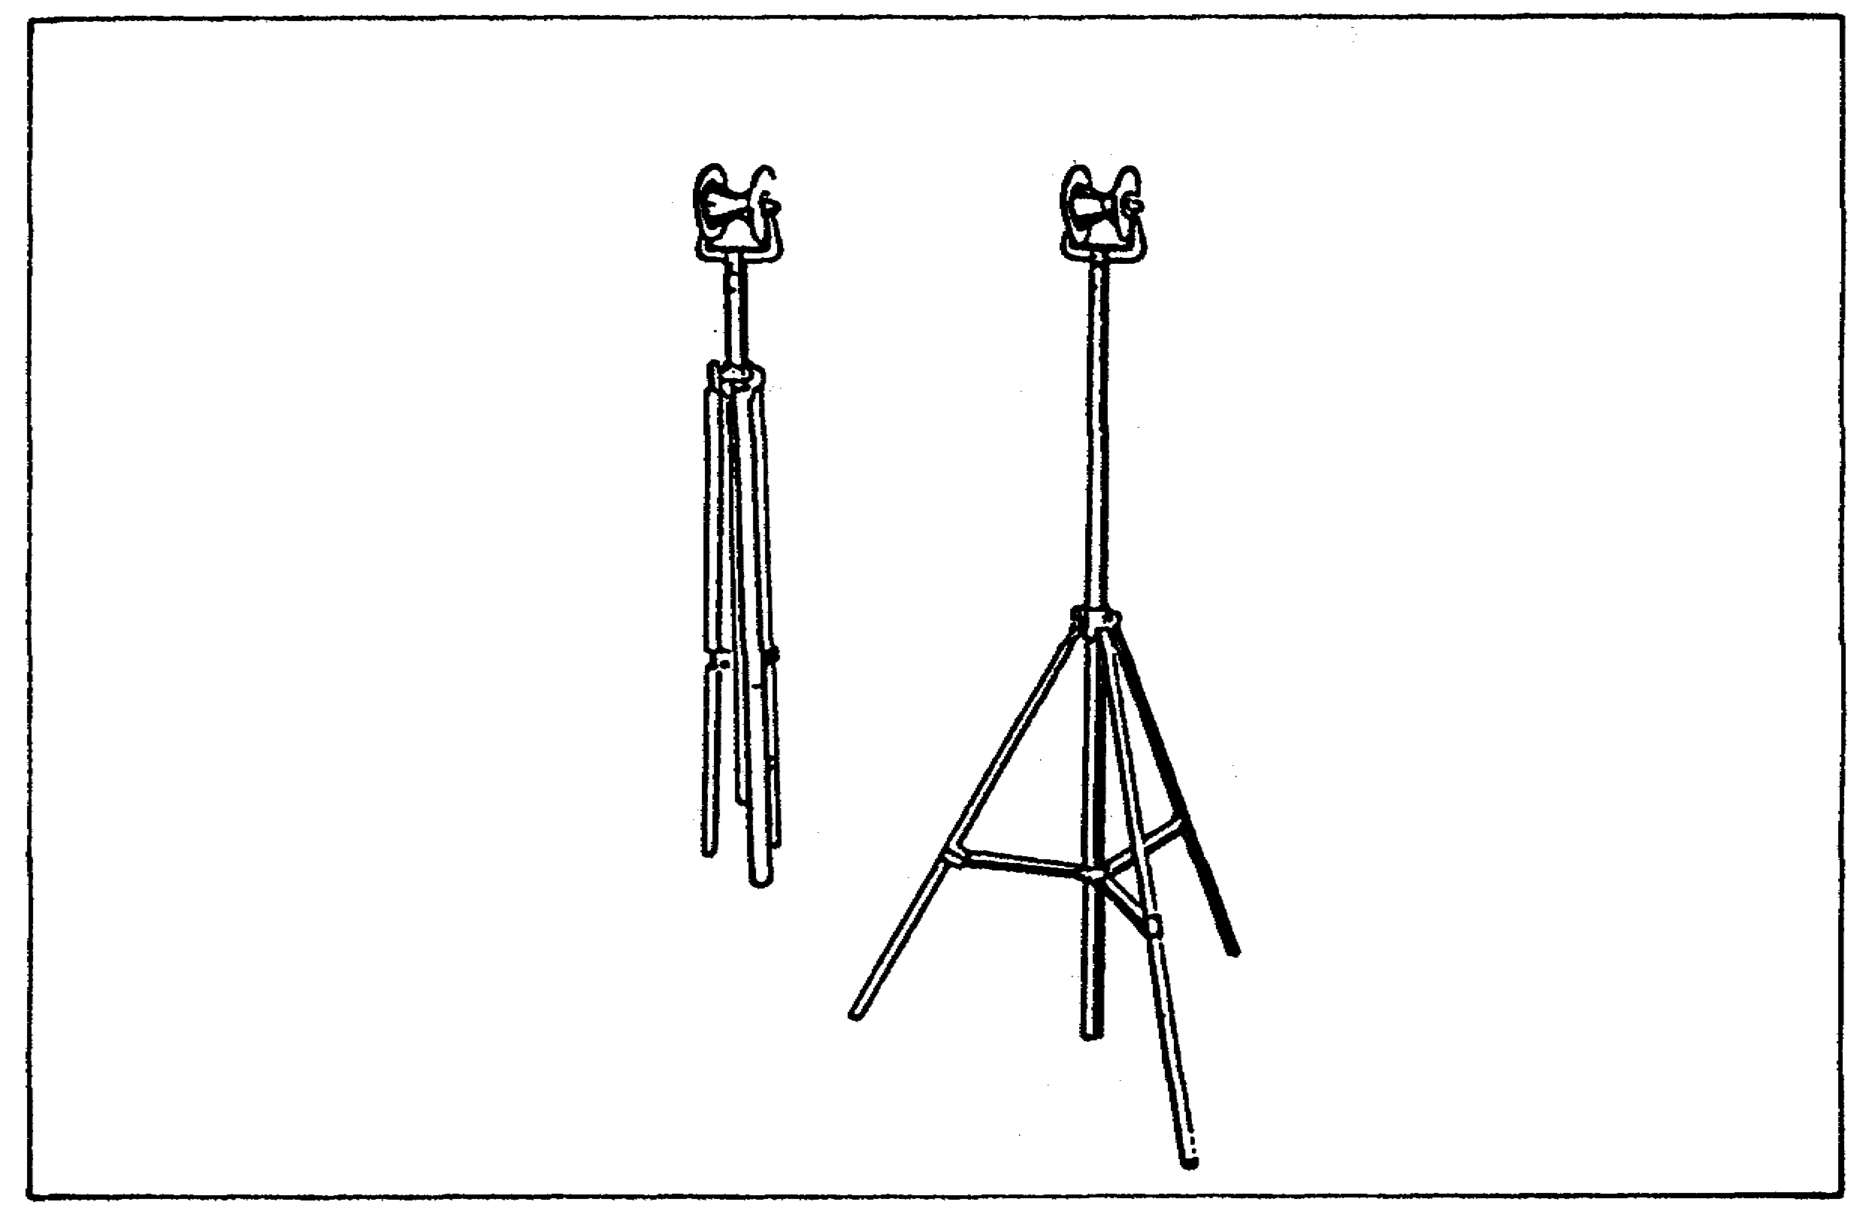

43

CANNON TUBE EVALUATION - OD 0463 - LESSON 3/TASK 1

(2) Borescope M2.

(a) Eyepiece Assembly. This assembly is the same as the eyepiece assembly shown in figure 15. It is interchangeable with the eyepiece assembly of borescope M1.

(b) Adapter Tube Assembly. This assembly (figure 22) connects the eyepiece assembly and extension tubes or objective tube assembly depending on the length of the bore to be inspected. The collector assembly is located on the adapter and provides the electrical connection between the lamp in the illuminating head and the transformer. The adapter is free to revolve in the collector assembly and still maintain electrical connection. The adapter contains the spring-loaded ball detents that secure the eyepiece assembly in place.

FIGURE 22. ADAPTER TUBE ASSEMBLY.
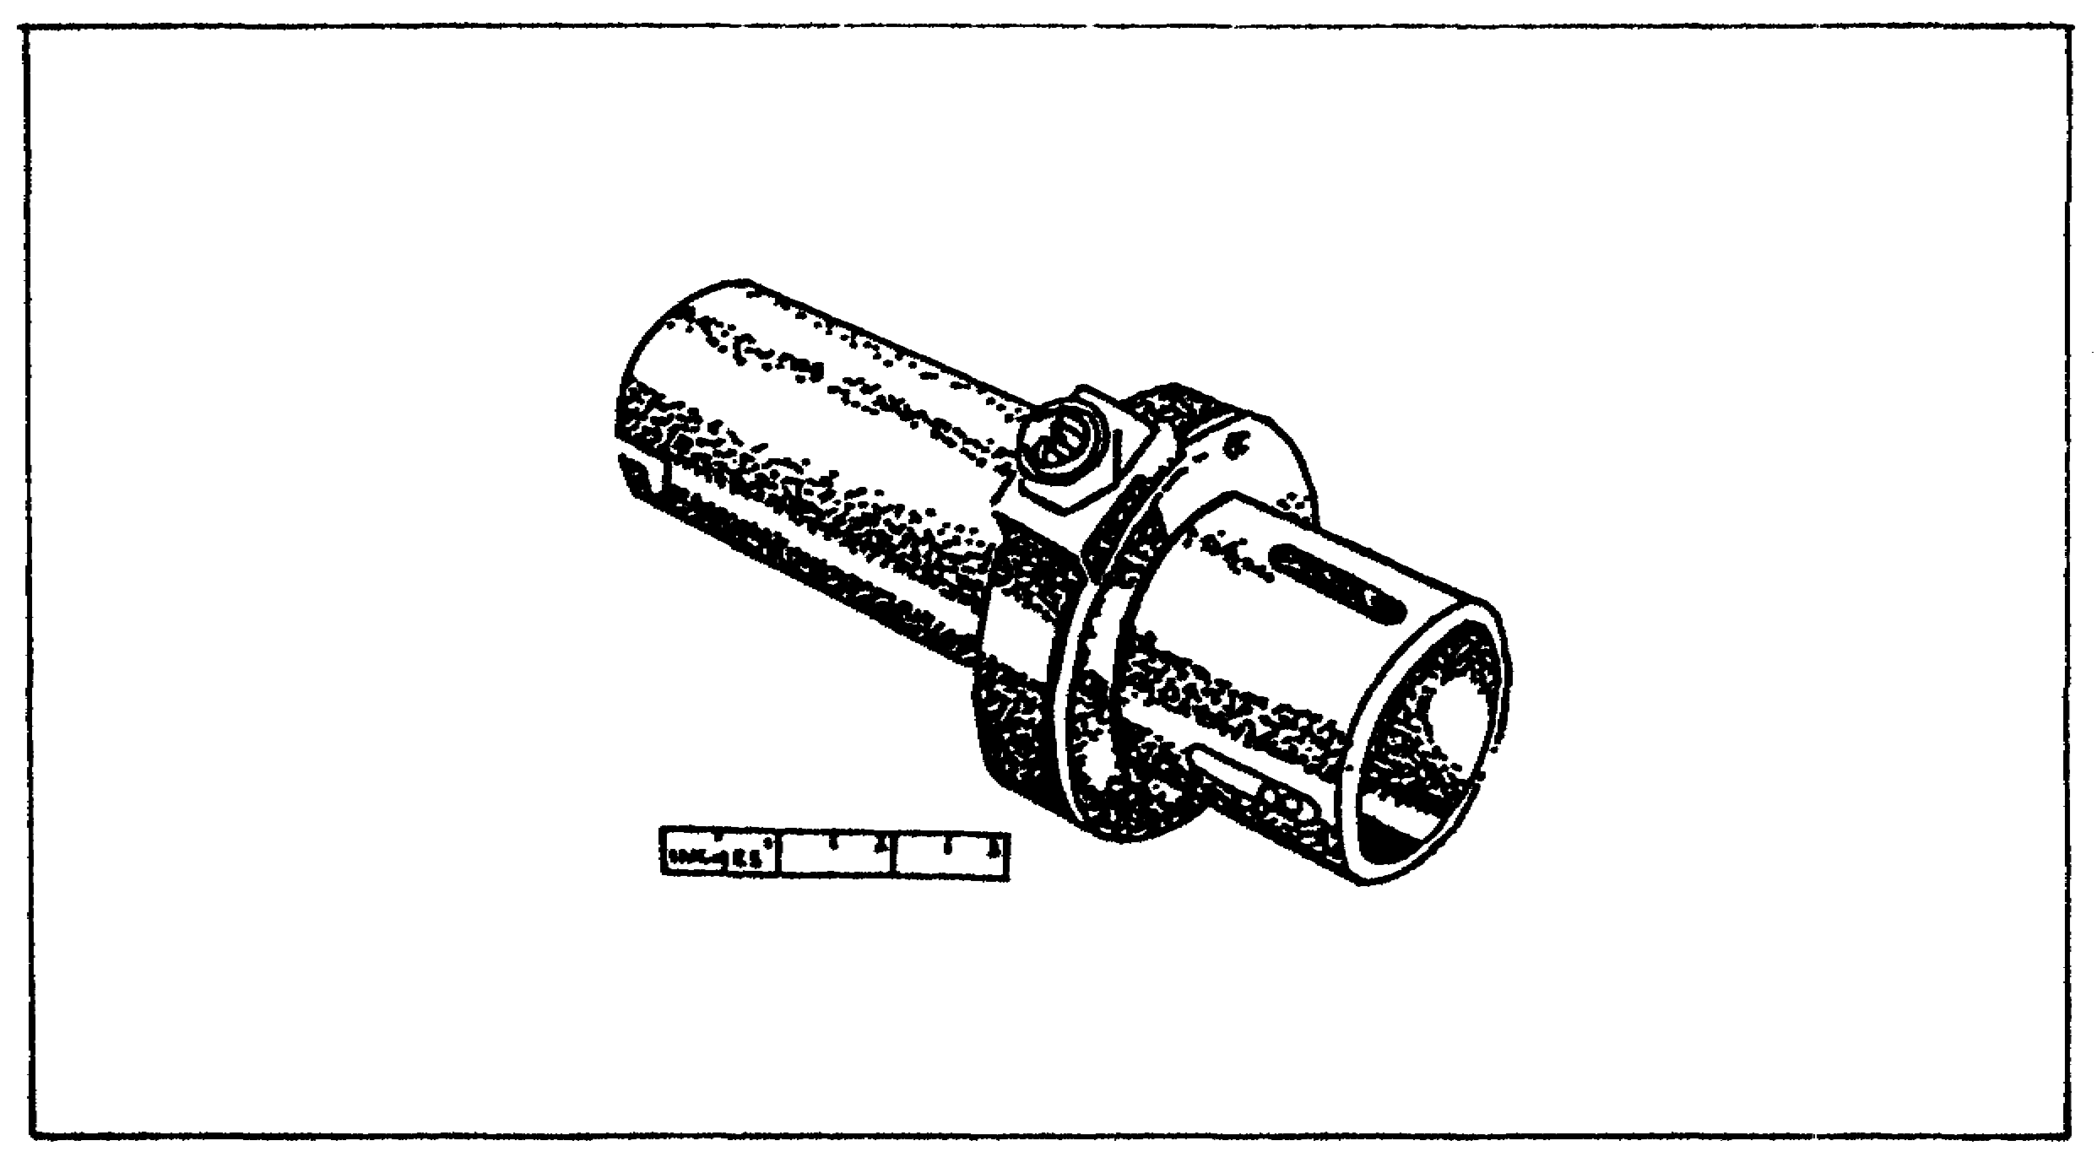

(c) Extension Tube Assembly. Three extension tubes are provided to extend the range of the borescope to cover the various weapon lengths encountered. These tubes permit inspection of all but the largest weapons. The tubes are numbered with Roman numerals (I, II, and III). These tubes relay the view to the operator. They do not magnify. The only difference in the tubes is the graduations on the outside of the barrel. The order of assembly between the objective tube

44

CANNON TUBE EVALUATION - OD 0463 - LESSON 3/TASK 1

assembly and adapter tube assembly is tube I, tube II, and tube III. These tubes have bayonet locks on one end and a spring-loaded sliding latch on the other end. The end with the sliding latch has two pins for locking in the bayonet slots of the next tube, (figure 23).

FIGURE 23. M2 BORESCOPE EXTENSION TUBES.
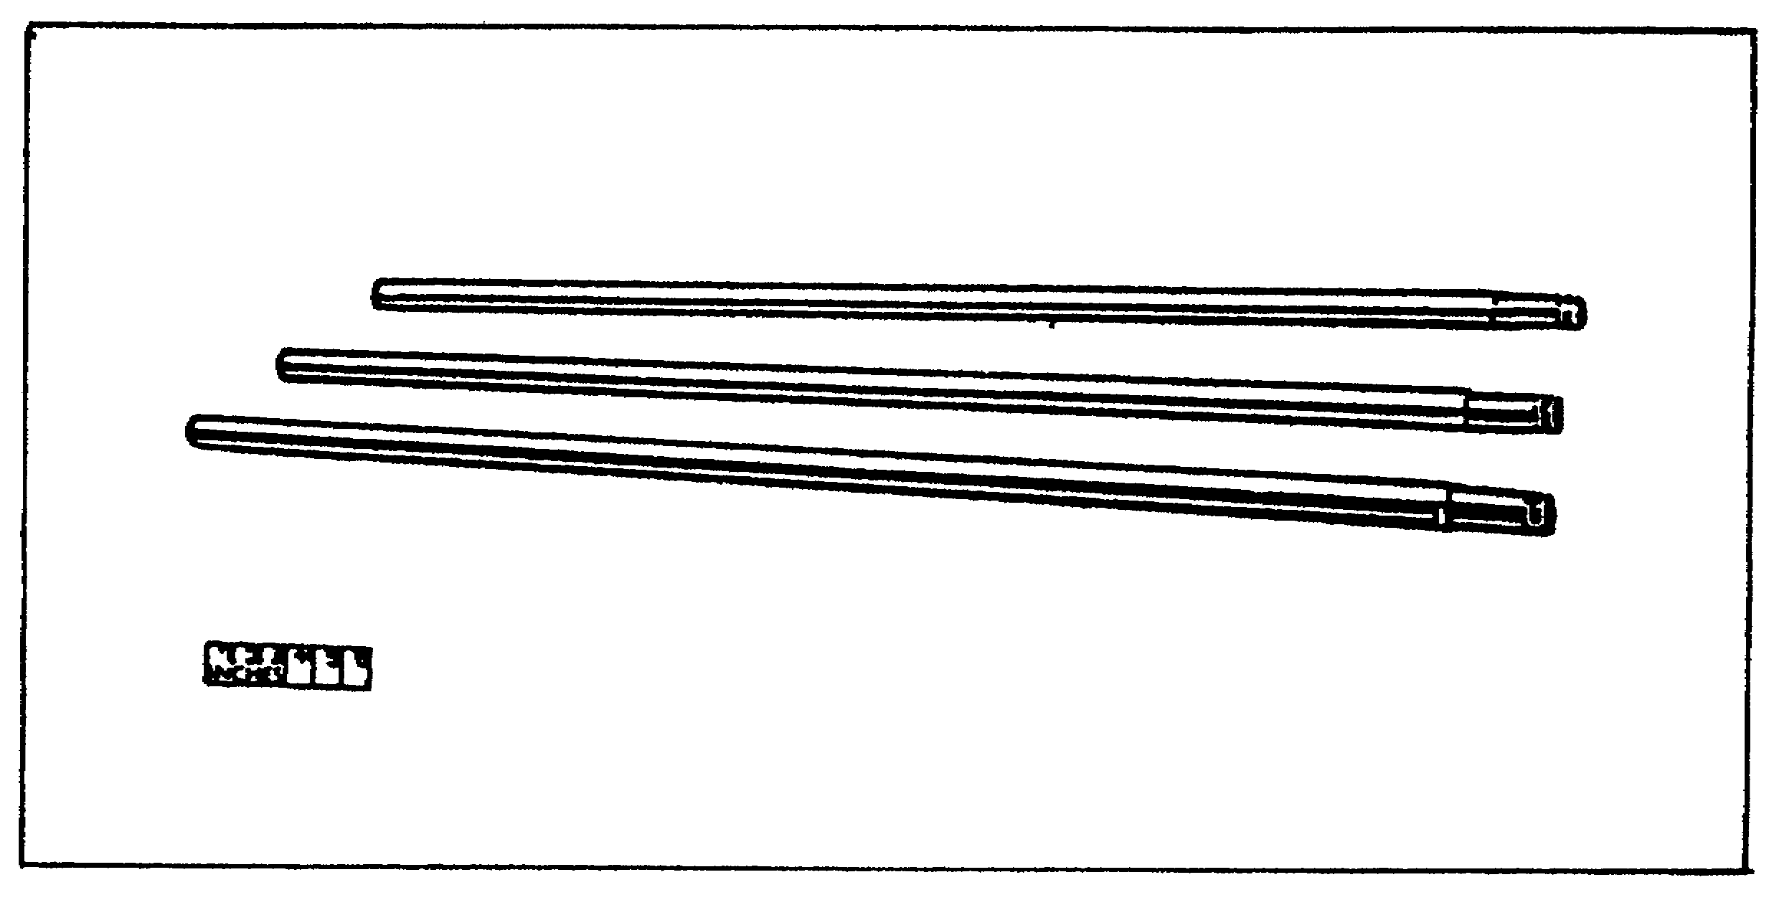

(d) Objective Tube Assembly. The objective tube assembly contains the lenses that focus on the mirror or prism. This tube always connects to the illuminating head for use, and the end that connects to the illuminating head contains two bayonet locks. The opposite end contains a spring-loaded sliding latch. The end with the latch has two pins for locking in the bayonet slots of the next tube. The outside surface of the tube is graduated in 6 inch and 1 foot intervals. The 1 foot lines encircle the tube and are numbered consecutively. The outside surface of the tube is also engraved the full length with a longitudinal line for the purpose of indexing the borescope properly.

(e) Illuminating Head Assembly. The illuminating head assembly is furnished in three sizes.

- Small illuminating head assembly. The head of this assembly has a fixed mirror and is used in weapons from 57mm through 90mm. The end that assembles to the objective tube has a spring-loaded sliding latch, contact rings for lamp power supply,

45

CANNON TUBE EVALUATION - OD 0463 - LESSON 3/TASK 1

and two pins that lock in the bayonet of the objective tube. The mirror is set at a fixed angle. The lamp is of the long tubular type.

- Large Illuminating Head Assembly. The large illuminating head assembly (figure 24) is used in weapons from 105mm through the largest size. The mirror mounts on a wide field of view ranging from a point ahead of the lamp to an area almost at right angles to the tube centerline. The lamp is of the long tubular type.

FIGURE 24. LARGE ILLUMINATING HEAD ASSEMBLY.
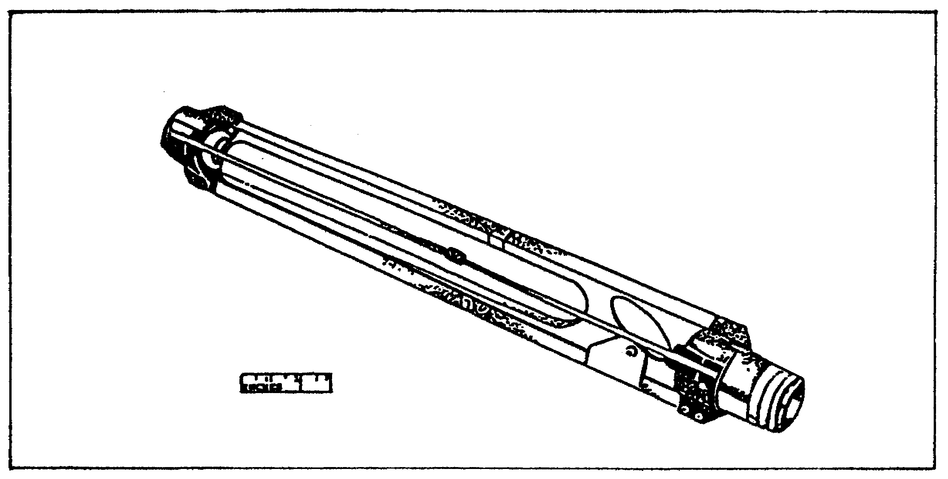

- Prism Illuminating Head Assembly. The prism illuminating head assembly is of a short design to permit the inspection of the bottom of mortar bores. The mirror is a prism mounted on a fixed angle on a mount that serves as a socket for two candelabra-bayonet-base lock lamps.

(f) Power Supply Assembly. The power supply assembly is an isolating transformer. It is contained in a box with the required plugs and leads. This transformer has an output of 110 volts, 60 cycles and serves to isolate the operator from the power source, thereby eliminating the chances for shock. One lead is the conventional two-pronged used in 110 volt electric equipment and incorporates a third wire with an alligator type clamp for grounding purposes. The other lead has a connector with a clamping ring. This connector attaches to the collector housing on the borescope.

46

CANNON TUBE EVALUATION - OD 0463 - LESSON 3/TASK 1

It is also provided with a single pole switch for safety purposes and ease of operation.

(g) Accessories. Four accessories are vital to the operation of the borescope:

- The adapter assembly is issued to adapt the supports to the borescope. The assembly is composed of a split collet with knurled shoulder that is slipped over the borescope tube and is threaded to receive a knurled collar and nut.

- Supports are provided for all types of artillery weapons from 57mm through 280mm. They are available in three types: split-sleeve support for 57mm and 60mm bores; hinged support for 75mm and 81mm bores; and washer support for 90mm through 280mm bores.

- Two reflectors are issued for inspecting the bore of the 280mm weapons.

- Stands are used to center and balance the weight of the borescope. They should be adjustable for height to provide a means of aligning the horoscope with the cannon bore. They should be procured locally.

47

CANNON TUBE EVALUATION - OD 0463 - LESSON 3/TASK 2

LESSON 3

STEPS IN THE USE OF THE BORESCOPE

TASK 2. Describe the correct procedures for operating the borescope.

CONDITIONS

Within a self-study environment and given the subcourse text, without assistance.

STANDARDS

Within one hour

REFERENCES

No supplementary references are needed for this task.

1. Introduction

Properly assembling the borescope is obviously essential to its use. This task contains instructions for the mechanical steps necessary to assemble and operate the borescope.

2. Operation of Borescope M1

a. Assembling Operation. Two stands placed about 4 1/2 feet apart are required to hold the borescope during assembly. The steps necessary to assemble the borescope are described below. See table 12 for the proper illuminating head assembly and number of supports required.

(1) Remove the borescope tube assembly from the case and place it on the stands (figure 25 on the following page).

48

CANNON TUBE EVALUATION - OD 0463 - LESSON 3/TASK 2

FIGURE 25. BORESCOPE TUBE ON STANDS.
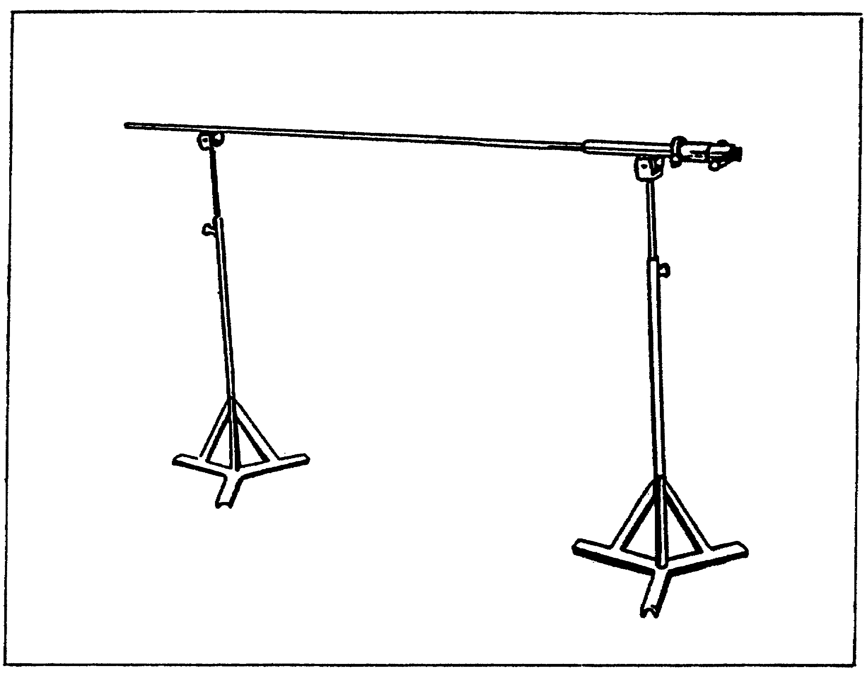

(2) Place a support assembly (figure 26) about 2 feet from the illuminating head end of the borescope tube assembly. Do not secure in place. Place a second support assembly about 3 inches from the illuminating head end of the borescope tube assembly and lightly secure in place. The first assembly will remain near the end of the bore and the borescope will slide through it.

FIGURE 26. SUPPORT INSTALLED ON M1 BORESCOPE.
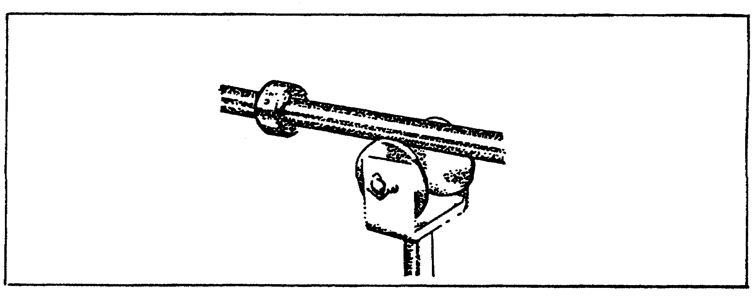

49

CANNON TUBE EVALUATION - OD 0463 - LESSON 3/TASK 2

TABLE 12. ASSEMBLY OF BORESCOPES.

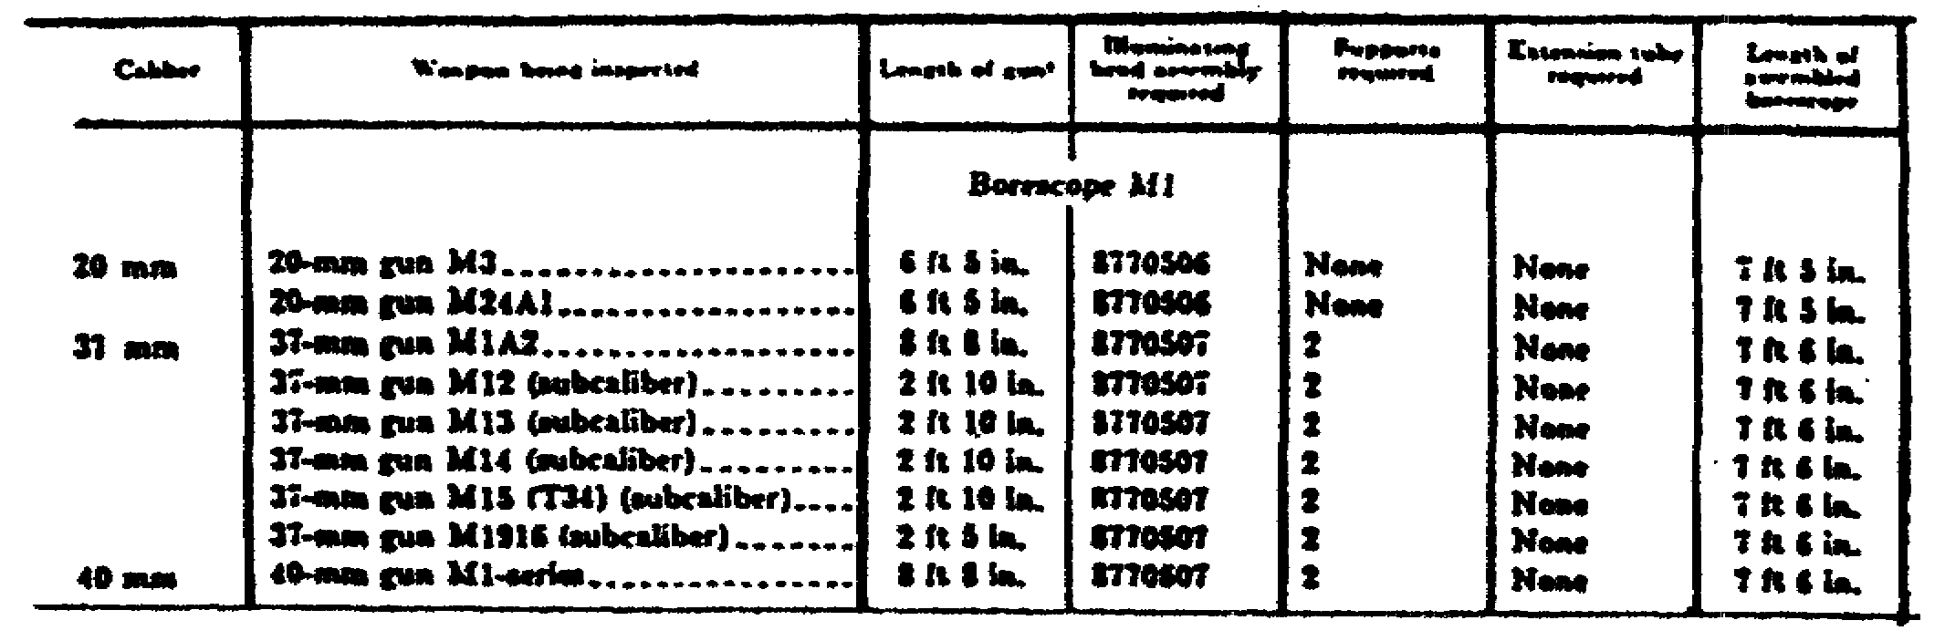

(3) Select the illuminating head assembly required for the weapon from table 12. While holding the borescope tube assembly with one hand, align the mirror of the illuminating head with the reference line on the borescope tube assembly (figure 27) and, with the other hand, firmly push the illuminating head into the borescope tube. The collet end of the illuminating head will snap into place in the borescope tube when the two are properly joined.

FIGURE 27. INSTALLING ILLUMINATING HEAD ASSEMBLY.
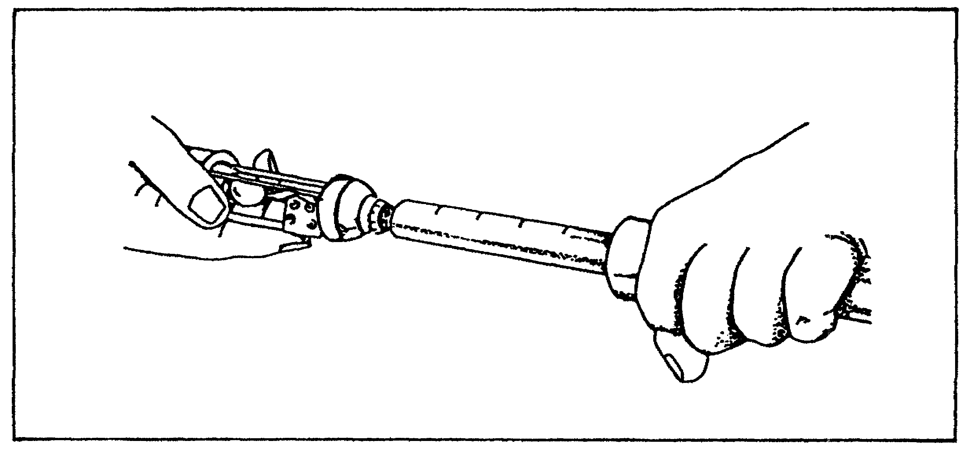

(4) Hold the borescope tube assembly with one hand and insert the eyepiece assembly into the borescope tube assembly until the ball detents are heard to snap in the groove (figure 28).

50

CANNON TUBE EVALUATION - OD 0463 - LESSON 3/TASK 2

FIGURE 28. INSTALLING EYEPIECE ASSEMBLY.
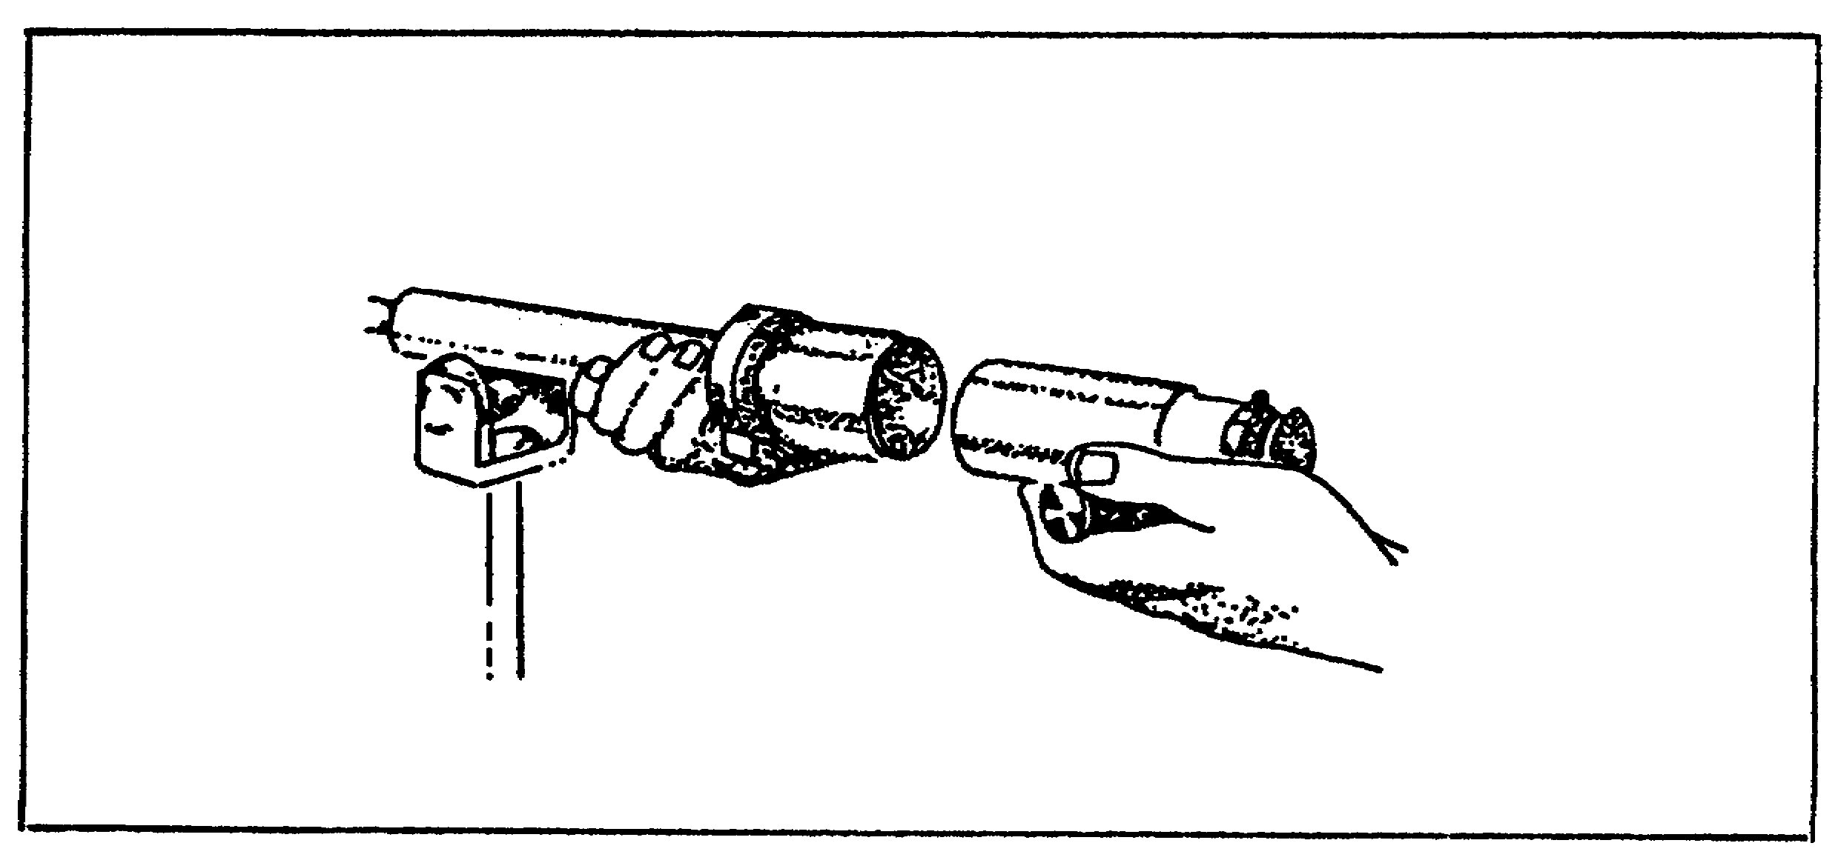

(5) Connect the transformer cord (with a knurled clamping ring) to the collector assembly. Secure the clamping ring finger tight: do not force or use pliers. Insert the remaining transformer cord on the electrical outlet supplying 110 volt 60 cycle current.

(6) Wipe all exposed surfaces clean: the outside surface of the tubes, the outside of the contact ring ends, and the inside of the connecting ends. Clean only the exposed lenses with lens tissue. Do not apply oil to any surface.

b. Inserting Borescope in Cannon Tube. Place the stands in line with the bore to be inspected and at a height to properly center the borescope in the bore. With the borescope resting on the stands, carefully insert it into the bore. Place the rearmost support in the end of the bore. Focus eyepiece and lock in place (figure 29). As the bore is examined, revolve the borescope to get complete coverage. After a complete revolution of the borescope, move it in about 3/4 inch and repeat the examination.

51

CANNON TUBE EVALUATION - OD 0463 - LESSON 3/TASK 2

FIGURE 29. FOCUSING EYEPIECE AND LOCKING FOCUS.
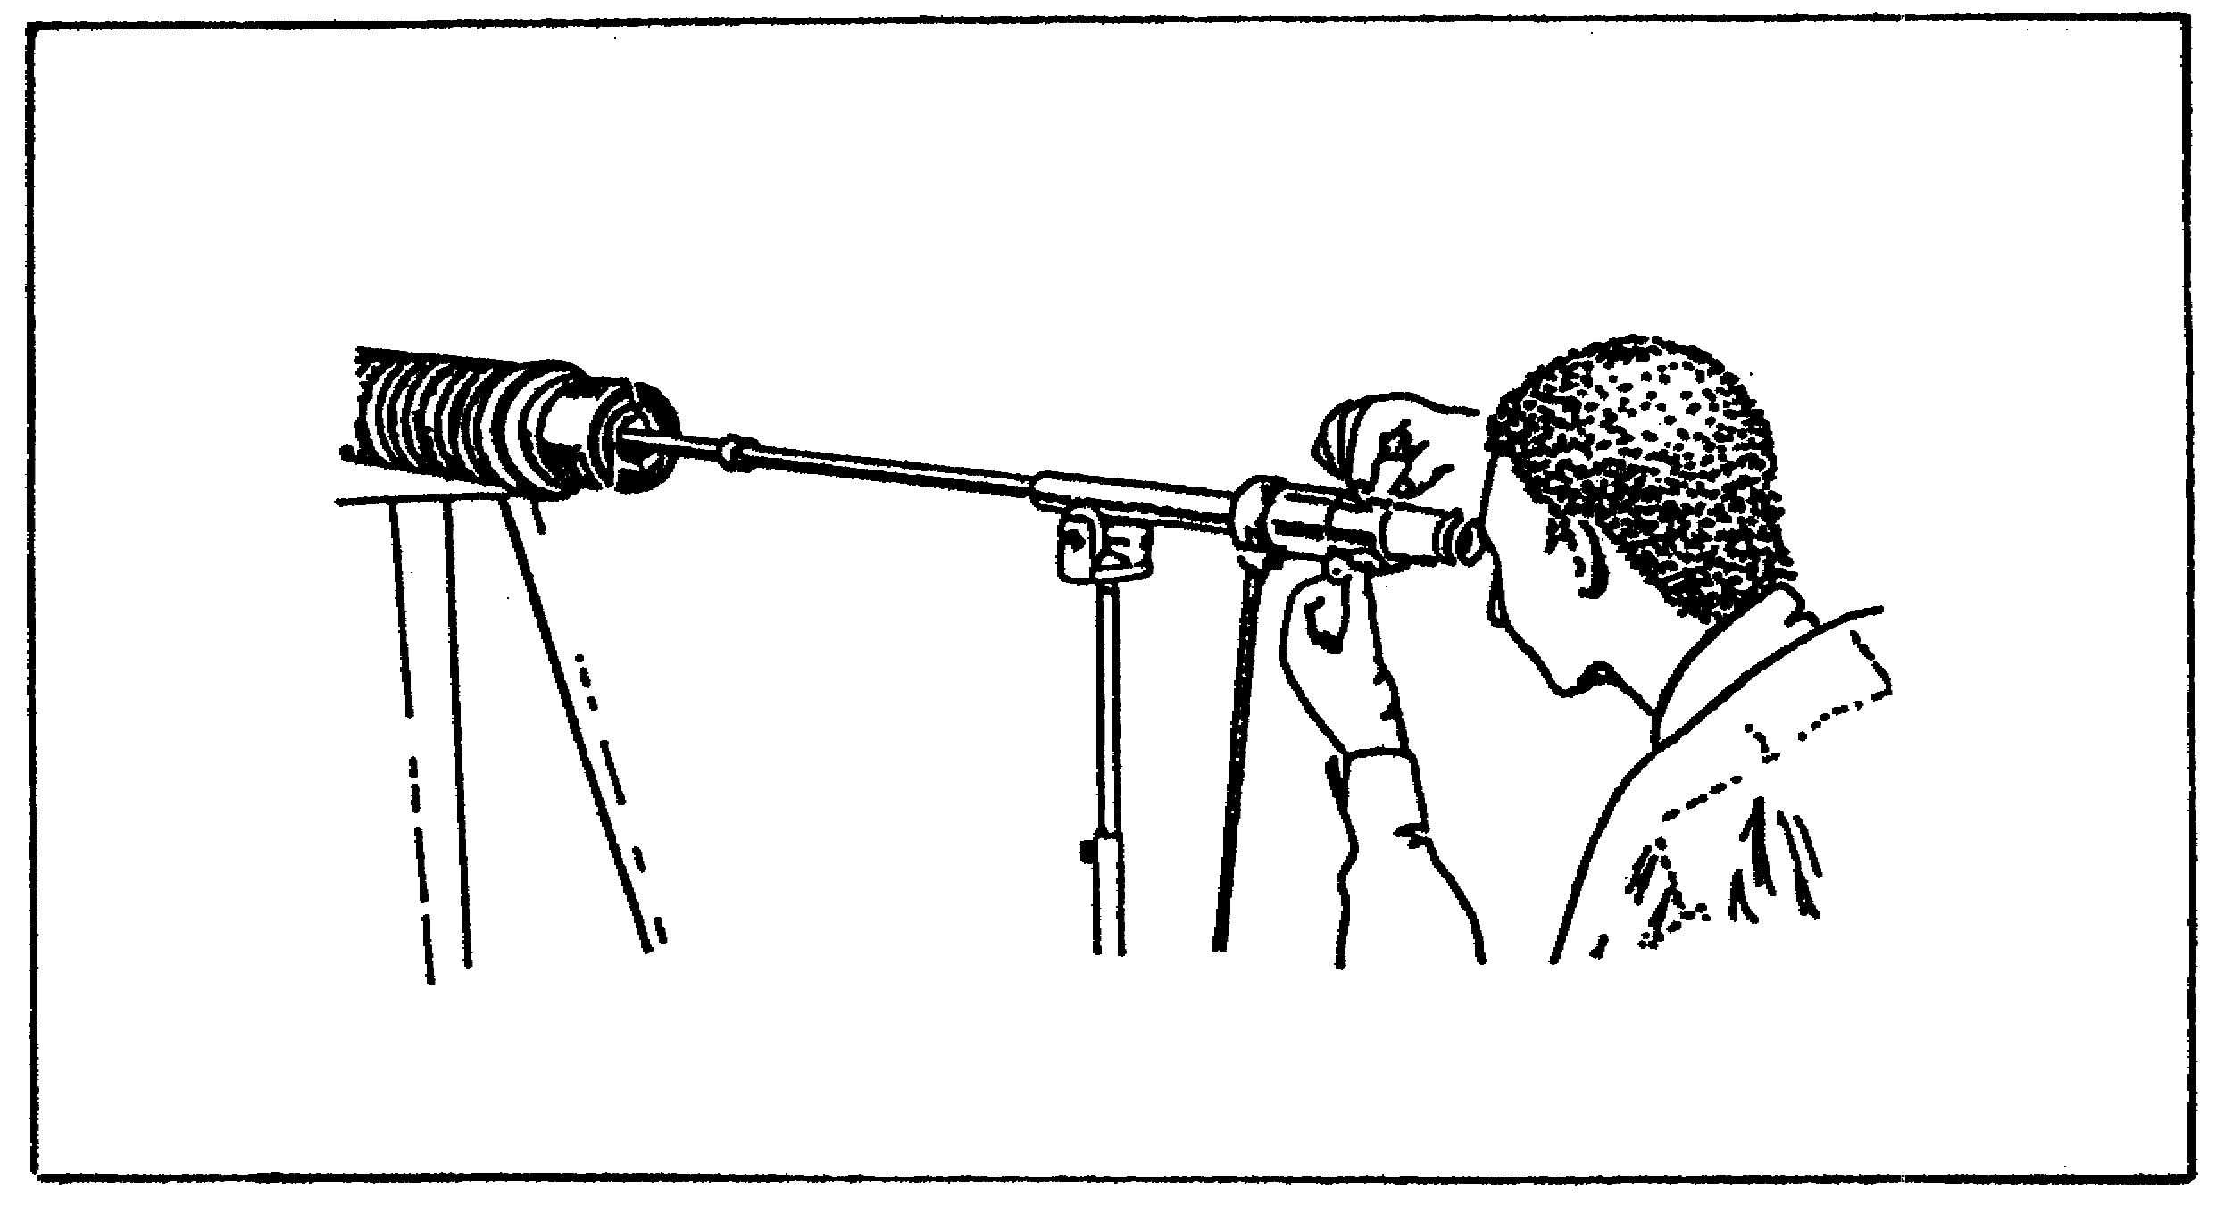

3. Operation of Borescope M2

Successful operation of the borescope requires several assembly steps, culminating with inserting the borescope into the cannontube. These are discussed next.

a. Assembling Operation. The assembly of the borescope requires a minimum of two stands, placed 4 1/2 feet apart, for the basic borescope (assembly without extension tubes). An additional stand is required for each extension tube. The steps necessary to assemble the borescope are below. See table 13 for correct illuminating head assembly and number of supports required.

(1) Remove the objective tube assembly from the case and place it on the stands.

(2) Slide two support assemblies over the objective tube. Clamp one about 6 inches from the illuminating head end and the other about one foot from the opposite end.

(3) Refer to table 13 to determine whether extension tubes are required. (The number of extension tubes required depends upon the weapon being inspected.) One support must be assembled to each extension tube at about the midpoint (figure 30 on the following page).

52

CANNON TUBE EVALUATION - OD 0463 - LESSON 3/TASK 2

FIGURE 30. EXTENSION TUBE INSTALLED AS BORESCOPE
ENTERS CANNON BORE.
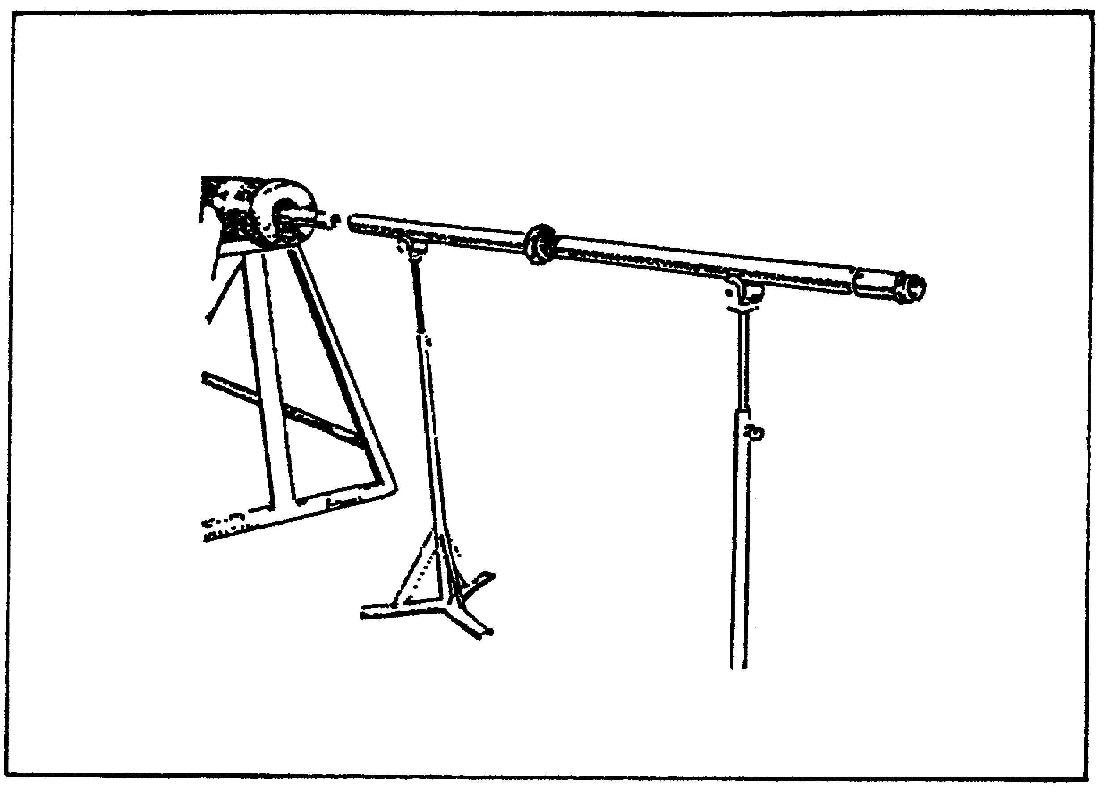

(4) When assembling extension tubes, align the engraved center lines and push each bayonet lock on the pins of the mating part; while, at the same time, firmly turning the tube so that the pins follow the shape of the bayonet lock slot. When the pins are seated, the spring-loaded latch will snap in place.

(5) Consult table 13 for correct illuminating head assembly for weapon being inspected. Assemble the illuminating head to the objective tube in the same manner as the extension tubes are assembled.

(6) Hold the adapter tube assembly with one hand and slide the eyepiece assembly into the adapter tube assembly until the ball detents are heard to seat in the groove (figure 31).

(7) Attach the adapter tube assembly and eyepiece assembly to the objective tube or extension tube.

53

CANNON TUBE EVALUATION - OD 0463 - LESSON 3/TASK 2

TABLE 13. ASSEMBLY OF BORESCOPES.

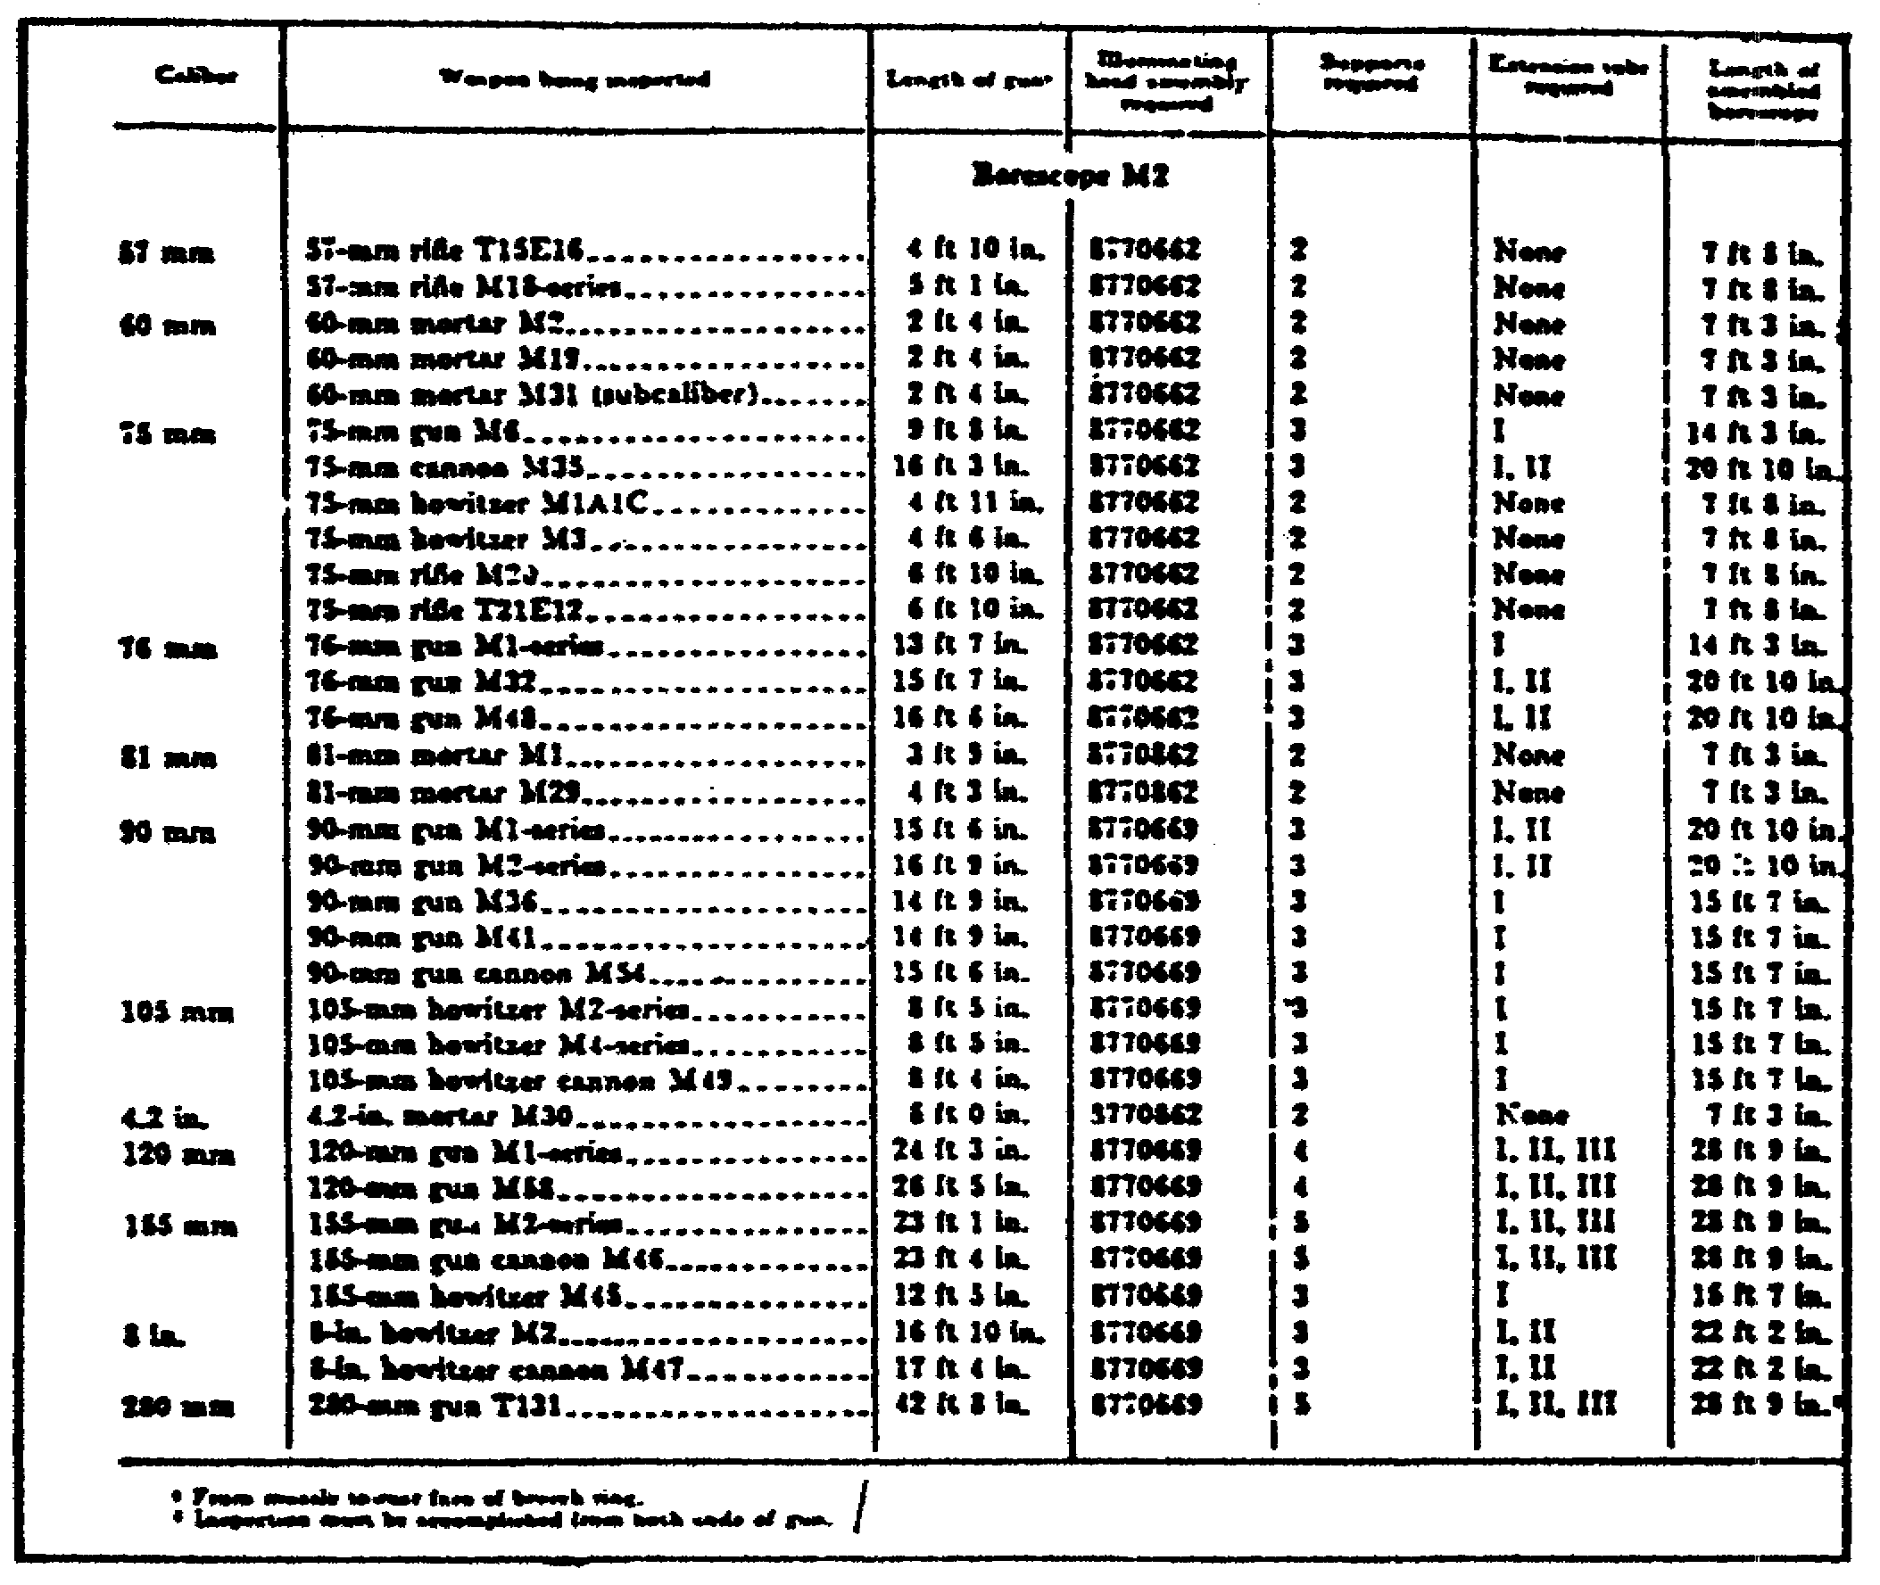

(8) Connect the transformer cord (the one with the knurled clamping ring) to the collector housing. Secure the clamping ring finger tight. Do not force or use pliers. Connect the remaining cord in an electrical outlet supplying 110 volt 60 cycle current. Secure alligator clip to the outlet box or metal conduit.

(9) Wipe all exposed surfaces clean, the outside surface of the tubes, the outside of the contact ring ends, and the inside of the connecting ends. Clean only the exposed lenses with lens tissue. Do not apply oil to any surface.

54
CANNON TUBE EVALUATION - OD 0463 - LESSON 3/TASK 2

FIGURE 31. INSTALLING EYEPIECE ASSEMBLY ON
ADAPTER TUBE ASSEMBLY.
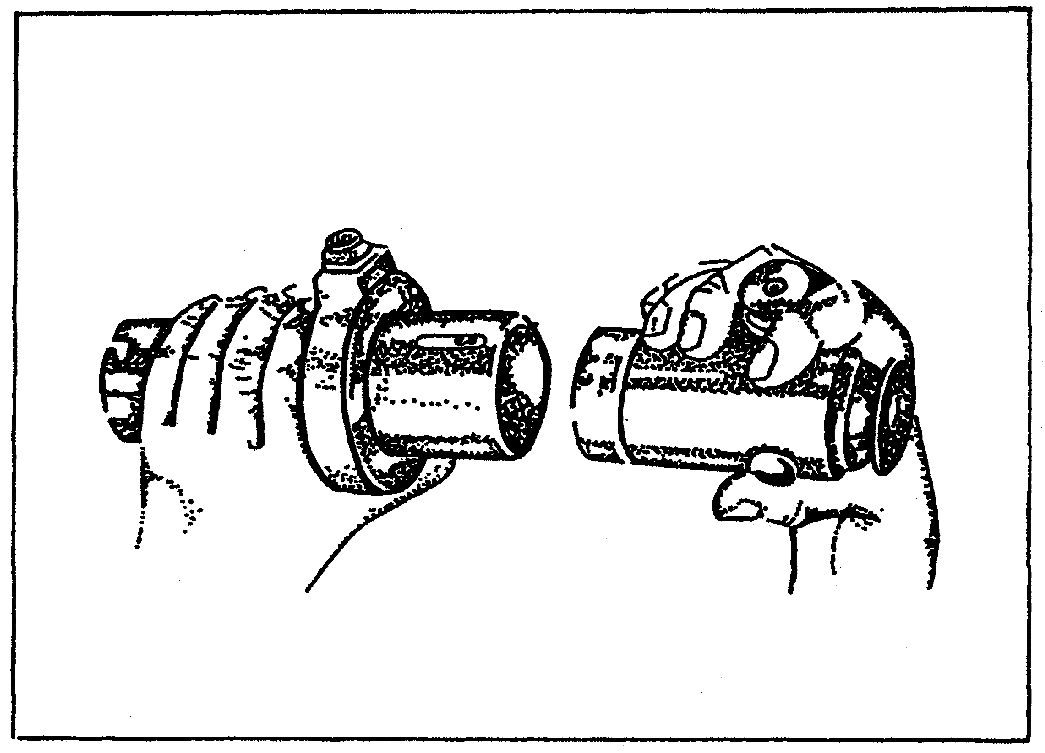

b. Inserting Borescope in Cannon Tube. Place the required stands in line with the bore to be inspected and at a height to properly center the borescope in the bore. With the borescope carefully resting on the stands, insert it into the bore (figure 32 on the following page). Locate the support(s) on the borescope during inspection of the bore, as required. As the bore is examined, revolve the borescope to get complete coverage. After a complete revolution of the borescope, move it in about 3/4 inch and repeat the examination.

55

CANNON TUBE EVALUATION - OD 0463 - LESSON 3/TASK 2

FIGURE 32. M2 BORESCOPE READY FOR INSPECTING
90mm CANNON.
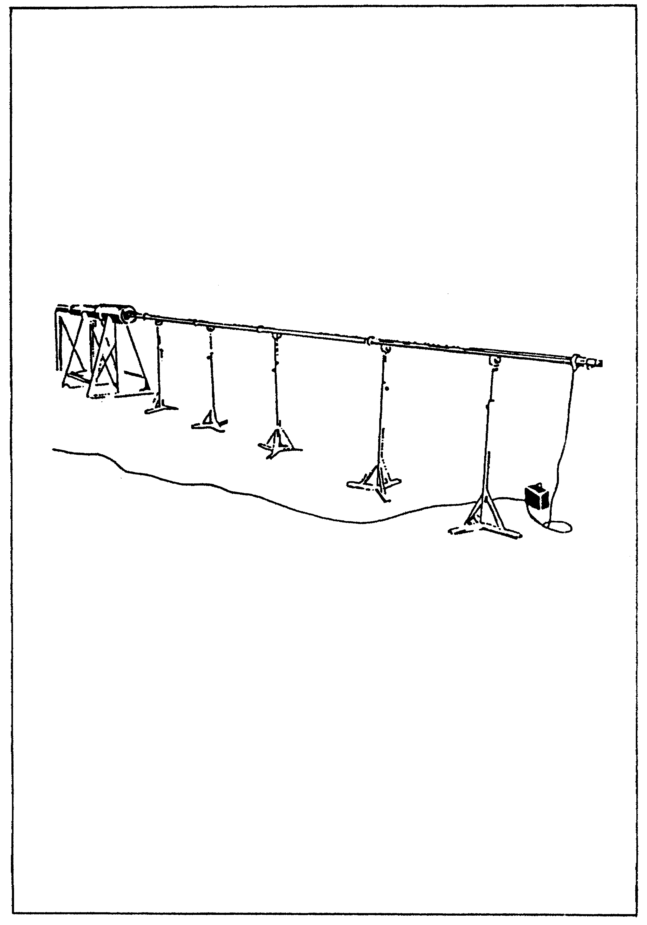

56
CANNON TUBE EVALUATION - OD 0463 - LESSON 3/TASK 3

LESSON 3

STEPS IN THE USE OF THE BORESCOPE

TASK 3. Interpret borescope views, given specific conditions of the tube.

CONDITIONS

Within a self-study environment and given the subcourse text, without assistance.

STANDARDS

Within thirty minutes

REFERENCES

No supplementary references are needed for this task.

1. Introduction

Following the initial setup and insertion of the borescope, it is vitally important that the user be able to properly interpret the borescope views. The knowledge gained in lesson 1 regarding cracks, rifling lands, deformation of lands, erosion, etc., should be applied to clarify the views when using the borescope. Also, refer to TM 9-1000-202-14, paragraph 9-3 for photographic views of various tube damage.

2. Interpretation of Borescope Views

a. Borescope M1. The bore of this weapon, as seen through a borescope, is usually not life size. Due to the various size bores to be inspected and the design of the borescope, the magnification of the viewed area varies. See table 14 to determine the approximate magnification to be encountered in each weapon.

57

CANNON TUBE EVALUATION - OD 0463 - LESSON 3/TASK 3

b. Borescope M2. A similar condition prevails with the borescope M2 as it does with borescope M1. Refer to table 14 for explanation and correction factors.

NOTE

When using the borescope M2 without the extension tubes, or with two extension tubes, the image appears to be on the opposite side of the tube from its actual position. Allowance must be made for this condition when expressing the position of the image.

TABLE 14. BORE MAGNIFICATION.

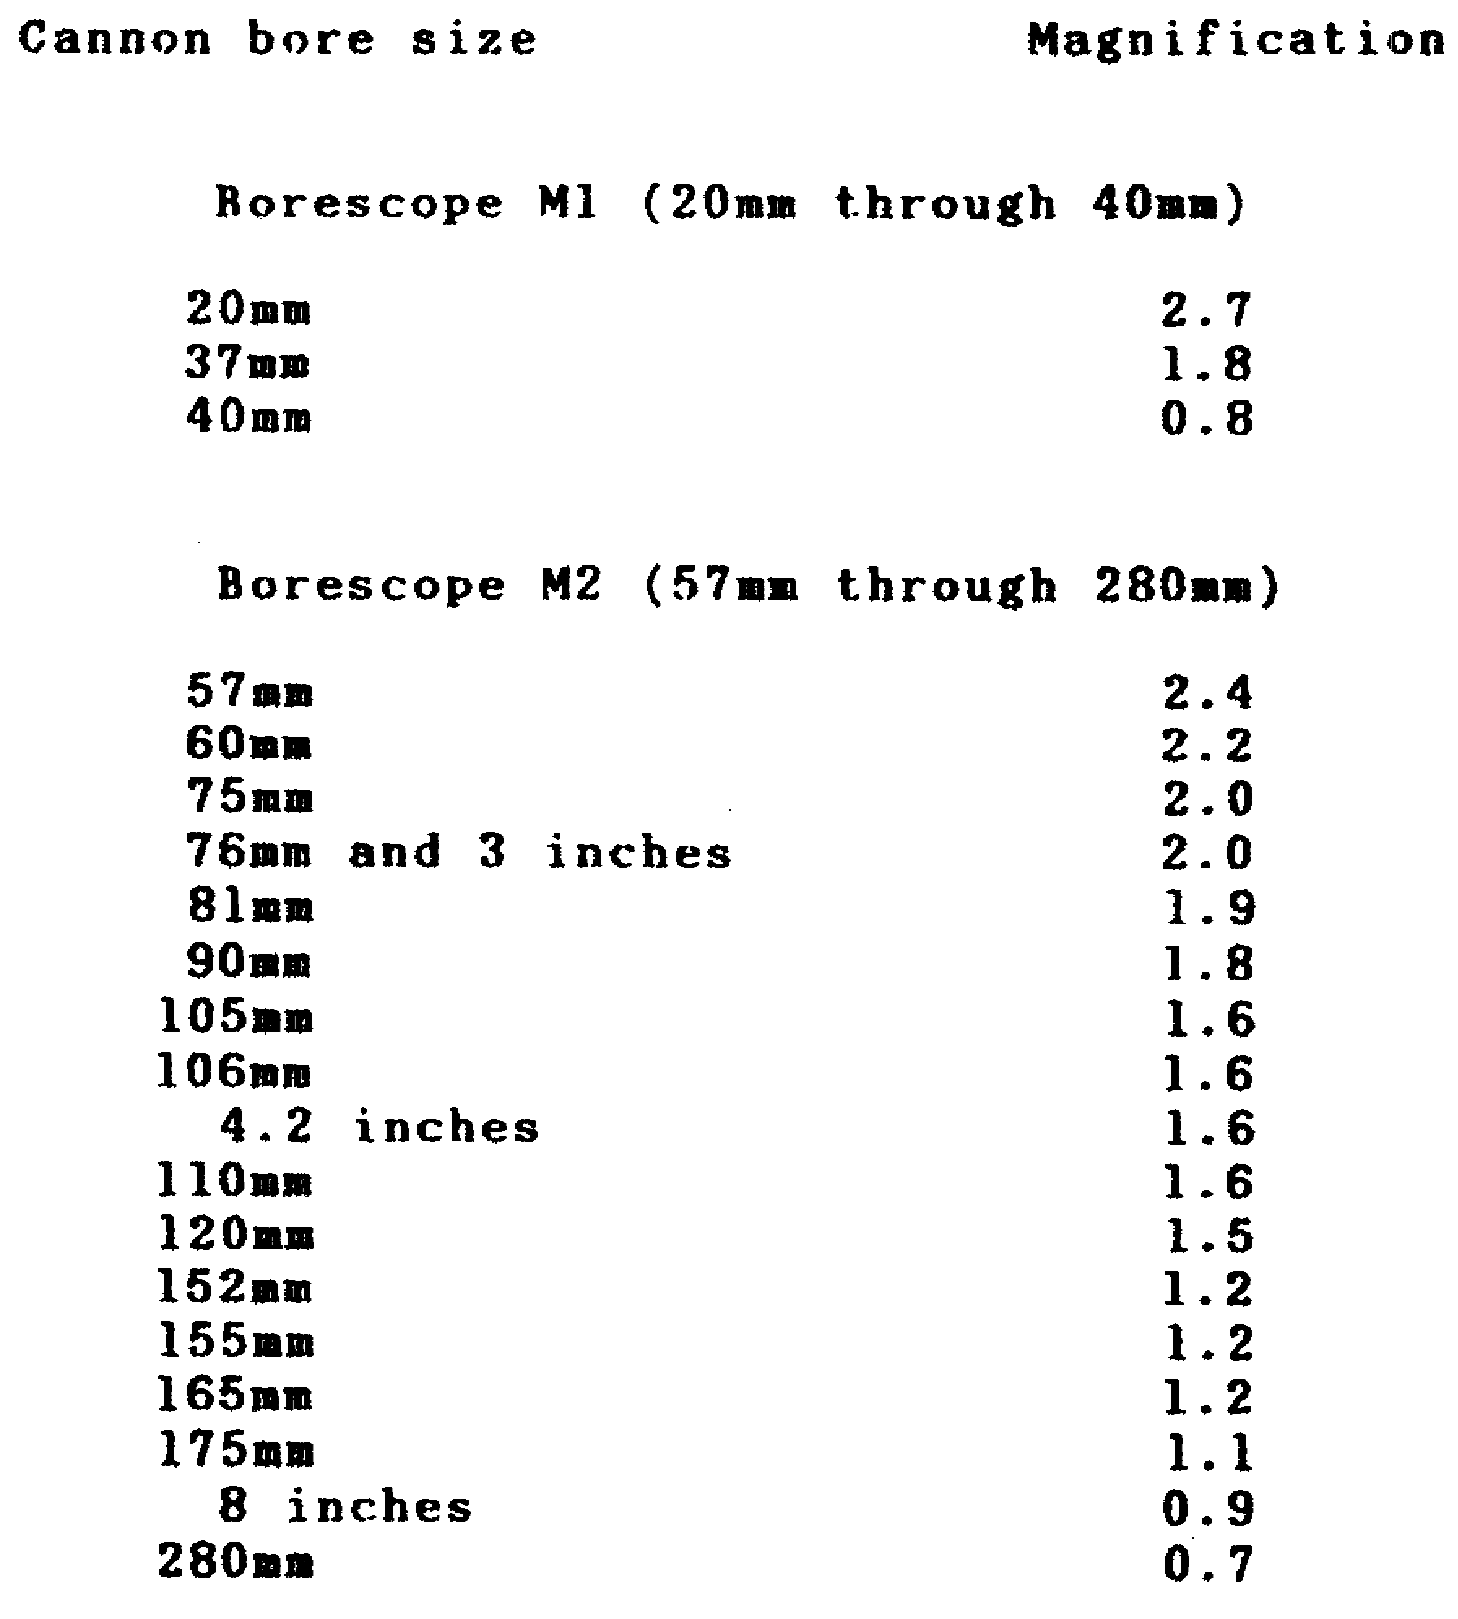

58

CANNON TUBE EVALUATION - OD 0463 - LESSON 3/PE 3

PRACTICAL EXERCISE 3

Instructions

On a plain sheet of paper, write down the answers to the following questions. When you have answered them, turn the page and check your answers.

(1) Cracks and bulges in the bore are 2 forms of erosion the borescope can be used to find. What are the other forms of erosion?

(2) What level(s) of maintenance is/are authorized to use the borescope?

(3) Name which borescope component(s) is/are located on the viewing end of the instrument.

(4) The borescope main tube assembly is graduated in what length intervals?

(5) Describe what function is performed by the lighting transformer assembly.

(6) The M2 borescope utilizes an objective tube assembly. Name the primary parts that are housed in this assembly.

(7) Name the four accessories that are vital to the operation of the borescope.

(8) When assembling the borescope, is it necessary to secure in place suitable support assemblies?

(9) After the borescope is in the cannon tube, how is complete coverage achieved?

(10) What table is used for borescope magnification interpretation?

59

CANNON TUBE EVALUATION - OD 0463 - LESSON 3/PE 3

LESSON 3. PRACTICAL EXERCISE - ANSWERS

(1) Damaged rifling and constrictions.

(2) Intermediate Direct Support/Intermediate General Support (IDS/IGS).

(3) Eyepiece assembly.

(4) 1 inch.

(5) Converts 110 volts into 6.3 volts.

(6) Lenses that focus on a mirror or prism.

(7) a. adapter assembly
b. supports
c. reflectors
d. stands

(8) No.

(9) Rotating the borescope.

(10) Table 14 of this lesson, or TM 9-4933-200-35.

60

CANNON TUBE EVALUATION - OD 0463 - LESSON 4/TASK 1

LESSON 4

PROCEDURES FOR USING THE WEAPON RECORD
DATA FORM (DA FORM 2408-4)

TASK 1. Describe the purpose and correct entry
procedure for the Weapon Record Data Form
(DA Form 2408-4).

CONDITIONS

Within a self-study environment and given the subcourse text, without assistance.

STANDARDS

Within one hour

REFERENCES

No supplementary references are needed for this task.

1. Introduction

In addition to the instruments discussed in the previous task, another essential component in cannon tube evaluation is the Weapon Record Data Form (DA Form 2408-4). This task will acquaint you with the purposes and applications of this most important form.

2. Purpose of the Weapon Record Data Form (DA Form 2408-4) DA Form 2408-4 is used to record firings and other information on the service life of weapons with cannon and mortar tubes. The main purpose of this form is to provide weapon users with a historical record to ensure the safe firing of the weapon. From the information contained on the Weapon Record Data Form, personnel can determine whether a weapon can be fired safely, estimate the remaining life of the tube, and the number of times the weapon has been retubed.

In addition, the Weapon Record Data Form has many essential uses, such as:

61

CANNON TUBE EVALUATION - OD 0463 - LESSON 4/TASK 1

- Figuring the equivalent full charge (EFC);

- Noting zeroing, boresight information, and pullover gage readings; and

- Recording services pulled on the tube on a rounds-fired or time basis.

3. Procedures for Entering Data on DA Form 2408-4 (figure 33)

FIGURE 33. BLANK WEAPONS RECORD DATA FORM
DA FORM 2408-4.
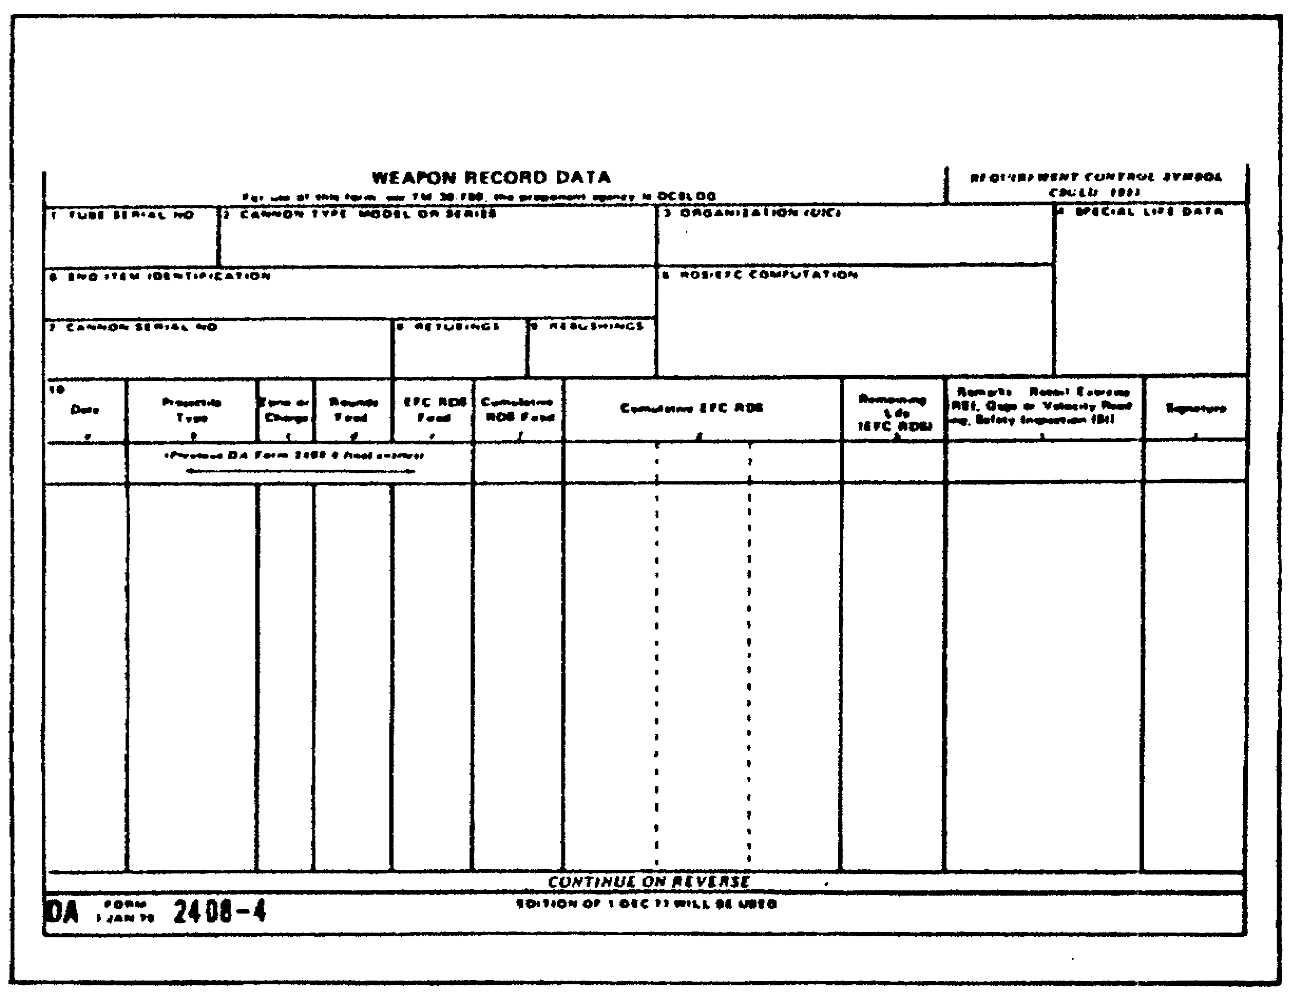

The step-by-step procedure for filling out DA Form 2408-4 is explained below on a block-by-block basis.

a. Block 1. Tube Serial No. Enter the cannon tube serial number. TM 9-1000-202-14 shows where tube serial numbers are located on cannons. For the 106mm Recoilless Rifle, put the assembly serial number here.

62

b. Block 2. Cannon type, Model or Series. The cannon type, model series—105mm, M68, for example, or 155mm, M185--goes in this block.

c. Block 3. Organization (UIC). Owning organization name and Unit Identification Code (UIC). Pencil entry only.

d. Block 4. Special life Data. Enter special life data on this specific weapon. Use this space to record Equivalent Full Charge (EFC) round life and other tube life information, when needed. Note any maintenance to be pulled on a rounds-fired basis. (Pencil entry.)

e. Block 5. End Item Identification. Enter the weapon end item identification, type series and model. For example, Howitzer, Medium, towed, M198, or Tank, Combat, M60A3. Also, put the end item chassis serial number in this block.

f. Block 6. RDS/EFC Computation. Enter EFC factors for various rounds here. TM 9-1000-202-14 gives EFC factor values. Write the zone figures above the subcolumns in column 10g.

g. Block 7. Cannon Serial No. Enter the cannon serial number. TM 9-1000-202-14 shows where the cannon serial numbers (breech ring) are.

h. Block 8. Retubings. Divide this block into 2 sections by drawing a diagonal (slanted) line from the upper right to the lower left comer.

(1) In the first (left side) section, put the number of times the installed breech ring has been retubed. See TM 9-1000-202-14 FOR DETAILS. If the initial tube is in the breech ring, put a zero in this section.

(2) In the second (right side) section, enter the total EFC rounds for the breech mechanism for the 105mm, M68 gun.

(3) For other equipment, put the total cumulative EFC rounds fired on the end item at the time of the last retubing in the second section. This figure is the total rounds on the whole system-the chassis or carriage-for overhaul under TB 750-231.

63

CANNON TUBE EVALUATION - OD 0463 - LESSON 4/TASK 1

i. Block 9. Rebushings. Enter the number of times the installed breech ring has been rebushed. For the 106mm recoilless rifle, put the number of times the breech ring has been revented. Leave this block blank on weapons that do not require rebushing or reventing.

j. Block 10. This block is subdivided into 10 columns, a-j.

(1) Block 10a, Date. Write the calendar date when the action occurred. Do not use Julian date (month, day, year).

(2) Block 10b, Projectile Type. Enter the type of projectile and cartridge mode.

(3) Block 10c, Zone or Charge. Enter the charge and zone number. Leave this column blank when it does not apply to your weapon.

(4) Block 10d, Rounds Fired. Write the number of rounds actually fired.

(5) Block l0e, EFC RDS Fired. Multiply the rounds fired in column 10d by the EFC factor value for that type round or propellent.

(6) Block 10f, Cumulative RDS Fired. Add the number of rounds fired in column 10d to the last entry made in column 10f.

(7) Block 10g, Cumulative EFC RDS. Add the number in column 10e to the last entry made in column 10g in the subcolumn for the zone that
applies to the rounds fired.

(8) Block 10h, Remaining Life (EFC RDS). Subtract the EFC rounds fired in column 10e from the last entry made in column 10h. The difference between those two numbers is the remaining life of the cannon tube.

(9) Block 10i, Remarks. Enter remarks you need on the operation or maintenance of the weapon. Include information on borescoping, gaging, velocity, pullover gage readings and recoil exercises.

64

CANNON TUBE EVALUATION - OD 0463 - LESSON 4/TASK 1

(10) Block 10j, Signature.

(a) The person designated by the Unit Commander to make entries on this form will sign this column. Both your signature and rank or title go here.

(b) When support personnel make entries, put the support unit identity under the signature and rank.

(c) The Unit Commander will sign in this column on the first line and last line entires.

NOTE

Draw a line under the last entry on a date.

FIGURE 34. COMPLETED WEAPON RECORD DATA FORM
DA FORM 2408-4.
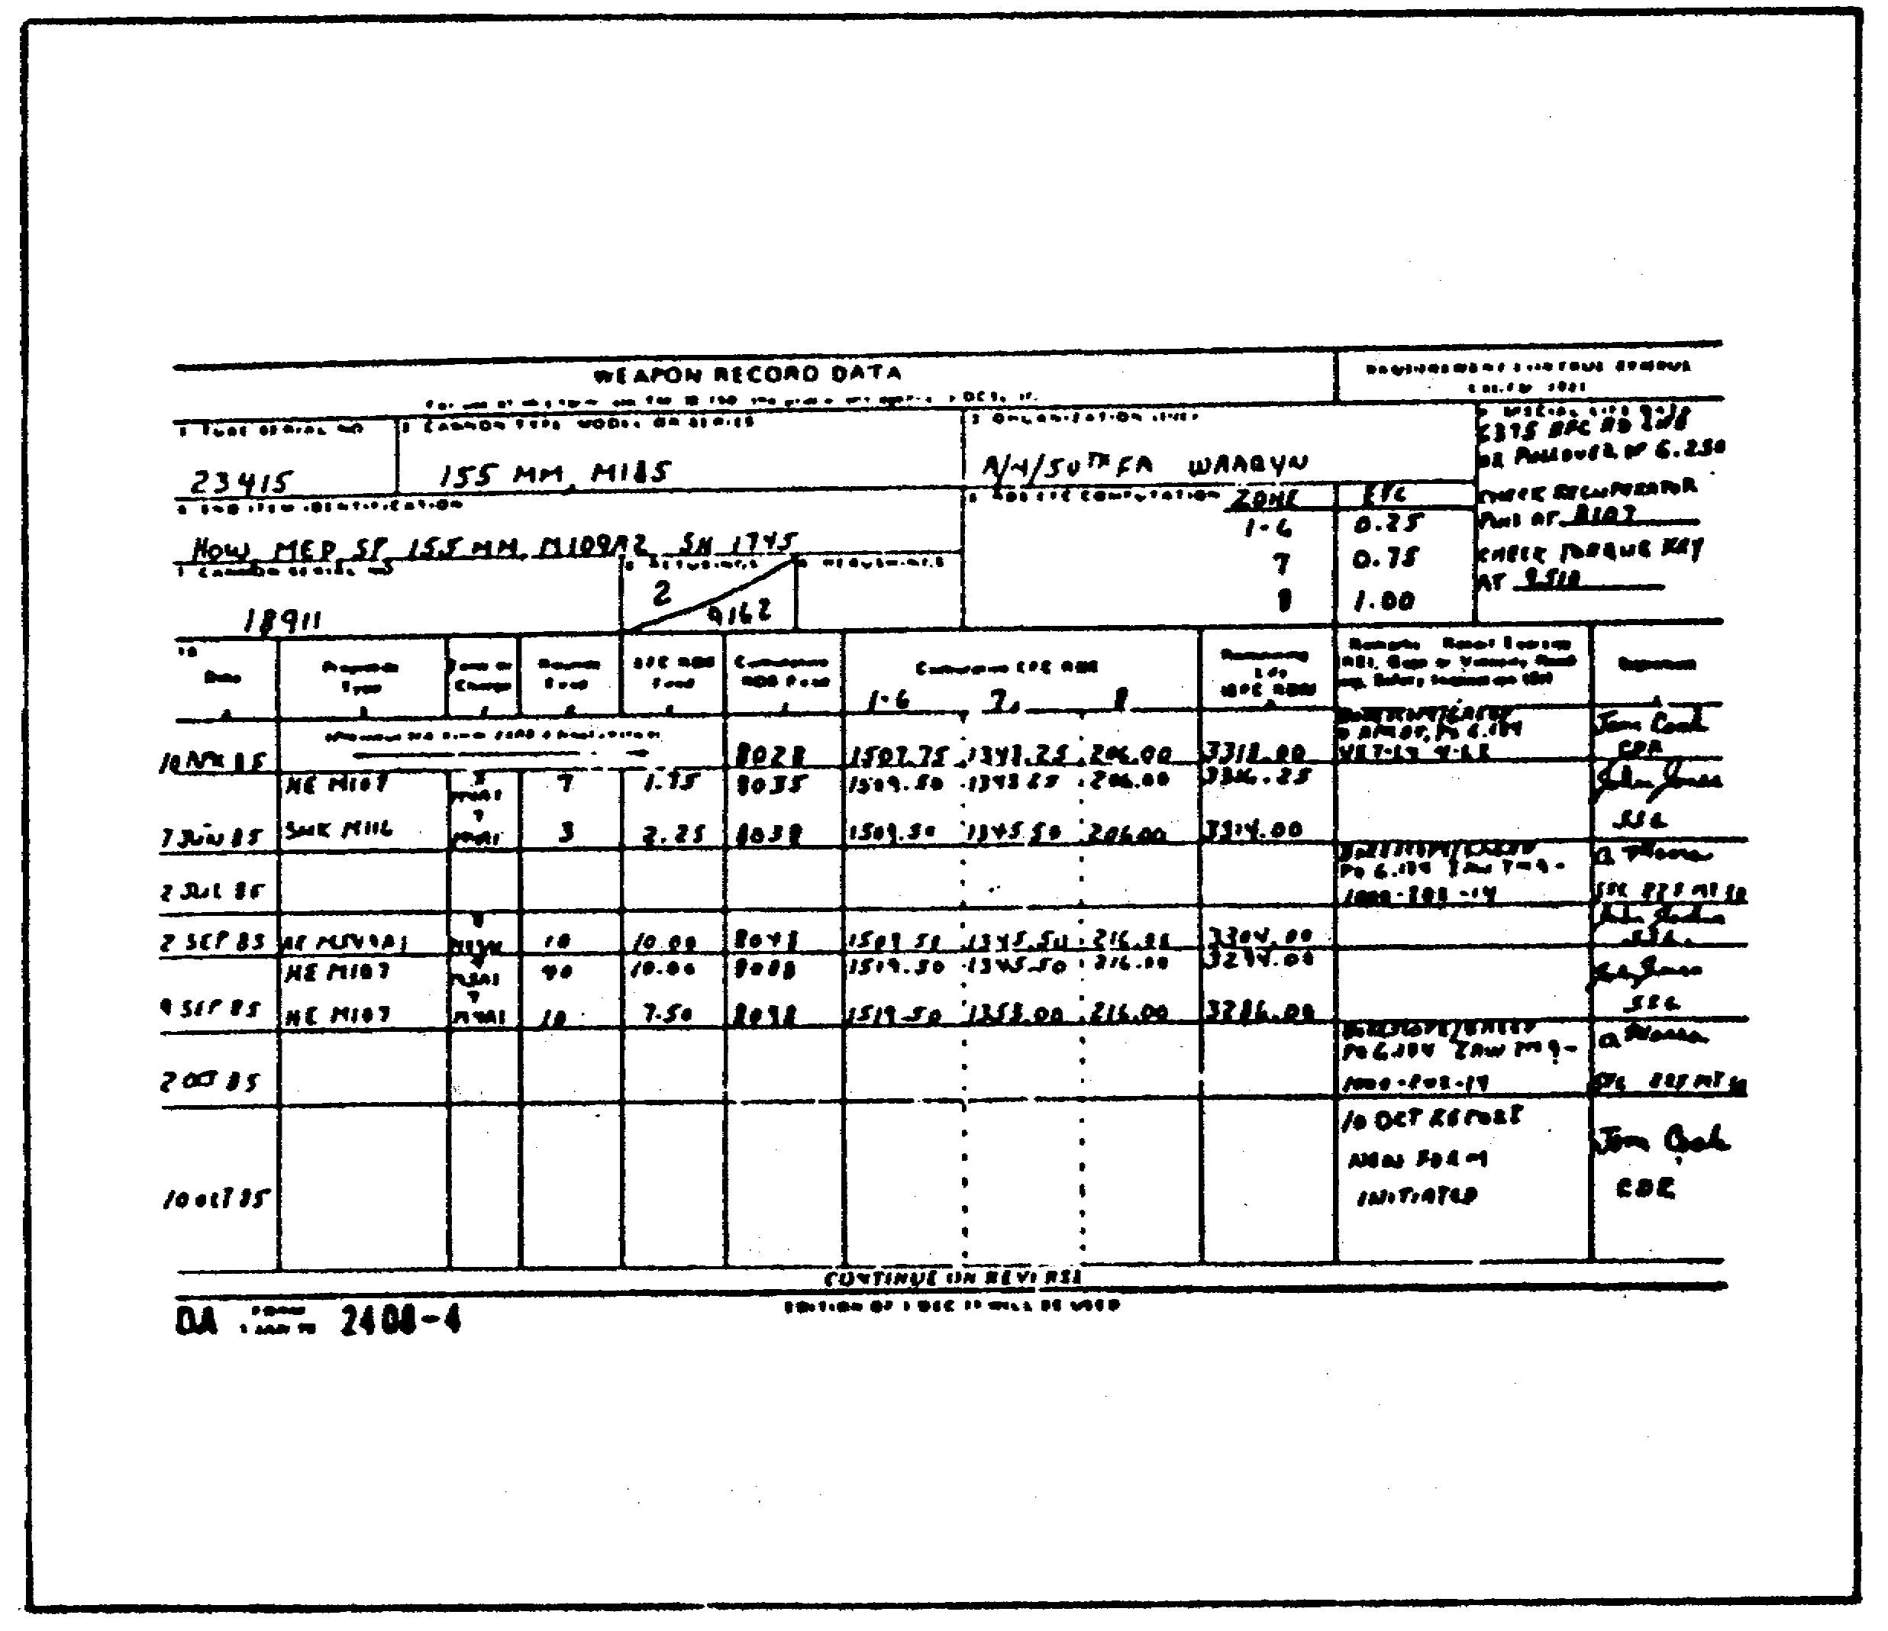

65

CANNON TUBE EVALUATION - OD 0463 - LESSON 4/TASK 2

LESSON 4

PROCEDURES FOR USING THE WEAPON RECORD
DATA FORM (DA FORM 2408-4)

TASK 2. Identify miscellaneous information entries and disposition of the Weapon Record Data Form (DA Form 2408-4).

CONDITIONS

Within a self-study environment and given the subcourse text, without assistance.

STANDARDS

Within one hour

REFERENCES

No supplementary references are needed for this task.

1. Introduction

Once DA Form 2408-4 is correctly completed, it is best to keep it in one logbook binder. Normally, the form is sent out on dispatch only when the weapon will be fired, repaired, or sent to support maintenance. If you need special information on a DA Form 2408-4, write: Commander, Watervliet Arsenal, ATTN: SMCWV-QAP Watervliet, New York 12189. When the tube or cannon is condemned or, if for any reason, the weapon is lost to the Army inventory, the DA Form 2408-4 is sent to Watervliet Arsenal. Before you send a form to Watervliet Arsenal, be sure to include the following information on a new DA Form 2408-4.

a. Special Life Data. Any special life data that should be sent in from RFC RDS life will be entered here. Enter any information on maintenance done on a round-count basis.

66

CANNON TUBE EVALUATION - OD 0463 - LESSON 4/TASK 2

b. Retubings. Enter the information from both sections in the previous form's block 8.

c. Date. Enter the current date.

d. Cumulative RDS Fired. Enter the total RDS fired from the last entry in column 10f of the form to be sent in.

e. Cumulative EFC RDS. Enter the EFC RDS fired from the last entry in column 10g of the form to be sent in.

f. Remaining Life EFC RDS. Enter the remaining life. Make sure this number matches the last entry in column log of the previous DA Form 2408-4.

g. Remarks. Transfer any needed remarks from the previous form.

h. Signature. The Unit Commander signs in this column.

67

CANNON TUBE EVALUATION - OD 0463 - LESSON 4/PE 4

PRACTICAL EXERCISE 4

1. Instructions

Read the scenario and respond to the requirements that follow the scenario.

2. Scenario

You are enrolled in the instructor training (IT) course at Aberdeen Proving Ground. You have one final presentation to give before completing the course. You have chosen to give your presentation on the subject of cannon tube evaluation.

First Requirement

Following is a list of uses and characteristics that apply to the pullover gage and the borescope. Demonstrate your knowledge of these two instruments by placing either a P for pullover gage, or a B for borescope in the space provided.

- Can be used to detect damage caused by erosion.

- Major component is an adapter tube assembly.

- Employs a vernier type scale to determine readings.

- Accessories include rods 3/8" and 5/8" in diameter.

- Comes with three extension tubes.

- Has a spring and hinge.

- A power supply assembly is a major component.

- Three types of supports are available for this instrument.

68

CANNON TUBE EVALUATION - OD 0463 - LESSON 4/PE 4

- A very rugged instrument and can be used in the field.

- Interpretations of readings are found in table V, TM 9-4933-200-35.

Second Requirement

On the DA Form 2408-4 explain the procedure for calculating:

a. Cumulative rounds (RDS) fired

b. Cumulative equivalent full charge (EFC) RDS

c. Remaining life

69

CANNON TUBE EVALUATION - OD 0463 - LESSON 4/PE 4

LESSON 4. PRACTICAL EXERCISE - ANSWERS

First Requirement

- B

- B

- P

- P

- B

- P

- B

- B

- P

- B

Second Requirement

a. Add the number of rounds fired in column 10d to the last entry made in column 10f.

b. Add the number in column 10e to the last entry made in column 10g in the subcolumn for the zone that applies to the rounds fired.

c. Subtract the EFC rounds fired in column 10e from the last entry made in column 10h.

70

CANNON TUBE EVALUATION - OD 0463 - REFERENCES

REFERENCES

71

CANNON TUBE EVALUATION - OD 0463 - REFERENCES

REFERENCES

The following documents were used as resource materials in developing this subcourse:

TM 9-1000-102-14
TM 9-4933-200-35
TM 0-6OS0-235-13&P
MAINTENANCE MANAGEMENT UPDATE

72

